

GRAPH NEURAL NETWORK ANALYSIS FOR SCALABLE FAKE PROFILE DETECTION AND BOTNETS
BotGraph: GCN, GAT and GraphSAGE on a social graph, with Louvain botnet clusters and a moderator review loop
A project report submitted in partial fulfilment of the requirements for the award of the degree of
BACHELOR OF TECHNOLOGY
in
COMPUTER SCIENCE AND ENGINEERING
Submitted by
BIJJA NAGA LAKSHMI | 23K91A0538
DIVVELA SRIVATSHAV | 23K91A0564
ADUMULLA DURGA | 23K91A0504
BURUGULA KOUSHIK | 23K91A0550
Batch A9 (CSE-A)
Under the esteemed guidance of
NEELIMA
[DESIGNATION]
DEPARTMENT OF COMPUTER SCIENCE AND ENGINEERING
TKR COLLEGE OF ENGINEERING & TECHNOLOGY (AN AUTONOMOUS INSTITUTION)
Medbowli, Meerpet, Balapur, Hyderabad, Telangana - 500 097
Academic year [ACADEMIC YEAR]

CERTIFICATE
This is to certify that the project report entitled "Graph Neural Network Analysis for Scalable Fake Profile Detection and Botnets" is a bonafide record of the work carried out by BIJJA NAGA LAKSHMI (23K91A0538), DIVVELA SRIVATSHAV (23K91A0564), ADUMULLA DURGA (23K91A0504), BURUGULA KOUSHIK (23K91A0550), in partial fulfilment of the requirements for the award of the degree of Bachelor of Technology in Computer Science and Engineering, during the academic year [ACADEMIC YEAR], under my supervision.

Project Guide | Head of the Department | Principal
Neelima | [HOD NAME] | [PRINCIPAL NAME]
[DESIGNATION] | Department of Computer Science and Engineering | TKR College of Engineering & Technology

External Examiner: [NAME AND SIGNATURE]
Place: [PLACE]
Date: [DATE]

DECLARATION
We hereby declare that the project report entitled "Graph Neural Network Analysis for Scalable Fake Profile Detection and Botnets", submitted to the Department of Computer Science and Engineering, TKR College of Engineering & Technology, in partial fulfilment of the requirements for the award of the degree of Bachelor of Technology in Computer Science and Engineering, is a record of original work carried out by us under the guidance of Neelima, [DESIGNATION]. The results embodied in this report have not been submitted to any other university or institution for the award of any degree or diploma.

BIJJA NAGA LAKSHMI 23K91A0538
DIVVELA SRIVATSHAV 23K91A0564
ADUMULLA DURGA 23K91A0504
BURUGULA KOUSHIK 23K91A0550

Place: [PLACE]
Date: [DATE]

ACKNOWLEDGEMENT
We express our sincere gratitude to our project guide, Neelima, [DESIGNATION], for valuable guidance, encouragement and constructive suggestions throughout this project.
We thank [HOD NAME], Head of the Department of Computer Science and Engineering, for providing the facilities and support needed to complete this work, and [PRINCIPAL NAME], Principal, TKR College of Engineering & Technology, for the encouragement given to us.
We thank the project coordinators and all faculty and staff members of the department for their help, and our families and friends for their constant support.
We also acknowledge the authors of the base paper and of the related work surveyed in Chapter 2, the Stanford Network Analysis Project for the social-circles data, the publishers of the Instagram and Twitter labelled datasets used in this project, and the maintainers of the open-source software used to build it (PyTorch, NetworkX, scikit-learn, FastAPI, SQLAlchemy, React, Vite and Playwright).

BIJJA NAGA LAKSHMI
DIVVELA SRIVATSHAV
ADUMULLA DURGA
BURUGULA KOUSHIK
Fake profiles and coordinated botnets are created faster than moderators can remove them, and a classifier that reads one account at a time cannot see a network whose members each look genuine. This project builds BotGraph, which treats the platform as a graph in which accounts are nodes and interactions are edges, learns from each account's neighbourhood with graph neural networks, and groups flagged accounts into botnet clusters that a moderator can confirm or dismiss. The graph holds 4,533 accounts and 94,456 ties: the topology of ten Facebook ego networks, labelled profile and posting rows from public datasets, and eight seeded botnets and 150 lone spammers added so that clusters can be scored against a known answer. Each account carries 23 features covering profile metadata, posting behaviour, timing and interaction frequency.
GCN, GAT and GraphSAGE were written in PyTorch and compared with a feature-only baseline on one stratified split (908 test accounts, 114 fake), over three seeds. The baseline reaches F1 0.827; GCN 0.837, GAT 0.900 and GraphSAGE 0.939, with GraphSAGE at precision 0.975, recall 0.906 and ROC-AUC 0.990 (seed 0: 3 false positives and 9 missed fake accounts). GCN gains only 1.0 F1 point and loses recall. Louvain community detection over the learned embeddings recovers all 8 injected botnets as single communities (mean precision 0.988). A training epoch grows from 0.06 s to 0.39 s as the graph grows from 4,533 to 36,264 accounts on a CPU. A FastAPI service, a React moderator application and a 36-check smoke test complete the system. The botnets are injected and several features are synthetic, so the results show what the method can do on this benchmark, not how it performs on a live platform; the base paper's figures measure a different task and are not compared.
Keywords: graph neural networks, fake profile detection, botnet detection, GCN, GAT, GraphSAGE, community detection, social network analysis.

TABLE OF CONTENTS
CERTIFICATE i
DECLARATION ii
ACKNOWLEDGEMENT iii
TABLE OF CONTENTS v
LIST OF FIGURES vii
LIST OF TABLES ix
LIST OF ABBREVIATIONS x
CHAPTER 1: INTRODUCTION 1
1.1 Domain 1
1.2 Background and Motivation 1
1.3 Problem Statement 2
1.4 Need for the Work 2
1.5 Objectives 3
1.6 Scope 3
1.7 Contributions 4
1.8 Limitations and Assumptions 4
1.9 Organisation of the Report 5
CHAPTER 2: LITERATURE SURVEY 6
2.1 Overview 6
2.2 Base Paper Analysis 6
2.3 Related Work 9
2.4 Datasets and Algorithms Used in This Project 10
2.5 Strengths and Limitations of the Surveyed Work 11
2.6 Research Gap 11
CHAPTER 3: FEASIBILITY STUDY 13
3.1 Technical Feasibility 13
3.2 Economic Feasibility 14
3.3 Operational Feasibility 14
3.4 Schedule Feasibility 15
3.5 Advantages and Constraints 15
CHAPTER 4: SYSTEM REQUIREMENTS AND ANALYSIS 17
4.1 Existing System and Its Limitations 17
4.2 Proposed System and Its Advantages 17
4.3 Functional Requirements 18
4.4 Non-Functional Requirements 18
4.5 Hardware Requirements 19
4.6 Software Requirements 19
4.7 User Roles and Constraints 19
4.9 Data Requirements 20
CHAPTER 5: SYSTEM DESIGN 21
5.1 Design Goals and Architecture 21
5.2 High-Level Workflow 22
5.3 Data Flow Diagrams 23
5.4 UML Design 25
5.5 Data Design 26
5.6 Algorithm Design 28
5.7 Module Design 31
5.8 API Design 31
5.9 User Interface Design 32
5.11 Security and Error-Handling Design 33
CHAPTER 6: METHODOLOGY AND SOFTWARE IMPLEMENTATION 35
6.1 Overall methodology 35
6.2 Dataset 35
6.3 Data preparation and node features 37
6.4 Algorithm choice and justification 38
6.5 Mathematical formulation 39
6.6 Model architecture and training configuration 41
6.7 Botnet cluster detection 42
6.8 Moderator feedback and retraining 43
6.9 Application architecture 43
6.10 API design 44
6.11 Security and error handling 45
6.12 Installation and execution 46
CHAPTER 7: SYSTEM TESTING 47
7.1 Testing strategy 47
7.2 Unit-level testing 47
7.3 Integration testing: the smoke test 48
7.4 Functional testing 48
7.5 Validation and edge cases 49
7.6 Security testing 49
7.7 Performance testing 50
7.8 User interface checks 52
7.9 User acceptance 52
7.10 Environment note 52
7.11 Limits of the testing done 52
CHAPTER 8: RESULTS AND OUTPUT SCREENS 54
8.1 Experimental set-up 54
8.2 Model performance 55
8.3 Threshold analysis 57
8.4 Which features matter: an ablation 58
8.5 Botnet cluster detection 59
8.6 Scalability and response time 61
8.7 Comparison with the base paper 62
8.8 Summary of the numbers 62
8.9 Learning from moderator decisions 63
8.10 Output screens 64
8.11 Sample inputs and outputs 68
8.12 Success and failure analysis 69
8.13 Limitations of the results 71
8.14 Objectives against outcomes 71
CHAPTER 9: CONCLUSION 73
9.1 Summary of the work 73
9.2 Objectives achieved 73
9.3 Key findings 73
9.4 Practical applications 74
9.5 Known limitations 74
CHAPTER 10: FUTURE SCOPE 75
10.1 Improvements to the models and the evidence 75
10.2 Additional features 75
10.3 Scalability and deployment 75
10.4 Further research 76
REFERENCES 77
APPENDIX A: IMPORTANT CODE 79
A.1 The GCN and GraphSAGE layers (`ml/gnn.py`) 79
A.2 The training loop 79
A.3 Botnet clusters (`ml/clustering.py`) 79
A.4 Moderator feedback and retraining 80
APPENDIX B: INSTALLATION AND USER GUIDE 81
B.1 Requirements and start 81
APPENDIX C: ADDITIONAL SCREENS 82

LIST OF FIGURES
Figure 1: Architecture of BotGraph: data and ML pipeline, trained artefacts, FastAPI service with SQLite, and the React web application. 21
Figure 2: High-level workflow from raw data to moderator decisions and back into training. 22
Figure 3: Data flow diagram, level 0 (context). 23
Figure 4: Use-case diagram. 23
Figure 5: Data flow diagram, level 1: seven processes and four data stores. 23
Figure 6: Data flow diagram, level 2: expansion of the serving process 5.0 into six steps. 24
Figure 7: UML class diagram of the model classes, the Store, the database entities and the FastAPI routers. 25
Figure 8: Sequence diagram of the main flow: sign in, score an account, record a decision, retrain. 26
Figure 9: Entity-relationship diagram: the three database tables and the file-based graph, account and cluster entities. 27
Figure 10: Model architecture: two message-passing layers, a linear head and the three layer types compared. 29
Figure 11: Flowchart of the training pipeline from graph to served model. 30
Figure 12: Flowchart of botnet cluster detection with Louvain over embeddings and real ties. 30
Figure 13: Overview screen: key counts, the score histogram and the model comparison. 33
Figure 14: Cluster detail: size, tie density, shared peak hour, reach, and the moderator decision. 33
Figure 15: Flow of the offline pipeline from raw data to served artefacts. 35
Figure 16: Degree distribution of genuine and fake accounts in the assembled graph. 37
Figure 17: Standardised difference between fake and genuine accounts for each feature group. 38
Figure 18: Two-layer message-passing network with a classifier head, and the three layer types that fill the layer slots. 41
Figure 19: Steps of botnet cluster detection from model scores and embeddings. 42
Figure 20: Median and 95th-percentile response time of ten API endpoints (20 requests each, 127.0.0.1). 51
Figure 21: Precision, recall and F1 of the four models on the test split (mean over three seeds). 55
Figure 22: F1 gained over the feature-only baseline by each graph architecture, in F1 points. 56
Figure 23: F1 of every model for each of the three training seeds. 56
Figure 24: Confusion matrices of the four models on the test split (seed 0). 57
Figure 25: ROC curves of the four models on the test split (seed 0). 57
Figure 26: Precision, recall and F1 of the served GraphSAGE model against the decision threshold (test split, seed 0). 58
Figure 27: Test F1 of the baseline and GraphSAGE when feature groups are removed (three seeds). 59
Figure 28: Recall and precision of the cluster that best matches each injected botnet. 60
Figure 29: Distribution of GraphSAGE fake-probabilities for genuine and fake accounts. 61
Figure 30: Training time per epoch and inference time against graph size, CPU, for the four models. 61
Figure 31: Landing page (light theme). 64
Figure 32: Overview screen, light theme. 65
Figure 33: Ranked accounts screen. 65
Figure 34: Account detail screen, upper half. 66
Figure 35: Botnet clusters screen. 66
Figure 36: Cluster detail screen for BN-00112. 67
Figure 37: Moderator queue, accounts tab. 67
Figure 38: Models and scale screen, comparison tab. 68
Figure 39: Test fake accounts caught and missed by GraphSAGE and by the baseline, by kind (botnet member, lone spammer). 70
Figure 40: Mean value of each feature for genuine and fake accounts (standardised). 70
Figure 41: Number of ties per account for genuine and fake accounts. 71
Figure 42: Sign-in page with the one-click demo accounts. 82
Figure 43: Graph and features screen: counts, data provenance and the 23 features. 82
Figure 44: Moderator queue, botnet clusters tab. 82
Figure 45: Overview screen in the dark theme. 82
Figure 46: Landing page, dark theme. 82
Figure 47: Account detail, lower half: reasons and neighbourhood. 82
Figure 48: Cluster detail with the cluster graph in a second layout state. 83
Figure 49: Moderator queue, Decision log tab. 83
Figure 50: Models & scale, Scalability tab. 83
Figure 51: Models & scale, Retraining tab before any run. 83

LIST OF TABLES
Table 1: Abbreviations used in this report x
Table 2: Project objectives and how each was addressed 3
Table 3: Batch literature survey and its verification 6
Table 4: The base paper at a glance 7
Table 5: Base paper compared with this project 8
Table 6: Data and algorithms of this project 10
Table 7: Related work compared 11
Table 8: Technical feasibility checks and what was measured 13
Table 9: Planned schedule (weeks, indicative) 15
Table 10: Functional requirements 18
Table 11: Non-functional requirements and their measured status 18
Table 12: Hardware 19
Table 13: Software 19
Table 14: Roles and what each may do 19
Table 15: Table users 27
Table 16: Table reviews (one moderator decision) 27
Table 17: Table training_runs 27
Table 18: Modules and responsibilities 31
Table 19: Endpoints 32
Table 20: Error responses 32
Table 21: Screen map 32
Table 22: Data sources and what each contributes 35
Table 23: The 23 node features with the mean value for genuine and fake accounts (stored scale, before standardisation) 37
Table 24: The three message-passing layers compared 38
Table 25: Parameter counts and mean training time per model (3 seeds, CPU) 42
Table 26: Training configuration (identical for all models) 42
Table 27: Backend modules 43
Table 28: API endpoints 44
Table 29: Test levels used and what they cover 47
Table 30: The 36 smoke-test checks by feature 48
Table 31: Functional coverage of features F1-F7 48
Table 32: Edge cases and how the system behaved 49
Table 33: Security measures and their evidence 49
Table 34: API response times (20 requests per endpoint, milliseconds) 50
Table 35: Training seconds per epoch / inference seconds, by graph size (CPU) 51
Table 36: Data used in the evaluation 54
Table 37: Test-split results, mean ± standard deviation over three seeds (908 accounts, 114 fake) 55
Table 38: F1 by training seed (with the validation-tuned threshold) 56
Table 39: Confusion counts on the 908-account test split (seed 0) 57
Table 40: Served GraphSAGE at different thresholds (test split, seed 0) 57
Table 41: Test F1 with feature groups removed (mean ± standard deviation over three seeds) 58
Table 42: Recovery of the eight injected botnets 60
Table 43: What each work reports 62
Table 44: Headline numbers 62
Table 45: F1 on the test split before and after retraining on moderator decisions (one seed) 63
Table 46: The six objectives of the project and what was measured 71
Table 47: The six objectives of the batch against the outcome 73
Table 48: Demo sign-ins (password Demo@1234) 81

LIST OF ABBREVIATIONS
Table 1: Abbreviations used in this report
Abbreviation | Expansion
API | Application Programming Interface
AUC | Area Under the Curve
bcrypt | Adaptive password-hashing function
CORS | Cross-Origin Resource Sharing
CPU | Central Processing Unit
CSV | Comma-Separated Values
DFD | Data Flow Diagram
ELU | Exponential Linear Unit
ER | Entity-Relationship
F1 | Harmonic mean of precision and recall
GAT | Graph Attention Network
GCN | Graph Convolutional Network
GNN | Graph Neural Network
GraphSAGE | Graph SAmple and aggreGatE
HTTP | Hypertext Transfer Protocol
JSON | JavaScript Object Notation
JWT | JSON Web Token
kNN | k Nearest Neighbours
MLP | Multi-Layer Perceptron
MST | Minimum Spanning Tree
NLP | Natural Language Processing
ORM | Object-Relational Mapping
PR | Precision-Recall
REST | Representational State Transfer
ROC | Receiver Operating Characteristic
SNAP | Stanford Network Analysis Project
SPA | Single-Page Application
SQL | Structured Query Language
UI | User Interface
UML | Unified Modeling Language

CHAPTER 1: INTRODUCTION
This chapter introduces the domain of the project, the motivation for building BotGraph, the problem it addresses, the objectives set for it, the scope that was actually delivered, its contributions, and the limitations and assumptions that govern every result reported later. It closes with a map of the rest of the report.

1.1 Domain
An online social platform is a network. Accounts are connected by follows, likes, comments and mentions, and what a user sees, believes and shares is shaped by the people around them. The same property that makes the platform useful makes it a target. A fake account is a profile that does not belong to the person or organisation it claims to represent; a bot is an account operated by software; a botnet is a set of such accounts run together by one operator. Their uses are well documented: spreading misinformation, inflating follower and engagement counts, amplifying chosen content and manipulating public opinion [18], [17].
Detecting them is a classification problem, but not a standard one. The label of interest, fake or genuine, depends on the account's own attributes and also on who it is connected to and who those accounts are connected to. This is why the domain is called deep learning for social network security: the data is a graph, and the models that read graphs directly are graph neural networks. A graph neural network (GNN) repeatedly lets every node collect a summary of its neighbours' features, so that after two rounds an account's representation already reflects the accounts two ties away [8], [10].

1.2 Background and Motivation
The motivation is stated in the project abstract. Indian social platforms are growing quickly, and with them the number of fake profiles and automated botnets that threaten user privacy and digital trust. Regional platforms with very large user bases, such as ShareChat and Moj named in the batch abstract, cannot staff moderation at the pace at which accounts are created, so the moderators who remain need to be pointed at the accounts and groups that matter most.
Two approaches dominate current practice. Rule-based filters look at profile fields, for example a missing profile picture, many digits in a username or a very low follower-to-following ratio. Classical machine-learning classifiers combine such fields with posting statistics. Both examine each account alone. A botnet defeats them by design: each member can be given a plausible profile, while the members follow and like one another and are created and active in the same time windows. The coordination is a property of the group and of the ties, so it is visible in the graph and invisible in any single row of a table.
Graph-based bot detectors exist and report strong results on Twitter benchmarks. Two recent examples concentrate on the difficulties named in this project's problem statement: RABot addresses class imbalance and noisy links with minority oversampling and reinforcement-learned edge filtering [2], and HW-GNN uses spectral filters guided by the homophily of the graph [3]. The base paper of this project, PruferNET [1], applies GraphSAGE to the Facebook social-circles graph with structural features derived from a minimum spanning tree and a Prufer sequence, but its task is to find influential nodes, not fake ones. What is missing is a complete, runnable system that takes the GNN idea through to the output a trust-and-safety team needs: a score per account, the coordinated group the account belongs to, and a way for a moderator to confirm or dismiss it and teach the model.
Class imbalance deserves its own mention because it shapes every number in the report. In the data used here about one account in eight is fake. On such data accuracy is a weak measure: a classifier that never raises an alarm is right for most accounts. A moderator's cost is counted in two ways, accounts that are wrongly flagged (precision) and fake accounts that are missed (recall), so the project reports both, together with F1 and the area under the ROC and precision-recall curves, and tunes the decision threshold on a separate validation split and not on the test accounts.

1.3 Problem Statement
The batch problem statement lists four weaknesses of current practice:
• fake profiles are created faster than manual moderation can remove them;
• per-account classifiers miss coordinated networks whose individual profiles appear legitimate;
• bot behaviour evolves quickly, so static rules and signatures become obsolete;
• class imbalance and label noise degrade conventional supervised models.
The problem addressed here is to build and evaluate a graph-based detector that classifies every account from its relational context, exposes coordinated botnet clusters, and does so at a scale that grows in proportion to the size of the graph rather than faster.

1.4 Need for the Work
• Relational evidence. A fake account with a genuine-looking profile can only be recognised from its neighbourhood. The project needs to show how much the graph adds over the same features without it, on the same split.
• Coordinated groups, not isolated labels. Moderators act on groups. A detector that returns a probability per account but no cluster leaves the grouping to a human.
• Honest measurement under imbalance. About one account in eight is fake in this data, so a model that predicts "genuine" for everyone is 87.4% accurate. Precision, recall and F1 on the fake class are the numbers that matter, and the report leads with them.
• A system a reviewer can run. A scored account list, a cluster view, a moderator queue with retraining and a model-comparison page make the method inspectable by people who do not read code.

1.5 Objectives
The six objectives set for the project, and what each became, are summarised in Table 1.1. Chapter 8 returns to this table with the measured outcome for each.
Table 2: Project objectives and how each was addressed
No. | Objective | How it was addressed
1 | Construct a graph representation of the platform with accounts as nodes and interactions as edges | Graph builder: 4,533 accounts and 94,456 undirected ties (88,156 real, 6,300 injected), documented node and edge schema
2 | Engineer node features covering profile metadata, posting behaviour and interaction frequency | 23 features in four groups (12 profile, 4 posting, 6 temporal, 1 interaction); no text features
3 | Implement and compare GCN, GAT and GraphSAGE for account classification | Three architectures written in plain PyTorch, one stratified split, same features and budget, three seeds, plus a no-graph baseline
4 | Detect coordinated botnet clusters from the learned graph embeddings | Louvain over an embedding-similarity graph; 8 of 8 injected botnets recovered
5 | Evaluate detection accuracy, precision and recall against labelled fake-account data | Accuracy, precision, recall, F1, ROC-AUC and PR-AUC on a held-out test split of 908 accounts
6 | Assess scalability as the number of nodes and edges grows | Training and inference time timed from 4,533 to 36,264 accounts (755,648 ties) on CPU

Objective 2 lists profile metadata, posting behaviour and interaction frequency, and all three are covered. The batch abstract also mentions linguistic cues; text features were not built, and the report says so wherever the feature set is described.

1.6 Scope
BotGraph consists of a machine-learning pipeline, a service and a web application:
• Graph builder and features: the social topology of ten Facebook ego networks (3,963 accounts, 88,156 ties), labelled profile rows from an Instagram fake-account set, posting rows from a Twitter bot set, and 570 injected accounts (eight botnets and 150 lone spammers) with 6,300 injected ties, giving 23 node features.
• Models: a feature-only baseline and GCN, GAT and GraphSAGE, trained with a class-weighted loss, early stopping on validation F1 and a validation-tuned threshold; gradient-times-input attribution for the traits behind each score.
• Botnet clusters: Louvain community detection over the embeddings of accounts scored at 0.30 or more, with a description of each cluster.
• Service and application: a FastAPI service (port 8309) with JWT sign-in, two roles and a SQLite store for users, moderator decisions and retraining runs; a React application (port 5309) with a landing page, sign-in and eight working screens: overview, graph and features, accounts, account detail, clusters, cluster detail, moderator queue and models.
• Evidence: a three-seed comparison, a scalability sweep, a threshold sweep, an error analysis, a feature-group ablation, a 36-check smoke test and measured API latency.
Out of scope are live platform ingestion, text and language-model features, dynamic (time-evolving) graphs, training on GPUs or on graphs of millions of accounts, adversarial robustness testing, and the Prufer-sequence features of the base paper. Section 1.8 and Chapter 8 return to these.

1.7 Contributions
1. An end-to-end graph-based fake-account system, from graph builder to moderator queue, with a documented schema, a REST API, role-based access and a smoke test that passes 36 of 36 checks.
2. A controlled comparison of GCN, GAT and GraphSAGE with a no-graph baseline on one split: mean F1 over three seeds is 0.827 for the baseline, 0.837 for GCN, 0.900 for GAT and 0.939 for GraphSAGE (precision 0.975, recall 0.906). The comparison shows that the gain is not automatic: GCN adds only 1.0 F1 point and loses recall.
3. Botnet clusters recovered from the learned embeddings: all 8 injected botnets come back as single communities (mean recall 1.000, mean precision 0.988), together with one loose group that the application labels as diffuse.
4. A moderator feedback loop whose retraining leaves the test split untouched, so the effect of each round is measured on the same accounts.
5. A scalability measurement from 4,533 to 36,264 accounts showing training and inference time growing roughly in proportion to the number of ties.

1.8 Limitations and Assumptions
The conclusions of this report hold under the following limitations and assumptions.
• The botnets are injected into the real topology with known membership. Cluster recovery therefore measures how well the method finds this kind of coordination, not how well it finds botnets in the wild.
• Several feature columns are synthetic: the six temporal features and the interaction-frequency feature (generated with a bot-leaning setting for non-camouflaged bots, so they carry label signal by construction), and the handles and display names. Profile rows and posting rows come from different datasets and are combined by resampling, which keeps realistic value ranges but not real correlations. 198 bots were given genuine-looking profiles and 231 genuine accounts fake-looking ones on purpose, because otherwise the profile alone would solve the task.
• The graph is a single static snapshot; there is no time dimension in the ties.
• Evaluation uses one stratified split and three training seeds, with no cross-validation. GAT results can shift by about a hundredth between runs because its edge softmax sums in a non-deterministic order.
• Scalability was measured to 36 thousand accounts by copying the graph as disjoint components, on a CPU. This does not establish behaviour on a platform with millions of accounts.
• The base paper's numbers measure a different task and are not comparable with these results. All timings come from one shared machine (12th Gen Intel Core i5-12500 (6 cores, 12 threads), 16 GB RAM, Windows 11 Pro, CPU only) and are indicative.
• Authentication is a demonstration: two seeded users, JWT sign-in, no password reset, multi-factor step or rate limiting.

1.9 Organisation of the Report
• Chapter 2 surveys the literature, analyses the base paper and states the research gap.
• Chapter 3 studies feasibility; Chapter 4 analyses the existing system and the requirements of the proposed one.
• Chapter 5 presents the system design: architecture, data flow diagrams, UML, database, modules and screens.
• Chapter 6 describes the methodology and the software implementation: data, features, models, clustering, API, security and installation.
• Chapter 7 reports system testing; Chapter 8 reports results and output screens, with the position against the base paper.
• Chapters 9 and 10 give the conclusion and the future scope, followed by the references and three appendices (important code, installation and user guide, additional screens).

CHAPTER 2: LITERATURE SURVEY
This chapter reviews the work on which the project builds. It first places the problem among the approaches to detecting fake accounts and bots, then analyses the base paper in detail, reviews related work by theme, lists the data and algorithms the project uses, and ends with the research gap that the design answers.

2.1 Overview
Social bot detection has been studied for more than a decade [18], [17]. The methods fall into two broad families, as the introductions of recent papers describe [2]. Feature-based methods classify each account from its metadata or its text. Graph-based methods add the relations between accounts, and in the last five years most of them use graph neural networks. The graph-based turn was driven by a practical observation: operators of bots can imitate a human profile, and increasingly imitate human posting, but they cannot easily imitate a human's position in the network, and bots that are run together tend to be tied to one another.
The batch literature survey lists five works. Table 2.1 states how each was checked in this project; only checked items are used for any claim in this report.
Table 3: Batch literature survey and its verification
No. | Work as listed in the batch survey | Year | Status in this project
1 | PruferNET (base paper) | 2026 | Read in full (PDF)
2 | AdapTGN: adaptive temporal-relational GNN for bot detection | 2026 | Not verified: a web search found no page under this title
3 | GNN approach for fake-news identification in Arabic | 2026 | Not verified: listed in the batch survey only
4 | Bot detection using account metadata, feature selection and stacking (IJSR) | 2026 | Exact title not found; the nearest match is Sharma and Borah on stacking over account-level data [33]
5 | LGB: language model and GNN-driven social bot detection | 2024 preprint | Found as an arXiv preprint [4]; the venue named in the batch survey was not confirmed

2.2 Base Paper Analysis

2.2.1 Problem and approach
The base paper is PruferNET by Saha, Sarkar and Pratihar [1], published in IEEE Access in May 2026. Its starting point is that classical GNNs aggregate local neighbourhoods and struggle to capture global or hierarchical structure. To add such structure, the authors build a minimum spanning tree of the graph, convert the tree into a Prufer sequence [22] (a sequence of n-2 integers that encodes a labelled tree uniquely), and derive node features from that sequence. These are concatenated with degree, closeness, PageRank and a trust score, and passed to a GraphSAGE classifier. The authors state that their contribution is not a new GNN architecture but a tree-based global structural encoding that can be attached to an existing one, and that the encoding is deterministic and independent of training.
The target is also derived from the tree: nodes are labelled by their depth in the MST, split by percentiles into Very Shallow, Shallow and Deep, and the authors read depth as a proxy for how deeply embedded, and therefore influential, a node is.

2.2.2 Evaluation protocol and reported numbers
Table 4: The base paper at a glance
Item | As reported in the paper
Task | Three-class node classification: each node of the SNAP Facebook graph is labelled Very Shallow, Shallow or Deep from its depth in a minimum spanning tree (MST), read as an influence proxy
Data | SNAP Facebook social circles, 4,039 nodes and 88,234 edges after pre-processing (largest connected component, self-loops and duplicates removed); Email-Eu-core (986 nodes, 16,064 edges) as a second network
Features | Degree, closeness and PageRank; a trust score (mean PageRank of the neighbours); and five features taken from the Prufer sequence of the MST: label frequency, sequence entropy, unique-label ratio, edge-transition influence and subtree depth
Tree | Edge weight 1 / (deg u + deg v); MST of the weighted graph; Prufer sequence of the tree
Model | GraphSAGE with 64 hidden units, dropout 0.5, AdamW (learning rate 0.003), 300 epochs, model chosen on validation accuracy
Split | 60 % train, 20 % validation, 20 % test, one fixed random permutation; 5-fold cross-validation on Facebook reported as stable (the fold values are not given in the text)
Reported result | Test accuracy 99.63 % with Prufer features against 96.54 % without them on Facebook; on Email-Eu-core 93.43 % against 80.30 %
Hardware | Python on a machine with a T4 GPU and 16 GB of RAM

2.2.3 Strengths
• The idea is cheap and general: the encoding is computed once, needs no training, and can be attached to any GNN.
• Ablation (with and without Prufer features) isolates the contribution of the new features on the same model and split.
• A second network (Email-Eu-core) and 5-fold cross-validation are used to argue that the gain is not an accident of one graph or one partition.
• GraphSAGE is chosen for the right reason: it is inductive and aggregates sampled neighbourhoods, which suits large social graphs.

2.2.4 Limitations
• The target and the features come from the same tree. Labels are percentiles of MST depth, and the feature set includes subtree depth and other quantities derived from the same MST. A large gain from such features is therefore not surprising; this report notes it as an observation about the setup, not as a claim made by the authors.
• It is not a fraud task. There are no fake-account labels, no class imbalance of the kind that bot detection faces, no coordinated groups and no adversary who is trying to avoid detection.
• Evaluation is on accuracy over three depth classes. The paper reports precision, recall and F1 per class, but none of the cost measures that matter to a moderator, such as false alarms among genuine users.
• No scalability measurement, although scalability is cited as a motivation; no run time or memory figures are given for the MST and Prufer step.
• No end-user output. The paper stops at a classification report.

2.2.5 What this project keeps from the base paper and what it changes
BotGraph keeps the family of data (the SNAP Facebook ego networks), GraphSAGE as one of the backbones, the 60/20/20 split and the idea that structure adds information a per-node model lacks. It changes the task, the labels, the model set, the outputs and the evaluation, as Table 2.3 shows. The Prufer-sequence features themselves are not implemented; they are listed as future work in Chapter 10.
Table 5: Base paper compared with this project
Aspect | Base paper | This project
Task | Influence: classify nodes by MST depth | Fraud: classify accounts as fake or genuine, then group them into botnets
Labels | Derived from the graph itself (percentiles of MST depth); no fake-account labels | External labels: 570 fake accounts (12.6%) from labelled profile data and injected botnets
Data | SNAP Facebook (4,039 nodes / 88,234 edges); Email-Eu-core | SNAP Facebook topology (3,963 nodes / 88,156 ties) plus 570 injected accounts; Instagram and Twitter rows for attributes
Features | Centrality, trust score and Prufer-sequence features | 23 node attributes: profile, posting, temporal, interaction; structure enters through message passing
Model | GraphSAGE only | GCN, GAT and GraphSAGE against a no-graph baseline, three seeds
Output | A depth class per node | A fake-probability per account, the traits behind it, and a botnet cluster per flagged group
Evaluation | Accuracy, precision, recall, F1 over three depth classes | Accuracy, precision, recall, F1, ROC-AUC, PR-AUC under a 1-in-8 class imbalance; cluster recovery; scalability
Human in the loop | None | Moderator confirms or dismisses; decisions feed retraining on a protected test split
Scale | Not measured | Timed from 4,533 to 36,264 accounts on CPU

The accuracy figures of the base paper (99.63 % and 96.54 %) measure how well depth classes are recovered. They say nothing about fake-account detection and are not used as a benchmark for BotGraph's results anywhere in this report.

2.3 Related Work

2.3.1 Feature-based detection
Early detectors treat each account as a row of metadata or text features and train a classifier [17]. These models are fast and easy to explain, and the profile fields they use are the same ones this project keeps in its feature set: whether there is a picture, how many digits are in the username, how long the bio is, the follower-to-following ratio. Their weakness is the one named in the problem statement: a bot given a careful profile looks genuine row by row. The batch survey lists a 2026 study of stacking classifiers over account metadata; the nearest match that could be found is [33], cited here only to show that metadata-only stacking remains an active line. This project's no-graph baseline plays the role of the feature-based family: same features, same split, same training budget.

2.3.2 Graph-based detection and the architectures compared here
Graph convolutional networks [8] update a node from a symmetrically normalised sum over its neighbours and itself. Graph attention networks [9] learn a weight for each neighbour. GraphSAGE [10] keeps a separate weight for the node's own features and for the mean of its neighbours, and was designed to generalise to unseen nodes. A relational variant, BotRGCN, was applied to Twitter bot detection with separate relation types [20], and the TwiBot benchmarks [19], [21] standardised evaluation; both are described in the recent papers [2], [3] that this survey did read in full. The three architectures chosen by the batch objectives are the standard spatial GNNs, and the survey shows them used as backbones and baselines in current work; this project compares them head to head, which the surveyed papers use mainly as baselines.

2.3.3 Imbalance and noisy links
RABot [2] treats two practical problems together. Because bots are costly to create, the minority class is small; the authors interpolate minority-class embeddings within local subgraphs to stabilise the decision boundary. Because bots forge links, they train a reinforcement-learning agent to remove spurious edges during message passing. On three benchmarks and four GNN backbones (GCN, GAT, RGT and RGCN) the paper reports the best accuracy and F1 in each case, for example 99.14 % accuracy and 98.94 % F1 on Cresci-15 and 87.92 % and 88.40 % on Twibot-20, and average gains of 2.0 to 3.0 points over the plain backbones. The framing is the one adopted here: imbalance is handled in this project by a class-weighted loss with a validation-tuned threshold (the classic alternative is oversampling [26]), and noisy or forged links are not filtered out: camouflage is built into the data (40 % of botnet accounts have genuine-looking profiles) so that every model is tested against it.

2.3.4 Spectral and multi-scale filters
HW-GNN [3] argues that low homophily corresponds to high-frequency spectral energy and that bots live in particular frequency bands, so it uses learnable Gaussian windows to focus a polynomial spectral filter, and a loss that ties the windows to the graph's homophily ratio. It evaluates on five benchmarks that range from 39,357 users (T-Finance) to 5,781,065 users (T-Social), and reports an average gain of 4.3 % in F1. MSGS [7] uses a multi-scale filter with signed attention so that both low- and high-frequency information is retained and over-smoothing is reduced. Both show that GNN bot detection is still developing; neither returns coordinated groups, and both are heavier than the spatial layers used here.

2.3.5 Language and time
LGB [4] observes that many bots have few connections and so escape purely graph-based methods; it fine-tunes a language model on account text and refines the result with a pre-trained GNN, reporting gains of up to 10.95 % over baselines on two real datasets. Dynamic-graph methods such as BotDGT [5] and BotTGCL [6] model how the network evolves, on the grounds that a static snapshot can be evaded by bots that interact with real users. Both lines are outside the scope of this project, which uses a single static graph and no text, and both are listed as future work.

2.3.6 Community detection and coordinated behaviour
Coordinated accounts form dense groups. The standard way to find such groups is modularity-based community detection, and Louvain [11] is the usual algorithm because it scales to large graphs. The surveyed bot detectors stop at a per-account label. This project applies Louvain to a graph built from the learned embeddings (which carry the attribute and neighbourhood signal) and from real ties between flagged accounts, so that the group, and not only the account, becomes the unit a moderator acts on.

2.4 Datasets and Algorithms Used in This Project
Table 6: Data and algorithms of this project
Element | Choice | Note
Topology | SNAP Facebook ego networks | Real friendship ties between 3,963 accounts [12]; the same graph family as the base paper
Profile attributes | Labelled Instagram fake / spammer / genuine rows | Real labelled profile fields; CC BY 3.0 [31]
Posting behaviour | Twitter bot detection rows | Real posting statistics; CC0 [32]; the label carries almost no signal, so these columns act as realistic noise
Botnets | Seeded generator, seed 7 | 8 botnets of 34 to 62 accounts and 150 lone spammers so that clusters can be scored against a known answer
Message passing | GCN, GAT, GraphSAGE | Neighbourhood aggregation with symmetric normalisation [8], attention [9] or a separate self weight and neighbour mean [10]
Optimiser and regularisation | Adam, dropout, ELU | Adam [13], dropout 0.3 [23], ELU activation [24], class-weighted loss
Community detection | Louvain | Modularity optimisation [11] through NetworkX [16]
Explanation | Gradient times input | First-order attribution of the fake-versus-genuine margin [25]

2.5 Strengths and Limitations of the Surveyed Work
Table 7: Related work compared
Work | Approach | Reported result | Limitation for this project
RABot [2] | Neighbourhood-aware oversampling of the minority class; reinforcement-learned edge filtering | Cresci-15 99.14 % accuracy, 98.94 % F1 (RGT backbone); Twibot-20 87.92 % / 88.40 %; MGTAB 91.16 % / 89.03 % (RGCN) | Twitter benchmarks only; a label per account; no clusters, no moderator loop
HW-GNN [3] | Learnable Gaussian windows over a spectral filter, steered by the homophily ratio | Five benchmarks, average +4.3 % F1 over the best baselines | Detection only; spectral filtering is costly to extend to new graphs
LGB [4] | Fine-tuned language model on account text, refined by a pre-trained GNN | Up to 10.95 % better than baselines on two real datasets | Needs account text, which this project does not use
BotDGT [5] | Dynamic graph transformer over network snapshots | Reports gains over static-graph methods (no figure read) | Needs time-stamped snapshots
BotTGCL [6] | Graph contrastive learning plus a temporal module | Two benchmarks; strong when labels are scarce (no figure read) | Needs a time-stamped graph
MSGS [7] | Multi-scale graph filter with signed attention | Outperforms several detectors (no figure read) | Detection only

2.6 Research Gap
The batch survey states the gap in one sentence: the surveyed work applies GNNs to influence and node classification in social graphs, and the gap is applying the same relational learning specifically to fake-profile and botnet detection at platform scale. The survey above refines it into five points:
1. The base paper applies GNNs to influence and node classification; applying the same relational learning to fake-profile and botnet detection is the gap this project fills [1]
2. Bot-detection GNN papers report per-account labels on Twitter benchmarks; coordinated clusters recovered from the learned embeddings, with a measured recovery rate, are rarely shown [2], [3]
3. Architecture comparisons often change the data or tuning between models; GCN, GAT and GraphSAGE are rarely compared with a no-graph baseline on one split, features and training budget
4. Moderator decisions are not fed back into training in the surveyed detectors, and the effect on a protected test split is not measured
5. Scalability of training and inference as nodes and edges grow is seldom reported next to accuracy
BotGraph answers these points on a benchmark of 4,533 accounts: it applies GCN, GAT and GraphSAGE to fake-account labels, compares them with a feature-only baseline under identical conditions, recovers coordinated clusters from the embeddings, closes the loop with moderator decisions, and measures cost as the graph grows. What it does not answer is also part of the gap: real-world botnets, platform-scale graphs, text and time.

CHAPTER 3: FEASIBILITY STUDY
A feasibility study asks whether a project can be built, run and maintained with the resources at hand. For BotGraph the question was answered partly by analysis and partly by building the system and measuring it on the development machine, so most entries below carry a measured value rather than an estimate. Where a question could not be settled with the data available to the team, the entry says so.

3.1 Technical Feasibility
The technical risk lay in five places: whether three graph neural network layers could be written and trained without a specialised graph library; whether the models could be trained and served on an ordinary processor; whether public data with real social-graph structure and labelled fake-account attributes could be obtained and joined into one graph; whether botnet clusters could be recovered from the learned embeddings; and whether all of it could sit behind one API and one web application. The development machine is a desktop with an 12th Gen Intel Core i5-12500 (6 cores, 12 threads), 16 GB RAM, Windows 11 Pro, CPU only. It was shared with other jobs during the measurements, so timings are upper bounds.
Table 8: Technical feasibility checks and what was measured
Question | Measurement | Verdict
Can GCN, GAT and GraphSAGE be implemented without torch-geometric? | Yes: ml/gnn.py is 188 lines of plain PyTorch sparse operations; all four models train on the same split and the same features | Feasible
Can the models be trained on a CPU? | Mean time per training run: baseline 3.0 s, GCN 10.4 s, GraphSAGE 11.7 s, GAT 40.6 s (up to 160 epochs, early stopping) | Feasible
Can real graph data and labelled fake-account data be combined? | Yes: 3,963 real accounts and 88,156 real ties come from ten Facebook ego networks; profile and posting rows come from two labelled public sets; the committed raw data is under 10 MB | Feasible, with a caveat
Does the graph help detection? | F1 on the 908-account test split: baseline 0.827, GCN 0.837, GAT 0.900, GraphSAGE 0.939 (mean of three seeds) | Feasible
Can botnets be recovered from the embeddings? | 8 of 8 injected botnets recovered as single Louvain communities (mean recall 1.000, mean precision 0.988) | Feasible on injected botnets
Does cost grow acceptably with graph size? | GraphSAGE epoch 0.060 s at 4,533 accounts and 0.392 s at 36,264 accounts (755,648 ties) | Feasible to the size measured
Can everything run behind one local API? | FastAPI with 18 routes, SQLite for users, decisions and retraining runs; 36 of 36 smoke-test checks pass; median API latency 3 to 16 ms | Feasible

The weakest point is the data, not the technology. Eight botnets and 150 lone spammers were injected into the real topology by a seeded script, and the timing and interaction features are generated, because no public data set offers a real social graph with labelled coordinated botnets, posting-time features and profile attributes at the same time. The technical feasibility of cluster recovery was therefore established against a known answer, which shows that the method finds this kind of coordination but not how often real botnets look like it. Chapter 8 repeats this caveat next to every result.
A second, smaller risk is the dependency chain on Windows. On the system Python used for the documentation run, importing fastapi before torch made the PyTorch libraries fail to initialise (WinError 1114). The smoke test and the experiment scripts therefore import torch first. The risk is cheap to remove and the project builds its own virtual environment through setup.bat.

3.2 Economic Feasibility
BotGraph was built entirely from open-source software and public data, so the economic question reduces to hardware and effort. No licence, subscription, hosted service or paid data source is involved, and the application makes no call to an outside service while it runs. The stack is listed in Section 4.6, the data in Section 4.9 and the machine in Section 4.5; no monetary figure is given because none was measured.
Two cost drivers would change at platform scale: memory and training time grow with the number of ties, and a production service would need a GPU or a sampled mini-batch design. The sweep in Chapter 8 measured 755,648 ties on a CPU in under half a second per GraphSAGE epoch, which says nothing about a graph thousands of times larger. The economic case for the demonstration is therefore sound; the case for a platform deployment is untested.

3.3 Operational Feasibility
Operational feasibility asks whether the people who would use the system can do so without effort that outweighs the benefit. BotGraph has two kinds of users. An analyst watches the overview, studies accounts and clusters and reads model results; a moderator does the same and also records decisions and starts retraining. Both sign in with an e-mail address and a password, and the sign-in page offers the two demonstration accounts.
• Set-up. setup.bat creates the virtual environment, installs the Python and Node packages and takes several minutes the first time because PyTorch is large; run.bat then starts the API and the web application in a few seconds. The trained models, scores and clusters are committed, so nothing needs training before the first start.
• Daily use. Every screen answers one question: who is flagged, what does the neighbourhood of this account look like, which botnets exist, what is waiting for review, and how good is the model. API calls return in a median of 3 to 16 ms, so the interface feels immediate.
• Maintenance. Retraining is a button for moderators. It trains the four models with one seed on the logged decisions and takes about 66 s of training, the sum of the measured per-run times, plus clustering. The full three-seed evaluation is a command, python -m ml.train.
• Skills. A moderator needs no machine-learning knowledge: each account shows a probability, the traits that pushed it up or down and a picture of its neighbours. Changing models or data needs Python and PyTorch knowledge.
What operational feasibility does not cover is organisational: the demonstration has two seeded users, no password reset, no audit export and no integration with a platform's moderation tooling. Those belong to Chapter 10.

3.4 Schedule Feasibility
No dated project log was kept, so the schedule below is the planned schedule the work followed, expressed in weeks rather than dates, and it is offered as a feasibility check and not as a record. The order matters more than the durations: the data and graph builder come first because every later step reads them, and the interface comes last because it only displays what the models and the API already produce.
Table 9: Planned schedule (weeks, indicative)
Phase | Work | Planned weeks
1 | Problem study, literature survey, base-paper reading, objectives | 2
2 | Data collection, graph builder, 23 node features, injected botnets (ml/data.py) | 2
3 | GCN, GAT, GraphSAGE and baseline, training loop, threshold selection (ml/gnn.py, ml/train.py) | 3
4 | Botnet clustering, recovery measure, scalability sweep (ml/clustering.py, ml/eval.py) | 2
5 | API, authentication, SQLite storage, moderator queue and retraining (backend/app) | 2
6 | Web application: ten screens, charts, neighbourhood graph, light and dark themes (frontend/src) | 3
7 | Smoke test, screenshots, measurements, documents and review preparation | 2

The plan sums to 16 weeks. Its main assumption, that the models and the interface could proceed in sequence on one machine, held; the main risk, that the graph would add nothing over the profile features, is addressed in the design: a share of bots is given genuine-looking profiles so that the profile alone cannot solve the task, and the final comparison shows a gain for all three graph models.

3.5 Advantages and Constraints

3.5.1 Advantages
• The graph is used for what it is good at: an account that looks ordinary by itself is scored against who it follows and who follows it.
• Three architectures are compared on the same split with a no-graph baseline, so the value of the graph is a measured number (GraphSAGE +11.2 F1 points), not an assumption.
• Botnets are reported as groups with size, tie density, shared peak hour and reach, which is how a moderator thinks about them.
• Decisions flow back as labels while the test split stays untouched, so improvement can be measured fairly.
• Nothing is hidden: each score has its traits and neighbourhood, and the interface states which data are real and which are generated.

3.5.2 Constraints
• Botnets and part of the features are synthetic; results describe this benchmark and not a live platform.
• There are no text or linguistic features, although the project abstract mentions behavioural language cues.
• The graph is a single static snapshot of 4,533 accounts; the scale test goes to 36,264 accounts using disjoint copies of that graph.
• Three seeds and one split give a standard deviation but not a confidence interval; there is no cross-validation.
• Authentication is a demonstration: two seeded users, JWT tokens, no password reset, no rate limiting.

CHAPTER 4: SYSTEM REQUIREMENTS AND ANALYSIS
This chapter states what BotGraph replaces, what it must do and what it needs in order to run. Requirements are numbered so that Chapter 7 can test them and Chapter 8 can report whether each was met.

4.1 Existing System and Its Limitations
Platforms defend against fake accounts with three layers that are older than graph learning. Manual moderation reviews reports and flagged profiles one at a time. Rule-based filters match patterns such as a missing profile picture, a username made of digits or a burst of posts. Per-account classifiers learn those signals from labelled profiles and score each account on its own attributes. The feature-only baseline in this project is a faithful stand-in for the third layer: it reads the same 23 features as the graph models and ignores every tie.
The central limitation is that each layer judges an account in isolation. A coordinated network is dangerous precisely because every member can be made to look ordinary, while the members' ties to each other and their shared timing are what give them away. A defence also needs a human step: a flag is only useful if someone can inspect it and the decision can improve the next model.

4.2 Proposed System and Its Advantages
BotGraph treats the platform as a graph in which accounts are nodes and interactions are undirected ties. It builds 23 features for every account, trains GCN, GAT and GraphSAGE alongside a no-graph baseline, serves the best architecture, groups suspicious accounts into botnet clusters with Louvain community detection over their embeddings, and gives moderators a queue whose decisions feed the next training run.
• Relational context. The best model reaches F1 0.939 against 0.827 for the no-graph baseline on the same 908 test accounts.
• Group view. 8 of 8 injected botnets come back as one cluster each, with size, density, shared peak hour and reach shown.
• Explanations. Each account shows the traits that pushed its score up or down and the contribution of its neighbours (a first-order gradient-times-input estimate, labelled as such).
• Human in the loop. Confirm or dismiss an account or a whole cluster; decisions are logged, can be undone until used, and become training labels.
• Measured scale. Training and inference time are reported as the graph grows from 4,533 to 36,264 accounts.

4.3 Functional Requirements
The seven features of the product are the functional core; the remaining rows are the access and housekeeping functions around them.
Table 10: Functional requirements
ID | Requirement | Where it is met
FR1 (F1) | Build one graph from accounts and interactions with a documented schema (node, edge, split, origin) | ml/data.py; GET /api/graph/summary; screen Graph and features
FR2 (F2) | Compute 23 node features in four groups: profile metadata 12, posting behaviour 4, temporal pattern 6, interaction frequency 1 | ml/data.py; same screen
FR3 (F3) | Train GCN, GAT, GraphSAGE and a feature-only baseline on one split with the same budget and three seeds | ml/gnn.py, ml/train.py; screen Models and scale
FR4 (F4) | Give every account a fake probability, the traits behind it and its neighbourhood | GET /api/accounts, /{id}, /{id}/neighbourhood; screens Accounts, Account detail
FR5 (F5) | Group suspicious accounts into botnet clusters and describe each | ml/clustering.py; GET /api/clusters, /{id}; screens Botnet clusters, Cluster detail
FR6 (F6) | Let a moderator confirm or dismiss an account or a cluster, log it, undo it until used, and retrain on the decisions | POST /api/queue/decisions, DELETE, POST /api/models/retrain; screen Moderator queue
FR7 (F7) | Report accuracy, precision, recall, F1, ROC-AUC and PR-AUC per model, confusion matrices, ROC curves and a scalability sweep | experiments/*.json; GET /api/models, /scalability
FR8 | Sign in with e-mail and password; two roles, analyst (read-only) and moderator | backend/app/auth.py; POST /api/auth/login, GET /api/auth/me
FR9 | Search, filter, sort and page through accounts (query, status, cluster, flagged only; five sort keys) | GET /api/accounts
FR10 | Show an overview: counts, score histogram, model comparison, top accounts and clusters, recent decisions | GET /api/overview
FR11 | Refuse decisions and retraining from analysts and unauthenticated callers | require_moderator; 401 and 403 responses
FR12 | Report health and key counts without signing in | GET /api/health

4.4 Non-Functional Requirements
Table 11: Non-functional requirements and their measured status
ID | Requirement | Status
NFR1 Accuracy | Beat the no-graph baseline on F1 with the served model | Met: 0.939 against 0.827; GCN gain only 1.0 points
NFR2 Responsiveness | Interactive latency for every read route | Met: medians 3.0 to 16.0 ms, p95 at most 28.4 ms on 127.0.0.1 (20 requests per route)
NFR3 Start-up | API ready in seconds with no training step | Met: 5.1 s to the first healthy response
NFR4 Scalability | Cost grows about in proportion to ties | Met to 755,648 ties on CPU; larger graphs not tested
NFR5 Security | Passwords hashed; signed expiring tokens; role checks on the server; CORS limited to the web origin | Met for the demonstration (bcrypt, HS256 JWT valid 12 hours); no rate limiting or password reset
NFR6 Reproducibility | Fixed seeds, committed data and models, one command to retrain | Met; GAT can move by about 0.01 F1 between runs
NFR7 Usability | Loading, empty, error and success states; light and dark themes; keyboard use; widths from 360 to 1440 px | Checked when the interface was built (scripts/ui_checks.py); not repeated in the documentation run
NFR8 Portability | Runs on one Windows computer without a GPU | Met on the measurement machine (12th Gen Intel Core i5-12500 (6 cores, 12 threads), 16 GB RAM, Windows 11 Pro, CPU only)
NFR9 Honesty of data | Say which data are real and which are generated | Met: provenance table on the graph screen and in the documents

4.5 Hardware Requirements
Table 12: Hardware
Item | Minimum to run | Used for the measurements
Processor | Any 64-bit x86 processor with four or more threads | Intel Core i5-12500, 6 cores, 12 threads
Memory | 8 GB | 16 GB (16,073 MB)
Disk | About 3 GB free (the PyTorch environment is most of it) | Local SSD
Graphics processor | Not required | None used
Network | Needed only for the first installation of packages | Not needed at run time

4.6 Software Requirements
Table 13: Software
Layer | Component | Version or constraint
Operating system | Windows 10 or 11 | Windows 11 Pro on the measurement machine
Language | Python | 3.11 or newer (3.11.9 used)
Deep learning | PyTorch (CPU) | torch>=2.2,<2.6 pinned in requirements; 2.14.1+cpu on the system interpreter used for the documentation runs
Data and graph | NumPy, pandas, scikit-learn, networkx | NumPy below 2, pandas 2, scikit-learn 1.4 to 1.6, networkx 3.2 or newer (Louvain)
API | FastAPI, Uvicorn, SQLAlchemy, PyJWT, bcrypt, python-dotenv | FastAPI 0.110 or newer, SQLAlchemy 2.0.x, bcrypt 4 or newer
Storage | SQLite | One file, data/app.db, WAL mode, foreign keys on
Front end | React, Vite, React Router, Recharts, react-force-graph-2d | React 18.3, Vite 5.4, React Router 6.30, Recharts 2.15
Tooling | Node.js LTS | v24.19.0 used
Browser | Any current Chromium, Edge, Firefox or Safari | Chromium (Playwright) for the screenshots

4.7 User Roles and Constraints
Table 14: Roles and what each may do
Capability | Analyst | Moderator | No sign-in
Read overview, accounts, clusters, models, scalability | Yes | Yes | No (401)
Search and filter accounts, open neighbourhoods and clusters | Yes | Yes | No (401)
Confirm or dismiss an account or cluster | No (403) | Yes | No (401)
Undo a decision not yet used in training | No (403) | Yes | No (401)
Start retraining | No (403) | Yes | No (401)
Read /api/health and sign in | Yes | Yes | Yes

• The test split is never relabelled by moderator feedback; before and after a retraining run are measured on the same test accounts.
• A cluster decision applies to every member; a decision on a single account applies to that account. The latest decision for an account wins.
• A decision used in a training run cannot be undone (409).
• The queue shows accounts at or above the served threshold and clusters nobody has decided; one retraining job runs at a time.

4.9 Data Requirements
The graph holds 4,533 nodes and 94,456 undirected ties. Every node has 23 numeric features, a label (1 fake, 0 genuine), a botnet identifier (-1 for none), an origin (real topology or injected) and a split. Every tie is stored once as a pair with the smaller id first and an edge kind (0 real, 1 injected). The split is stratified 60/20/20, giving 2,719 training, 906 validation and 908 test accounts, identical for every model.
Profile rows and posting rows are not about the same people; they are combined per account by resampling, which keeps realistic value ranges but not real correlations between them. The documents say so wherever results are discussed.

CHAPTER 5: SYSTEM DESIGN
This chapter describes how BotGraph is built: the architecture and workflow, the data flow, the class and sequence design, the data design, the algorithms, the module and API design and the user interface. Every diagram was drawn from the code (ml/, backend/app/ and frontend/src/) and is reproduced with an explanation; the full set is also collected in the Block Diagrams document.

5.1 Design Goals and Architecture
Five goals shaped the design. First, the graph must earn its place: every graph model is compared with a model that reads the same features without any tie, on the same split. Second, groups, not just accounts: the output must include botnet clusters with the evidence that makes them coordinated. Third, a human decides: model output is a queue for a moderator, and moderator decisions become training labels without contaminating the test set. Fourth, honest data: the graph schema records which nodes and ties are real and which were injected. Fifth, small and runnable: one API, one web application, one SQLite file and no external service, on a laptop CPU.
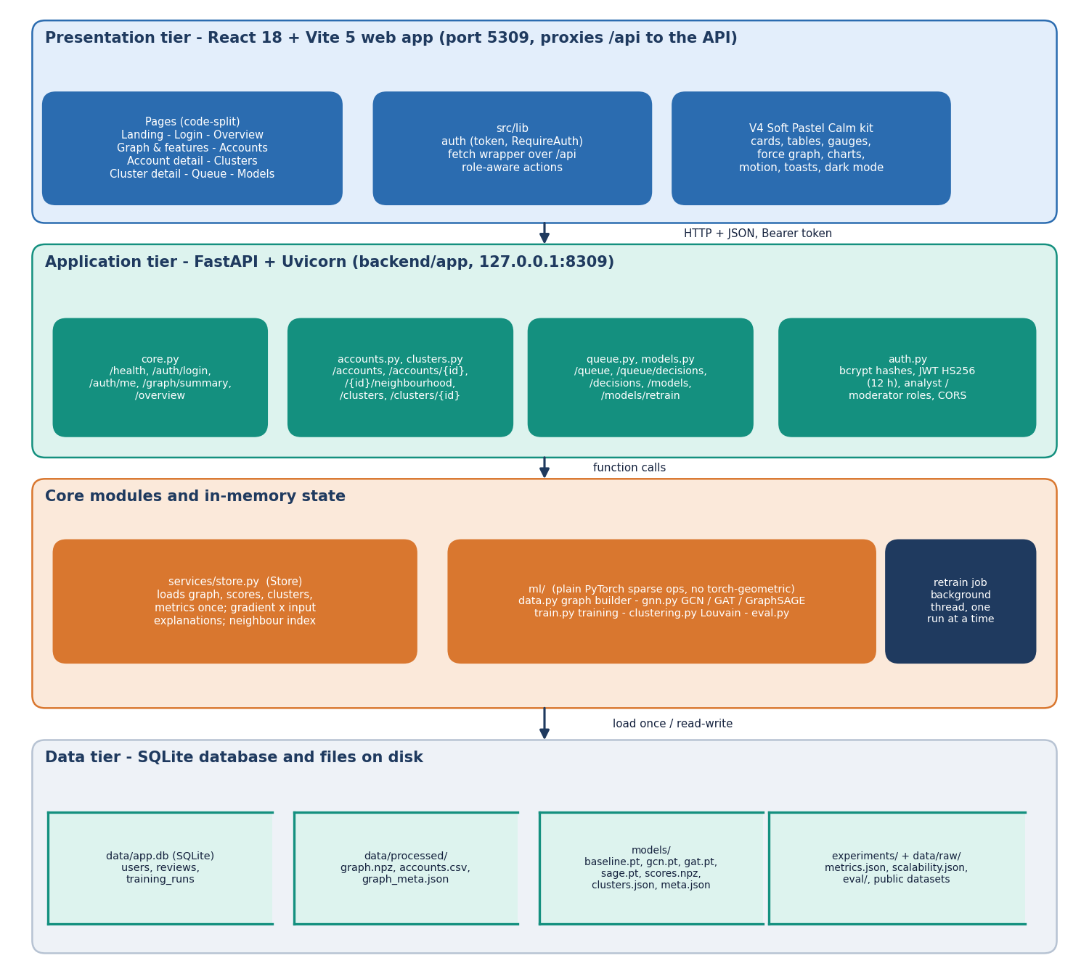
Figure 1: Architecture of BotGraph: data and ML pipeline, trained artefacts, FastAPI service with SQLite, and the React web application.
The system has four parts that meet at files and at one HTTP interface. The ML pipeline (ml/) builds the graph from the raw data and trains the models; it writes the graph (data/processed/), the trained weights, scores and clusters (models/) and the metrics (experiments/). The API (backend/app/, FastAPI on port 8309) loads those artefacts once when it starts and serves them under /api, and it keeps users, moderator decisions and retraining runs in SQLite. The web application (frontend/, React 18 and Vite on port 5309) proxies /api to the API. Retraining closes the loop: the API calls the same training code in a background thread, rewrites the artefacts and reloads its in-memory store.

5.2 High-Level Workflow
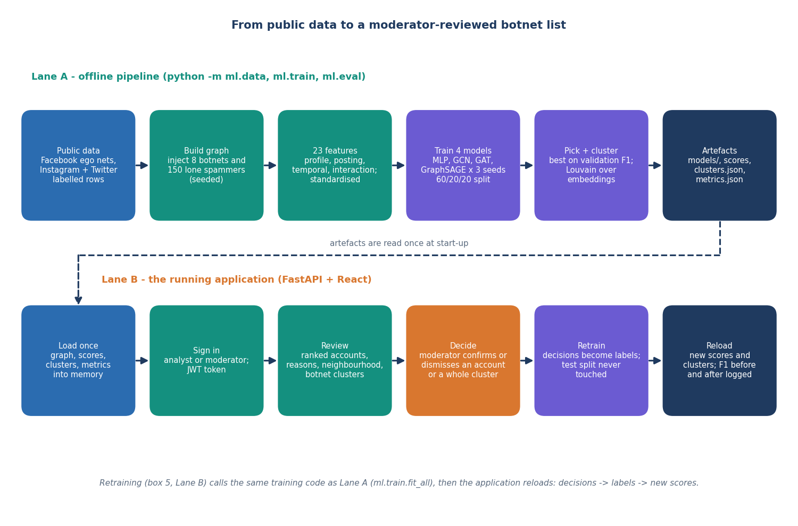
Figure 2: High-level workflow from raw data to moderator decisions and back into training.
The workflow runs in two directions. Forwards, raw datasets become a graph with 23 features per account; four models are trained on one stratified split; the best graph model on validation F1 is served; its embeddings feed Louvain clustering; and the API presents flagged accounts and clusters in a queue. Backwards, a moderator's confirm or dismiss decision is stored as a label, and the next retraining run adds those accounts to the training set, rewrites scores and clusters, and records F1 before and after.

5.3 Data Flow Diagrams

5.3.1 Level 0
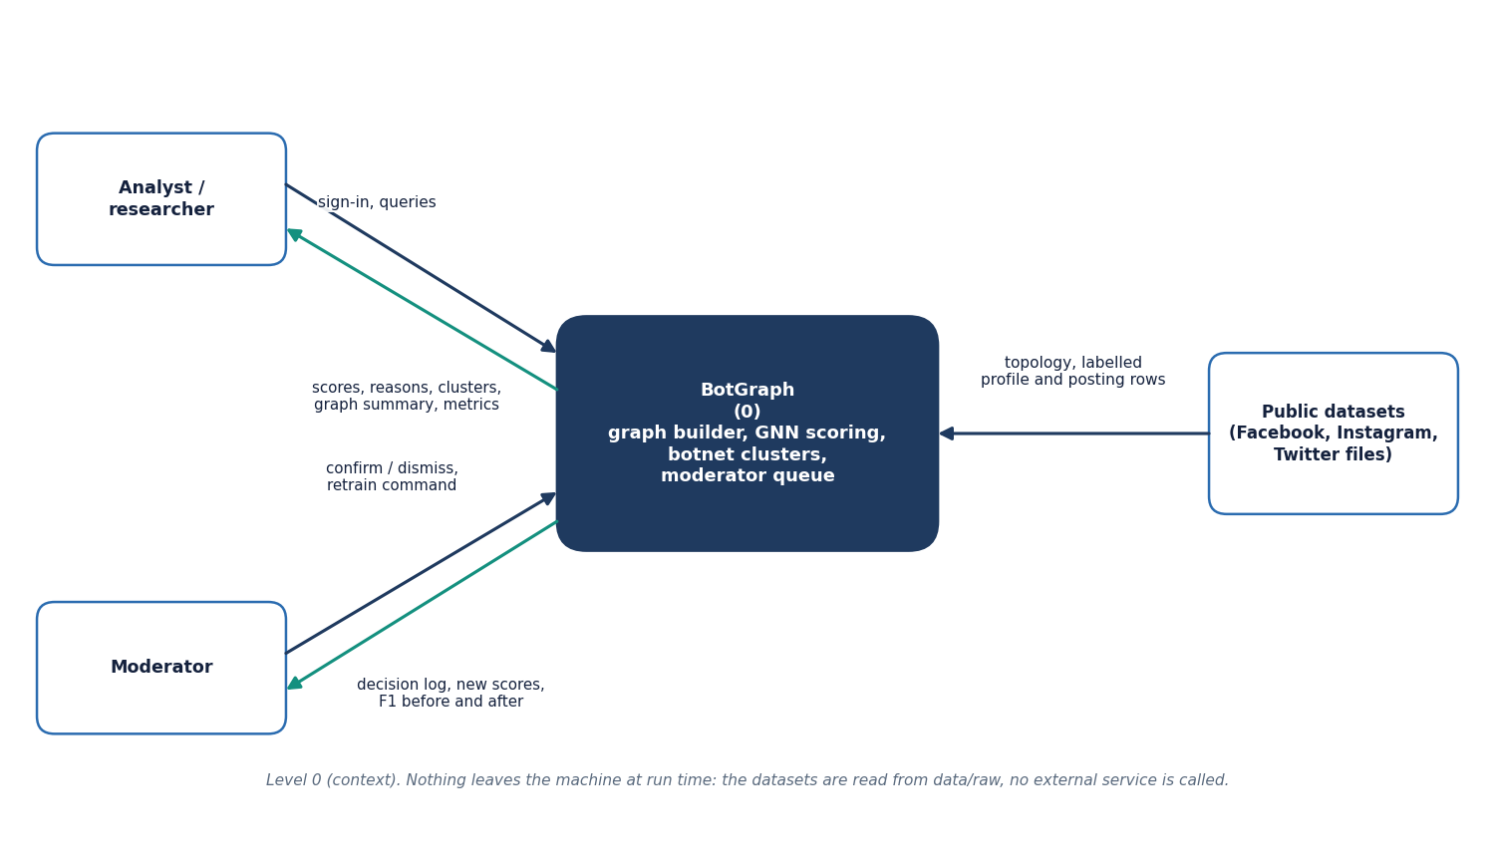  Figure 3: Data flow diagram, level 0 (context). | 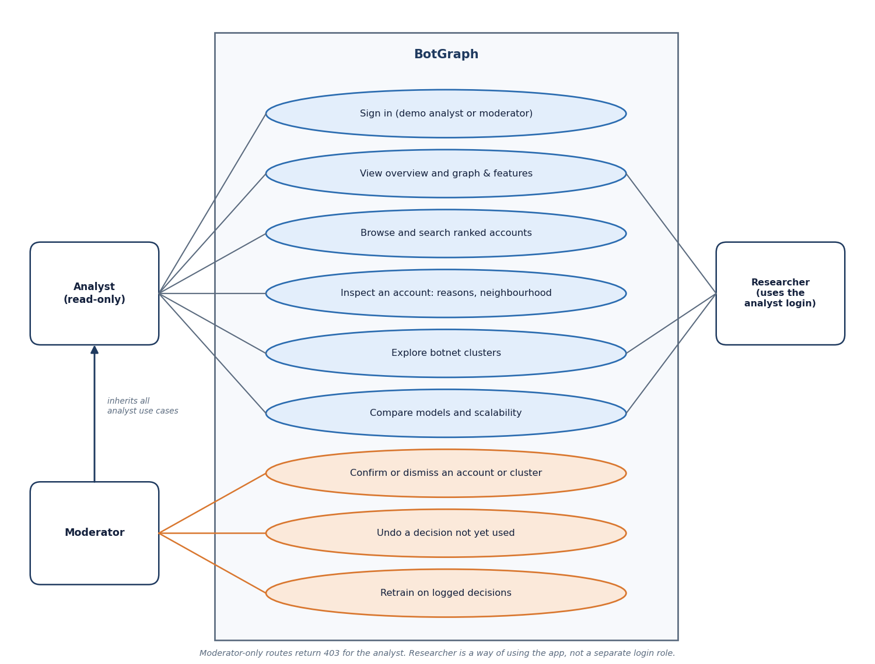  Figure 4: Use-case diagram.

At level 0 the platform is one process. The analyst or researcher sends sign-in details and queries and receives scores, reasons, clusters, the graph summary and metrics; the moderator sends confirm or dismiss decisions and a retraining command and receives the decision log, new scores and F1 before and after. The three public data sets enter only when the graph is built or rebuilt; nothing leaves the machine at run time and no live platform feed exists.

5.3.2 Level 1
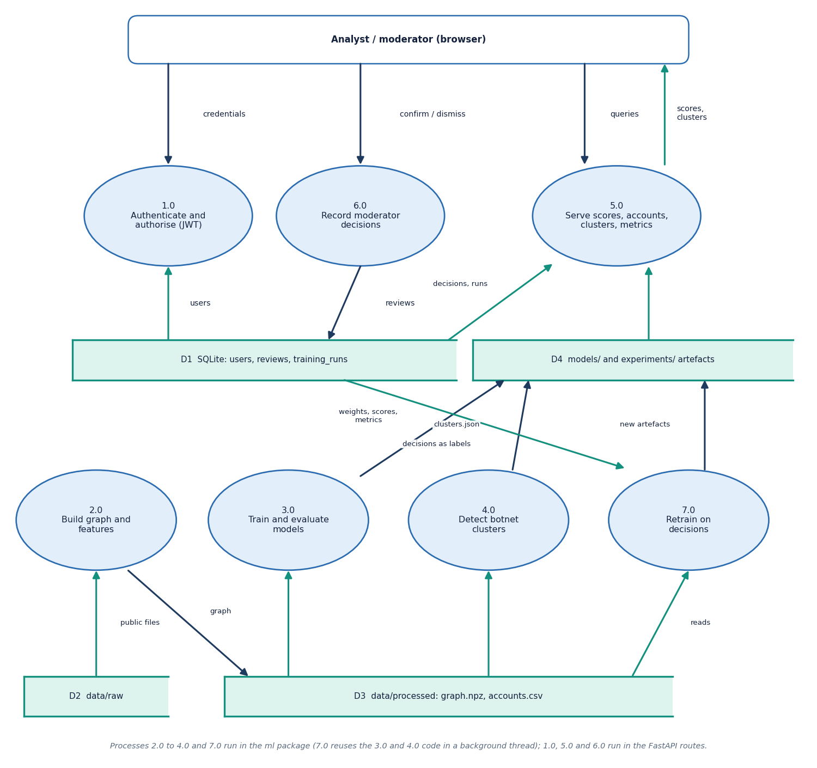
Figure 5: Data flow diagram, level 1: seven processes and four data stores.
Level 1 has seven processes and four data stores. Processes 2.0 (build the graph and features), 3.0 (train and evaluate the models) and 4.0 (detect botnet clusters) run in the ml package; they read the raw files (D2) and write the processed graph (D3) and the model and metric artefacts (D4). Process 1.0 authenticates requests against the users table, 5.0 serves scores, accounts, clusters and metrics from D3 and D4 and from the decisions in D1, and 6.0 records moderator decisions in D1. Process 7.0 retrains on those decisions: it reuses the training and clustering code in a background thread and writes new artefacts to D4. The review process is the only one that writes labels, and retraining is the only one that reads them back.

5.3.3 Level 2
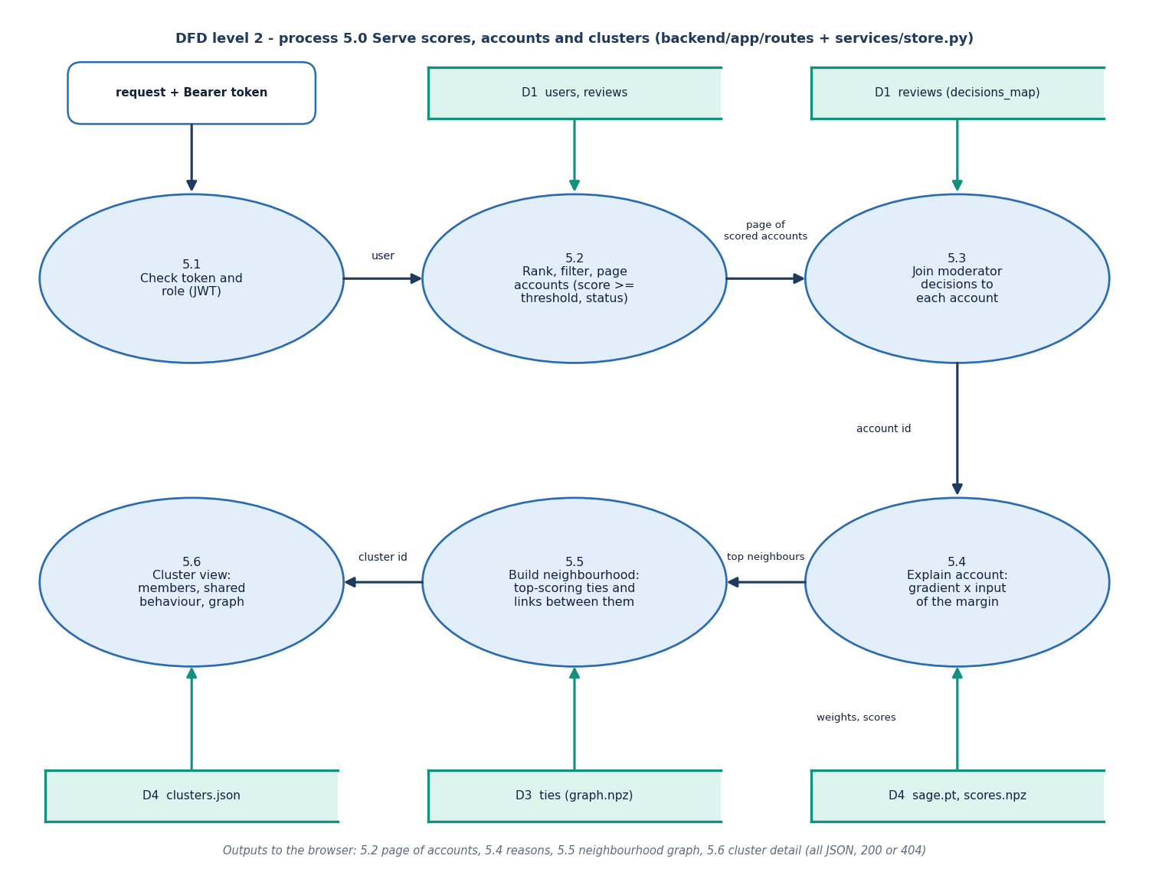
Figure 6: Data flow diagram, level 2: expansion of the serving process 5.0 into six steps.
Level 2 expands process 5.0, the serving process, into six steps. Step 5.1 checks the bearer token and the role. Step 5.2 ranks, filters and pages the accounts (score at or above the threshold, status, cluster, search) and 5.3 joins each account with the latest moderator decision, using the decision map built from the reviews. Step 5.4 explains one account by gradient times input through the served network, using the saved weights and scores; 5.5 builds the neighbourhood from the highest-scoring ties and the links between them; and 5.6 assembles the cluster view from clusters.json with members, shared behaviour and graph. Every output is JSON with a 200 or 404 status.

5.4 UML Design

5.4.1 Class Diagram
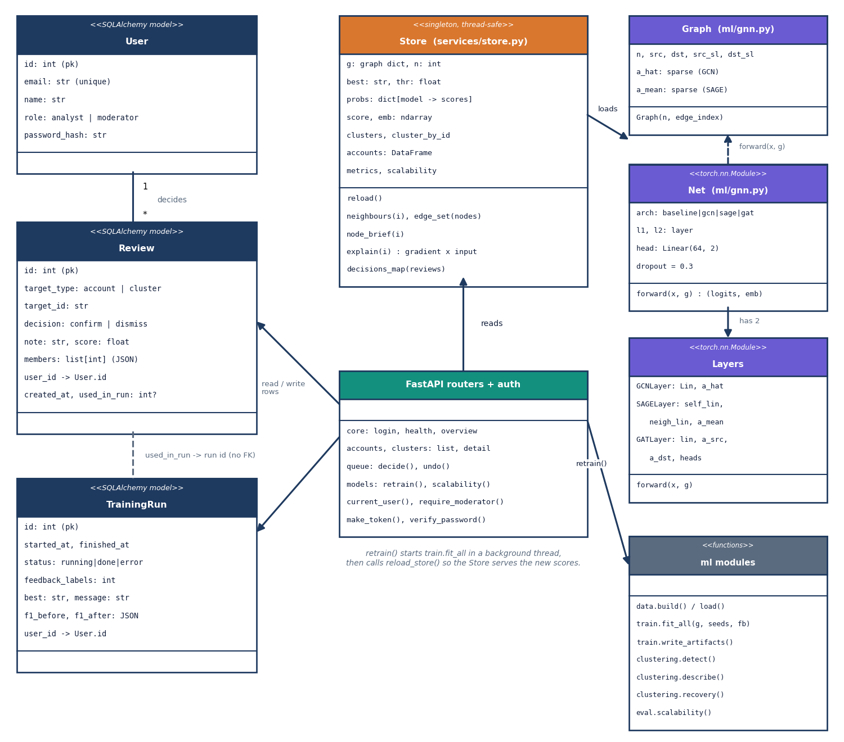
Figure 7: UML class diagram of the model classes, the Store, the database entities and the FastAPI routers.
The model side has a Graph class that precomputes the symmetric-normalised and the mean-aggregation adjacency, three layer classes (GCNLayer, SAGELayer, GATLayer) and Net, which stacks two layers and a linear head, or two dense layers for the baseline. On the service side, Store holds the graph, scores, clusters and metrics in memory and answers neighbourhood, explanation and decision queries; the three SQLAlchemy entities User, Review and TrainingRun persist state; and five routers expose the functions.

5.4.2 Sequence Diagram
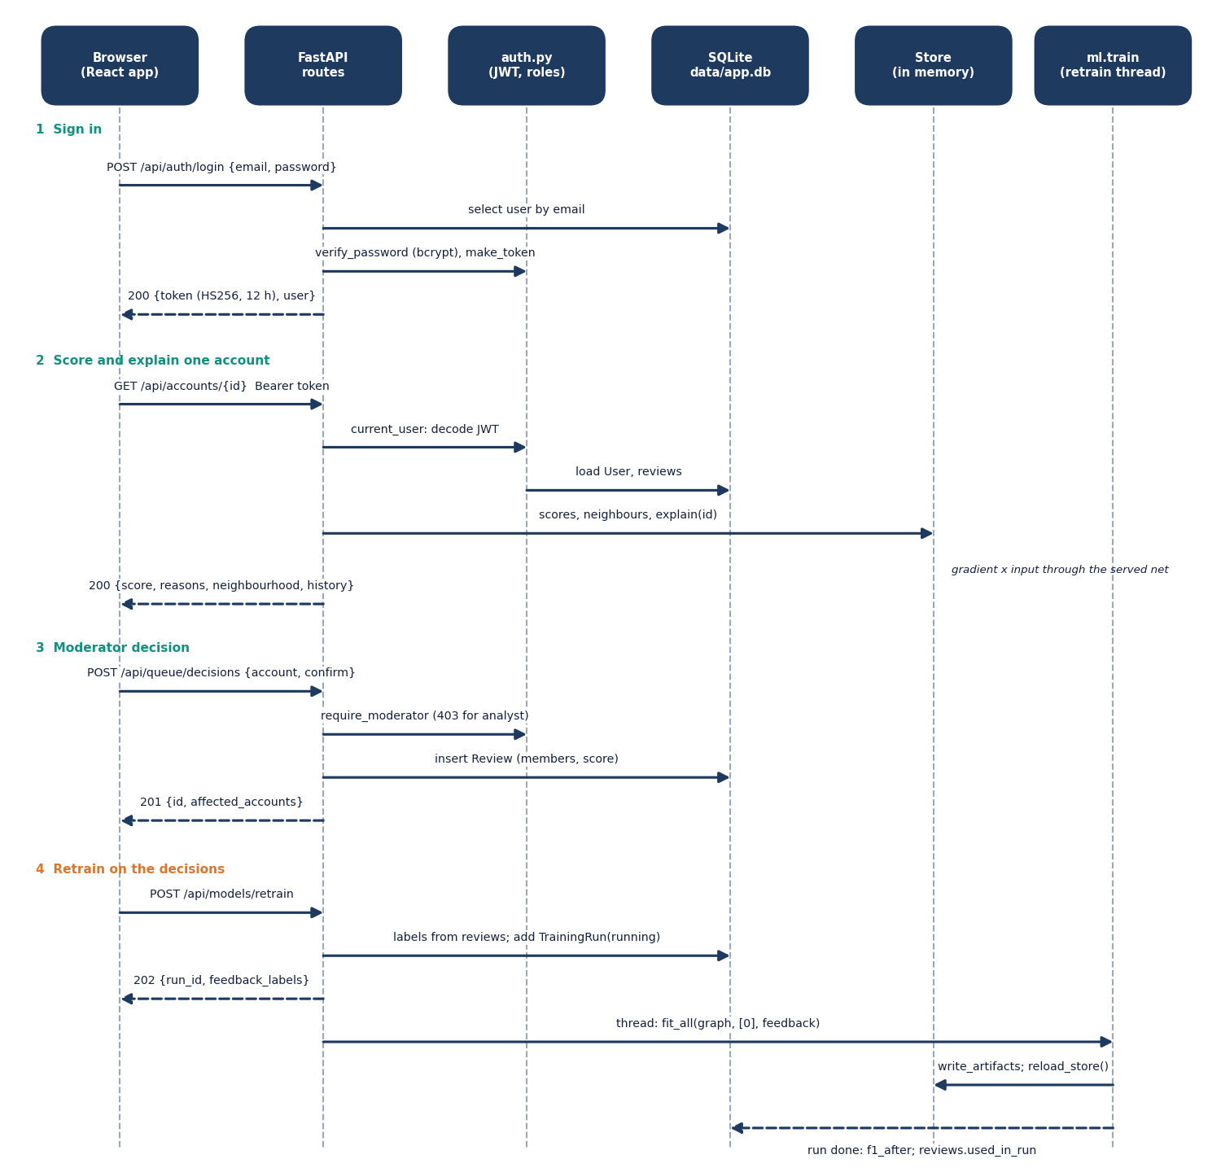
Figure 8: Sequence diagram of the main flow: sign in, score an account, record a decision, retrain.
The main flow starts with POST /api/auth/login, which checks the bcrypt hash and returns a signed token. GET /api/accounts/{id} then asks the Store for the score, the per-model scores, the gradient-times-input explanation and the neighbourhood summary. A moderator's POST /api/queue/decisions writes a Review row with the model score at the time and the affected account ids. POST /api/models/retrain creates a TrainingRun, starts a background thread that trains with the decisions as labels, reloads the Store and stamps the used decisions with the run id.

5.5 Data Design
Two stores are used. Structured, small, mutable data (users, decisions, retraining runs) live in SQLite. Large, read-only data (graph, scores, clusters, metrics) live in files that the API loads once. The split follows the access pattern: the files change only when a training run completes, the database changes with every moderator click.
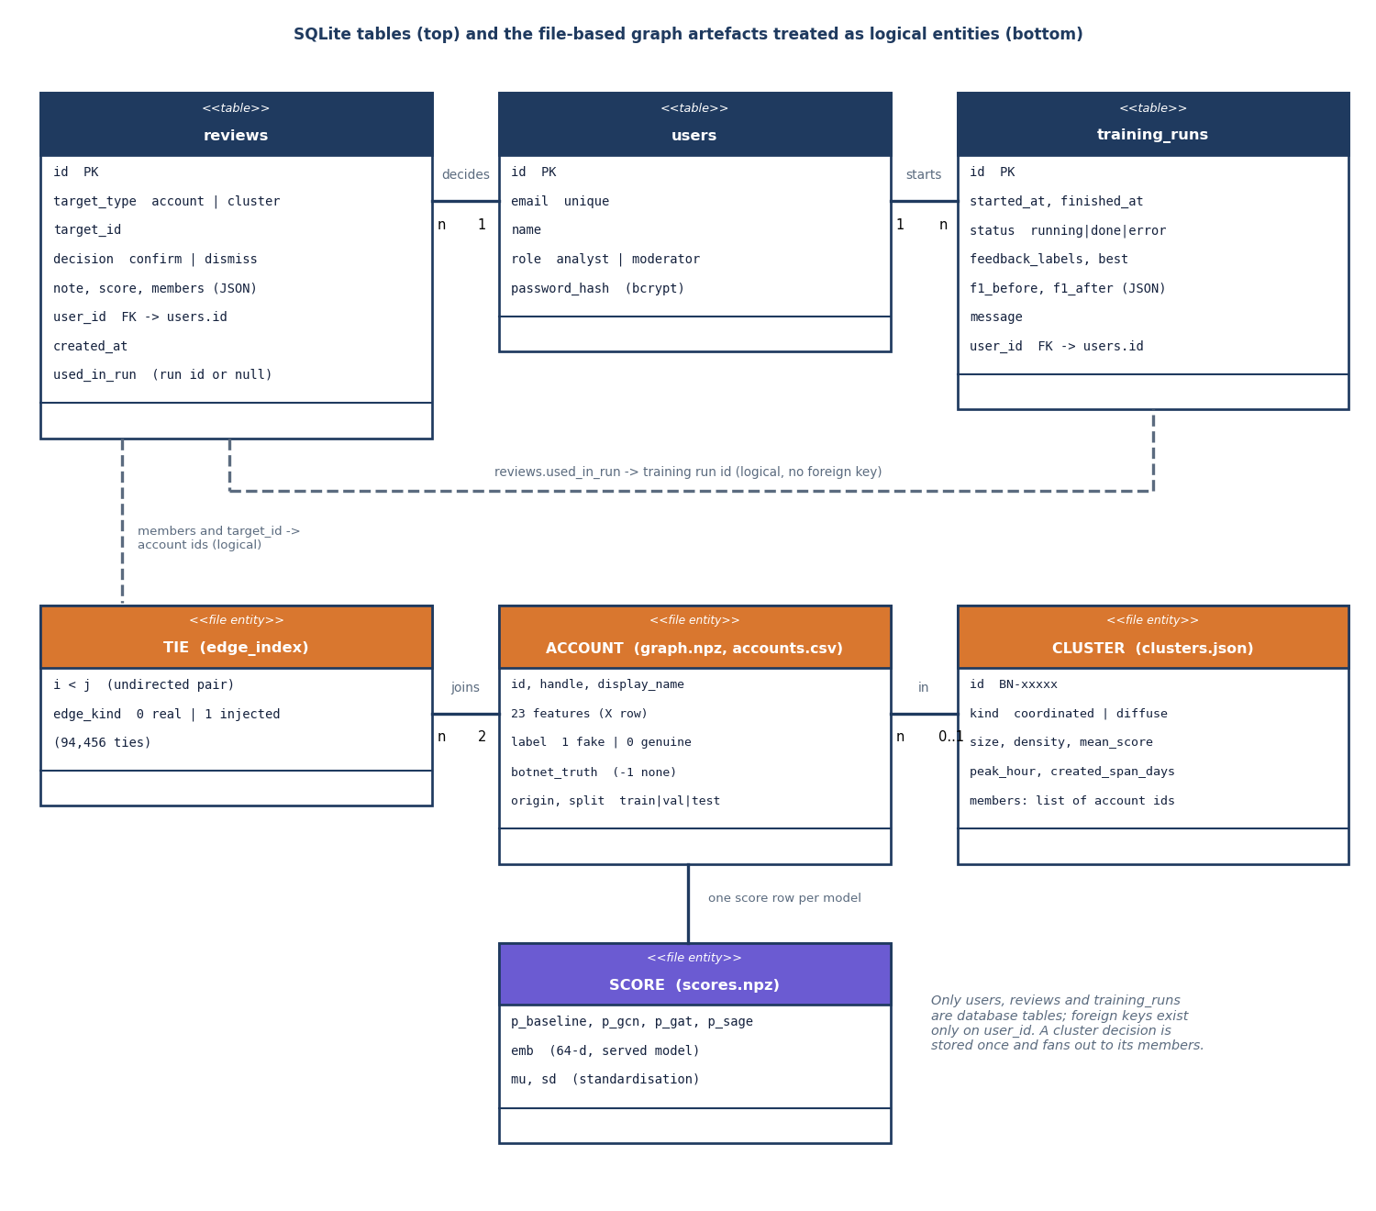
Figure 9: Entity-relationship diagram: the three database tables and the file-based graph, account and cluster entities.
Table 15: Table users
Column | Type | Notes
id | INTEGER, primary key
email | VARCHAR(160) | unique, indexed; matched in lower case
name | VARCHAR(120) | display name
role | VARCHAR(20) | analyst or moderator
password_hash | VARCHAR(80) | bcrypt hash; passwords longer than 72 bytes are truncated before hashing

Table 16: Table reviews (one moderator decision)
Column | Type | Notes
id | INTEGER, primary key
target_type | VARCHAR(10), indexed | account or cluster
target_id | VARCHAR(32), indexed | account id as text, or cluster id such as BN-00112
decision | VARCHAR(10) | confirm (fake) or dismiss (genuine)
note | TEXT | up to 500 characters from the API
score | FLOAT | model score at decision time (cluster mean for clusters)
members | JSON | ids of every account the decision applies to
user_id | INTEGER, foreign key to users.id | the moderator
created_at | DATETIME (UTC) | decision time
used_in_run | INTEGER, nullable | id of the training run that used it; set means the decision can no longer be undone

Table 17: Table training_runs
Column | Type | Notes
id | INTEGER, primary key
started_at, finished_at | DATETIME (UTC), finished_at nullable | run times
status | VARCHAR(12) | running, done or error
feedback_labels | INTEGER | number of moderator labels used
best | VARCHAR(12) | architecture served after the run
f1_before, f1_after | JSON | F1 per model before and after
message | TEXT | result or error text
user_id | INTEGER, nullable, foreign key to users.id | moderator who started the run

SQLite runs in write-ahead-logging mode with foreign keys on.

5.6 Algorithm Design

5.6.1 Graph and features
The graph builder takes the ten Facebook ego networks as the real topology (3,963 accounts, 88,156 ties), draws a profile row for every real account from the labelled Instagram set and a posting row from the Twitter set, and generates the timing and interaction features. It then injects eight botnets and 150 lone spammers with their ties. Inside a botnet every pair of accounts is tied with probability 0.28, plus a ring so that each botnet is connected; every bot also follows two to seven real accounts, chosen in proportion to the square root of their degree; some botnets tie to each other; each lone spammer ties to three to ten real accounts and to no other bot. Botnet members share a creation window and a peak posting hour, which makes those traits common to a cluster without making any single member stand out.
Camouflage keeps the task honest: 198 bots receive a genuine-looking profile and 231 genuine accounts a fake-looking one. Features are standardised with the mean and deviation of all nodes before training and the same values are stored for explanations.

5.6.2 Message passing and the classifier
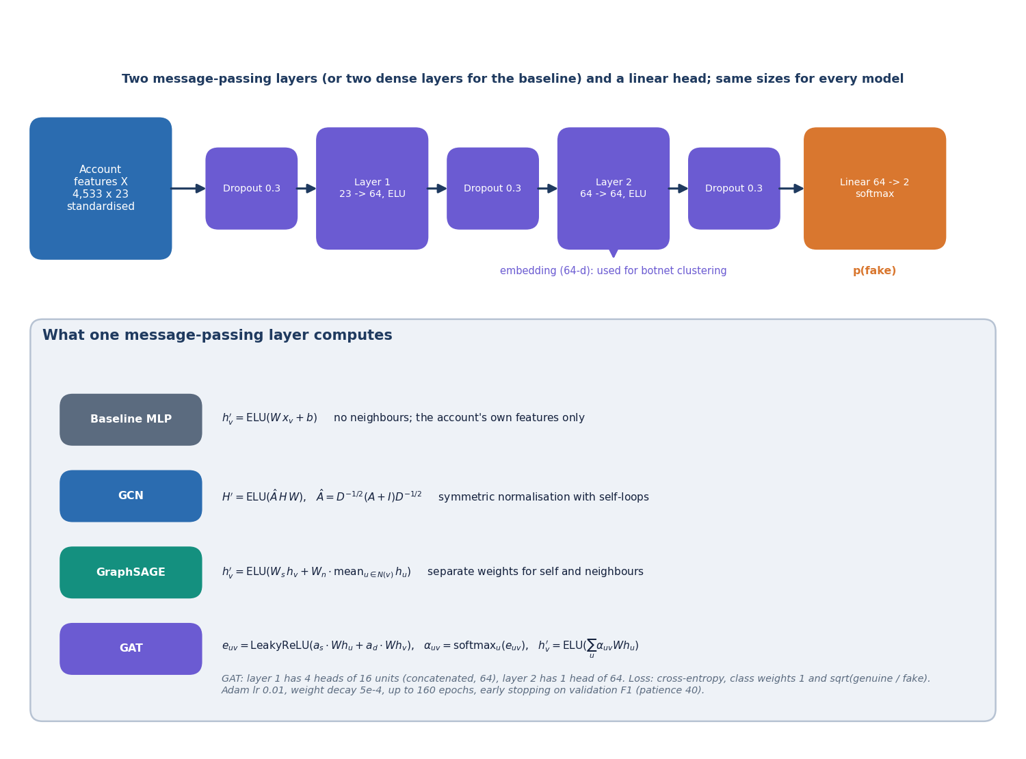
Figure 10: Model architecture: two message-passing layers, a linear head and the three layer types compared.
Every graph model has two message-passing layers of 64 units with ELU activation, dropout 0.3, and a linear head with two outputs. For node v with features x, the layers compute:
GCN: h_v = sum over u in N(v) + {v} of x_u W / sqrt(d_u d_v) (d counts the self-loop) (1)
GraphSAGE: h_v = W_self x_v + W_neigh * mean over u in N(v) of x_u (2)
GAT: e_uv = LeakyReLU(a_src . W x_u + a_dst . W x_v), alpha_uv = softmax over u of e_uv, h_v = sum over u of alpha_uv W x_u (4 heads of 16 units, then 1 head of 64) (3)
The baseline replaces each message-passing layer with a dense layer, so it reads only the account's own features. Training uses Adam (learning rate 0.01, weight decay 5e-4), a cross-entropy loss with class weights 1 for genuine and the square root of the imbalance for fake, up to 160 epochs, and keeps the epoch with the best validation F1 (patience 40). After training, the decision threshold is chosen on the validation set from 33 values between 0.1 and 0.9 to maximise F1. The architecture with the best validation F1 among the graph models is served.
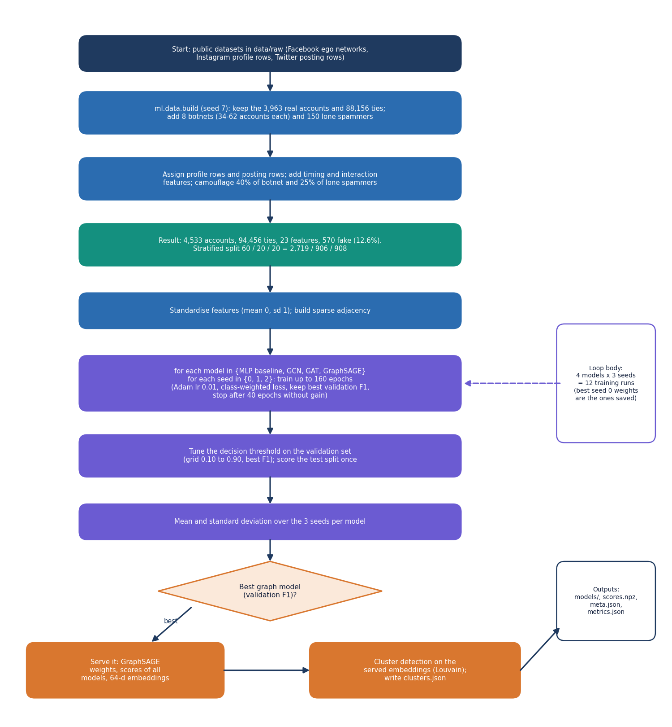
Figure 11: Flowchart of the training pipeline from graph to served model.

5.6.3 Botnet clustering
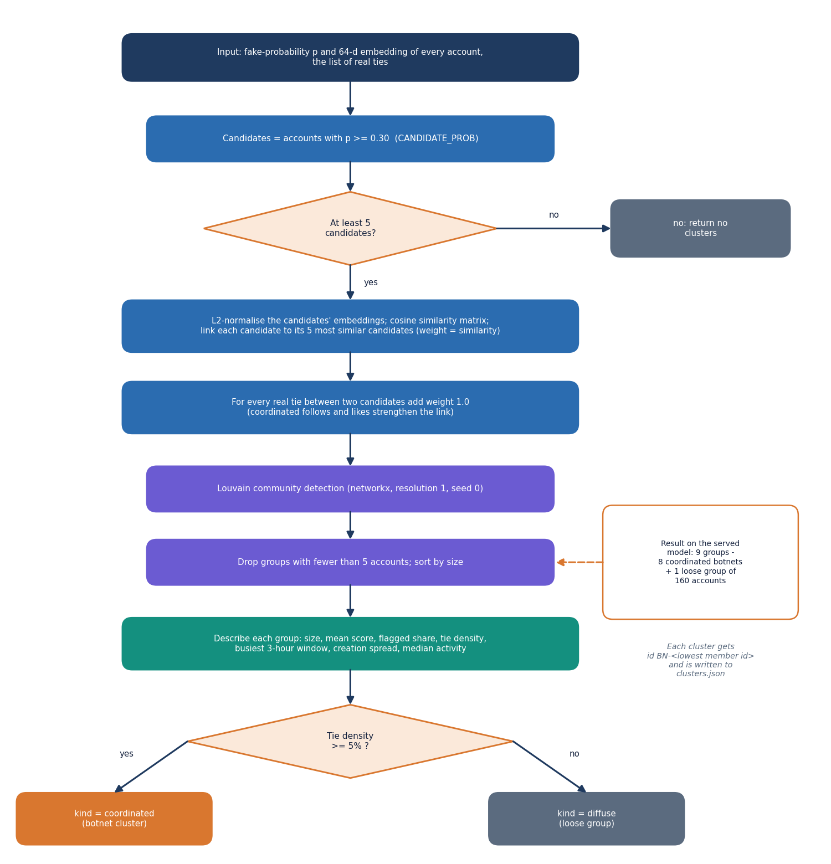
Figure 12: Flowchart of botnet cluster detection with Louvain over embeddings and real ties.
Clustering works on the accounts whose probability is at least 0.30. Each candidate is linked to its five most cosine-similar candidates in embedding space (weight equal to the similarity) and every real tie between two candidates adds weight 1.0. Louvain community detection (networkx, resolution 1.0, seed 0) groups the weighted graph and groups under five accounts are dropped. Each group is described by size, mean score, share flagged, internal ties, tie density (internal ties divided by n(n-1)/2), the busiest 3-hour window and the share of members in it, the spread of creation dates, and median posting rate, interactions and followers. A group is labelled coordinated when its density is at least 5% and diffuse otherwise.

5.6.4 Explanations
The reason shown for an account is the gradient of the model's fake-versus-genuine margin with respect to the input features, multiplied by the input values. For the account's own seven largest contributions the application draws a bar; one further number reports how much the other accounts' features contribute through message passing. This is a first-order approximation and the interface says so.

5.7 Module Design
Table 18: Modules and responsibilities
File | Responsibility | Lines
ml/config.py | paths, seed, model list, training and clustering constants | 39
ml/data.py | load the three sources, inject botnets, build 23 features, split, save and summarise the graph | 345
ml/gnn.py | sparse Graph, GCN, SAGE and GAT layers, Net, class weights, threshold search, metrics, training loop | 188
ml/train.py | train every model for every seed, summarise, write weights, scores, clusters and metrics; also used for retraining with feedback labels | 138
ml/clustering.py | candidate selection, similarity graph, Louvain, cluster description, recovery against truth | 100
ml/eval.py | scalability sweep over 1, 2, 4 and 8 disjoint copies of the graph; evaluation summary | 90
backend/app/main.py, settings.py | application, CORS, start-up (database, demo users, Store); environment settings | 31, 31
backend/app/auth.py | bcrypt, JWT creation and checking, current_user, require_moderator, demo users | 70
backend/app/db.py | SQLAlchemy engine, User, Review, TrainingRun, session dependency | 87
backend/app/services/store.py | in-memory graph, scores, clusters, adjacency, neighbour statistics, explanations, decision map | 181
backend/app/routes/core.py | health, login, current user, graph summary, overview | 87
backend/app/routes/accounts.py | ranked list with filters, account detail, neighbourhood | 122
backend/app/routes/clusters.py | cluster list and detail with members, graph, reach and headline | 73
backend/app/routes/queue.py | queue, decisions, undo, decision log | 125
backend/app/routes/models.py | model comparison, scalability, retraining job and its status | 124
frontend/src/pages/ | Landing, Login, Overview, GraphData, Accounts, AccountDetail, Clusters, ClusterDetail, Queue, Models, NotFound | 11 files
frontend/src/components/ | UI kit (ui), motion, charts (Recharts), graph/ForceGraph, app (decision panel, retrain card), reactbits/Blobs | 6 folders
scripts/ | smoke_test.py, capture_screens.py, ui_checks.py, download_data.py, run_extra_experiments.py | 5 files

5.8 API Design
The API is a JSON interface under /api. Every route except /api/health and /api/auth/login requires Authorization: Bearer <token>; moderator routes also check the role.
Table 19: Endpoints
Method and path | Access | Purpose
GET /api/health | public | status, account and tie counts, served model, flagged and botnet counts, best and baseline F1
POST /api/auth/login | public | e-mail and password to token and user
GET /api/auth/me | signed in | current user
GET /api/graph/summary | signed in | counts (real and injected), class balance, split, 23 feature summaries, degree histogram, provenance
GET /api/overview | signed in | KPIs, score histogram, model F1, top accounts and clusters, recent decisions
GET /api/accounts | signed in | ranked page; query, status, flagged only, cluster, sort, order, page, page size (at most 100)
GET /api/accounts/{id} | signed in | score, per-model scores, explanation, neighbourhood summary, profile, decision history
GET /api/accounts/{id}/neighbourhood | signed in | nodes and links, highest-scoring neighbours first (5 to 120)
GET /api/clusters | signed in | all clusters with status
GET /api/clusters/{id} | signed in | members, graph, shared behaviour, reach, headline
GET /api/queue | signed in | pending or decided accounts or clusters with summary counts
POST /api/queue/decisions | moderator | record confirm or dismiss for an account or cluster (201)
DELETE /api/queue/decisions/{id} | moderator | undo a decision not yet used in training
GET /api/decisions | signed in | decision log
GET /api/models | signed in | per-model metrics, ROC, confusion, cluster recovery, runs, retraining state
GET /api/models/scalability | signed in | training and inference time against graph size
POST /api/models/retrain | moderator | start a retraining run on the logged decisions (202)
GET /api/models/retrain/status | signed in | state, progress, message

Table 20: Error responses
Status | When
401 | no token, an invalid or expired token, or a wrong e-mail and password
403 | an analyst calls a moderator route
404 | unknown account or cluster id (a cluster id can change after retraining), no evaluation file
409 | undo of a used decision; retraining with no decisions or while a run is in progress
422 | request validation failed (for example a non-numeric account id or a decision other than confirm or dismiss)

5.9 User Interface Design
The web application uses the V4 Soft Pastel Calm design kit: warm off-white surfaces, rounded cards, six pastel accent colours (lavender, mint, peach, sky, rose, butter) read from CSS variables, light and dark themes, and restrained motion. Charts take their colours from the same variables, so they follow the theme. Every route is code-split and loaded on demand.
Table 21: Screen map
Route | Screen | What it answers
/ | Landing | what BotGraph is; live counts from the health route
/login | Sign in | demonstration accounts with one-click fill
/app | Overview | how many accounts, flags, botnets, items waiting; does the graph help
/app/graph | Graph and features | what is in the graph, which part is real, which features exist
/app/accounts | Accounts | who is flagged; search, filters and paging
/app/accounts/:id | Account detail | why this score; who the neighbours are; decide
/app/clusters, /app/clusters/:id | Botnet clusters | which groups exist; their graph, members and shared behaviour
/app/queue | Moderator queue | what is waiting; decision log; retrain
/app/models | Models and scale | which model is best; how cost grows

Every screen has a loading skeleton, an empty state with an action, an error state with a retry and visible success feedback through toasts. Keyboard focus rings, dialogs that close with Escape, a persisted theme toggle and respect for reduced-motion settings are part of the kit; they were checked when the interface was built and recorded in docs/FRONTEND_PLAN.md, and were not repeated in the documentation run. Two of the screens are shown below; the others appear in Chapter 8 and Appendix C.
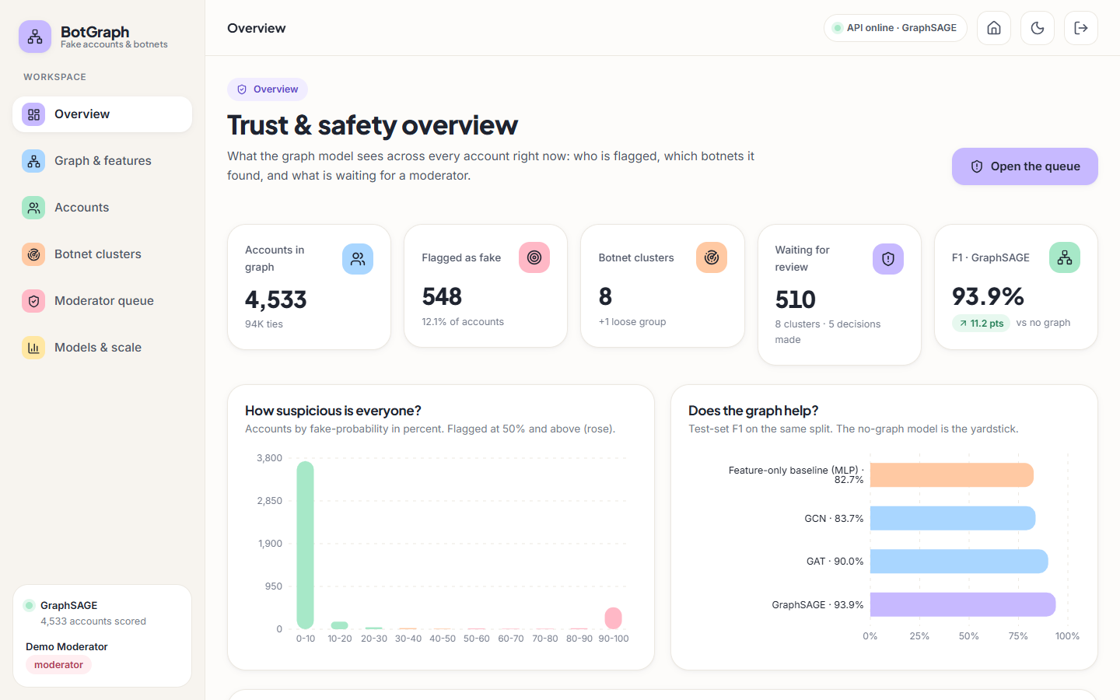
Figure 13: Overview screen: key counts, the score histogram and the model comparison.
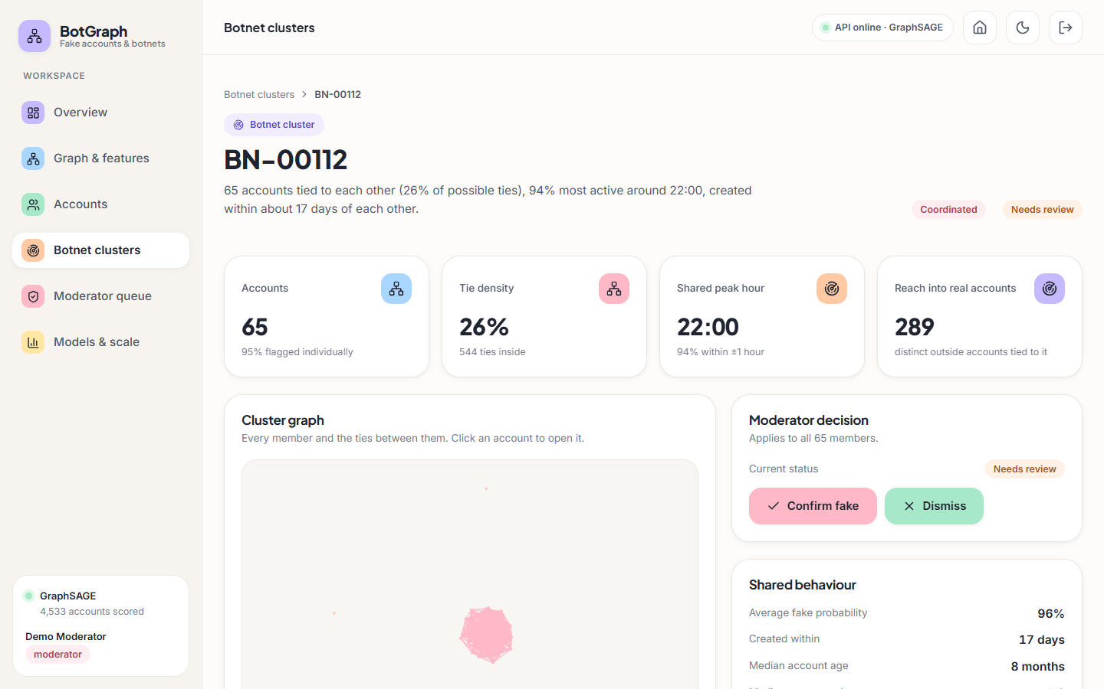
Figure 14: Cluster detail: size, tie density, shared peak hour, reach, and the moderator decision.

5.11 Security and Error-Handling Design
• Passwords are stored as bcrypt hashes. Tokens are HS256 JWTs that expire after 12 hours; a placeholder secret is replaced by a development secret and should be replaced for any real deployment.
• Role checks run on the server in the require_moderator dependency; hiding a button in the interface is not relied on.
• CORS allows only the web application's own origin (localhost and 127.0.0.1 on port 5309).
• Request bodies are validated by Pydantic (target type, decision, note length) and query parameters by bounds (page size, neighbour limit).
• Errors are returned as plain sentences the interface can show, such as Please sign in to continue or That decision was already used to train a model run and cannot be undone.
• A failing retraining run is recorded with status error and the first 400 characters of the message, and the served model is left unchanged.

CHAPTER 6: METHODOLOGY AND SOFTWARE IMPLEMENTATION

6.1 Overall methodology
BotGraph treats fake-account detection as semi-supervised-style node classification on a social graph and botnet discovery as community detection on what the classifier has learned. The work follows seven steps, run in order by the ml package and then served by the API: (1) assemble one graph of 4,533 accounts and 94,456 ties from public data and a seeded generator; (2) build 23 numeric features per account; (3) split the accounts once, stratified by label, into 60 % training, 20 % validation and 20 % test; (4) train a feature-only baseline and three message-passing networks (GCN, GAT, GraphSAGE) on that split with three seeds each; (5) tune the decision threshold on the validation set and report every metric on the untouched test set; (6) keep the architecture with the best validation F1 as the served model, write its fake-probabilities and 64-dimensional embeddings to disk; (7) cluster the suspicious accounts in embedding space with Louvain community detection and describe every cluster.
Figure 15: Flow of the offline pipeline from raw data to served artefacts.

6.2 Dataset
No platform data can be scraped or shared, so the graph is assembled from three public datasets and a documented generator. The split between real and synthetic parts is kept visible in the app, in the schema and in every table below.
Table 22: Data sources and what each contributes
Source | Licence | Size used | Used for
SNAP Facebook social circles [12] (ten ego networks, Kaggle mirror) | Public research data | 3,963 accounts, 88,156 ties | All real nodes and ties
Instagram fake, spammer and genuine accounts | CC BY 3.0 | 696 labelled rows | Profile attributes (resampled and jittered)
Twitter Bot Detection Dataset | CC0 | 50,000 rows | Retweets, mentions, post length, hashtags, account age
Injected botnets (ml/data.py, seed 7) | Generated | 570 accounts, 6,300 ties | Known-answer clusters, timing and interaction features, handles

6.2.1 How the graph is assembled
The ten Facebook ego networks are merged into one undirected graph of 3,963 accounts and 88,156 ties. Every real account receives a profile row and a posting row by resampling the labelled datasets. Accounts that will stay genuine draw a genuine profile; accounts that are bots draw a fake profile, except for the camouflaged ones described below.
Eight botnets of 34 to 62 accounts (420 accounts in all; sizes 62, 50, 52, 60, 48, 56, 58, 34) and 150 lone spammers are added. The botnet recipe is:
• every pair of accounts inside a botnet is tied with probability 0.28, plus a ring through all members so the botnet is connected (coordinated mutual follows and likes);
• every bot also follows 2 to 7 real accounts, chosen in proportion to the square root of their degree (follow-spam);
• each pair of botnets has a 0.35 chance of one tie between them;
• each lone spammer follows 3 to 10 real accounts and no other bot;
• members of one botnet share a creation window (about 6 days of spread) and a peak posting hour (within one hour of the botnet's hour).
This adds 6,300 injected ties to the 88,156 real ones, giving 94,456 in total. Fake accounts number 570 (12.6% of 4,533); genuine accounts are the other 3,963.

6.2.2 Camouflage
If every bot carried an obviously fake profile, the profile alone would solve the task and the graph would add nothing. Two rules prevent that. 198 bots (40 % of botnet members and 25 % of lone spammers) are given a genuine-looking profile, and 231 genuine accounts (6 % of real accounts) are given a fake-looking one. A model that reads only the profile therefore cannot be perfect; the neighbourhood has to help. This design choice is deliberate and is also a limitation: the difficulty of the benchmark was set by the authors, not observed on a platform.

6.2.3 Split
Accounts are split once, stratified by label, with a fixed seed: 2,719 for training, 906 for validation and 908 for testing (114 fake accounts in the test split). Because message passing needs the whole graph, all four models see every account's features and ties at training time (transductive setting); only the labels of the training accounts enter the loss. Validation labels select the threshold and the early-stopping epoch; test labels are used for reporting only.
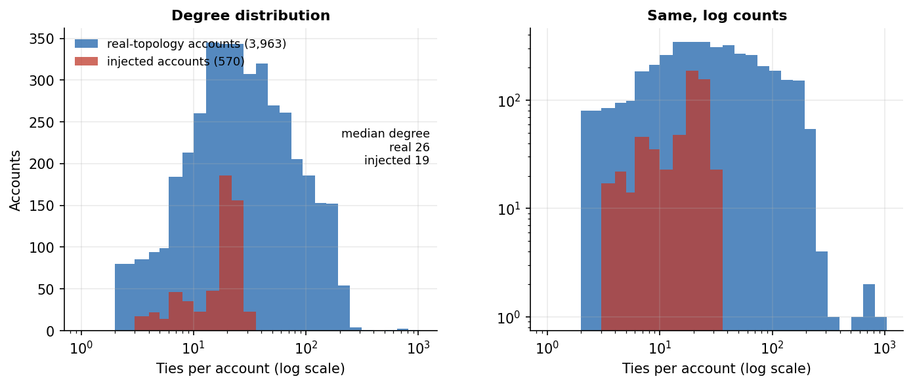
Figure 16: Degree distribution of genuine and fake accounts in the assembled graph.

6.3 Data preparation and node features
Each account is described by 23 numeric features in four groups. Heavy-tailed counts (posts, followers, following, retweets, account age, posting rate, interactions) are log-transformed, the peak posting hour is encoded as a sine and a cosine so that 23:00 and 01:00 are close, and every column is standardised to zero mean and unit variance with the training mean and standard deviation before it reaches a model (the same statistics are stored in scores.npz so the explanation code can reverse them).
Table 23: The 23 node features with the mean value for genuine and fake accounts (stored scale, before standardisation)
Group | Feature | Genuine mean | Fake mean
Profile metadata | Has profile picture | 0.94 | 0.62
Profile metadata | Digits in username | 0.06 | 0.21
Profile metadata | Words in display name | 1.77 | 1.43
Profile metadata | Digits in display name | 0.02 | 0.07
Profile metadata | Name equals username | 0.03 | 0.08
Profile metadata | Bio length | 40.02 | 20.79
Profile metadata | Has external link | 0.24 | 0.10
Profile metadata | Private account | 0.43 | 0.35
Profile metadata | Posts (log) | 3.88 | 2.15
Profile metadata | Followers (log) | 6.65 | 4.83
Profile metadata | Following (log) | 5.84 | 5.01
Profile metadata | Follower / following ratio (log1p) | 1.50 | 0.95
Posting behaviour | Average retweets (log) | 3.62 | 3.61
Posting behaviour | Average mentions per post | 2.50 | 2.52
Posting behaviour | Average post length | 62.57 | 63.88
Posting behaviour | Hashtags per post | 2.51 | 2.54
Temporal pattern | Account age (log days) | 6.62 | 5.51
Temporal pattern | Posts per day (log) | -0.23 | 0.48
Temporal pattern | Posting burstiness | 0.28 | 0.46
Temporal pattern | Share of activity in peak hour | 0.13 | 0.26
Temporal pattern | Peak hour (sine) | -0.52 | -0.53
Temporal pattern | Peak hour (cosine) | 0.40 | 0.05
Interaction frequency | Interactions per week (log) | 3.26 | 3.92

Two things stand out in the table. The profile features separate the classes well on average (profile pictures 0.94 against 0.62, bio length 40 against 21 characters, posts and followers lower for fake accounts), and the timing features separate them even more (burstiness 0.28 against 0.46, share of activity in the peak hour 0.13 against 0.26). The four posting-behaviour features, in contrast, are practically identical for the two classes: the Twitter dataset's bot label carries almost no signal, so these columns behave as realistic noise and are not evidence. The temporal and interaction features are generated by the seeded script, with a bot-leaning and a human-leaning distribution; this matters for how the results are read (Section 6.4 and Chapter 8).
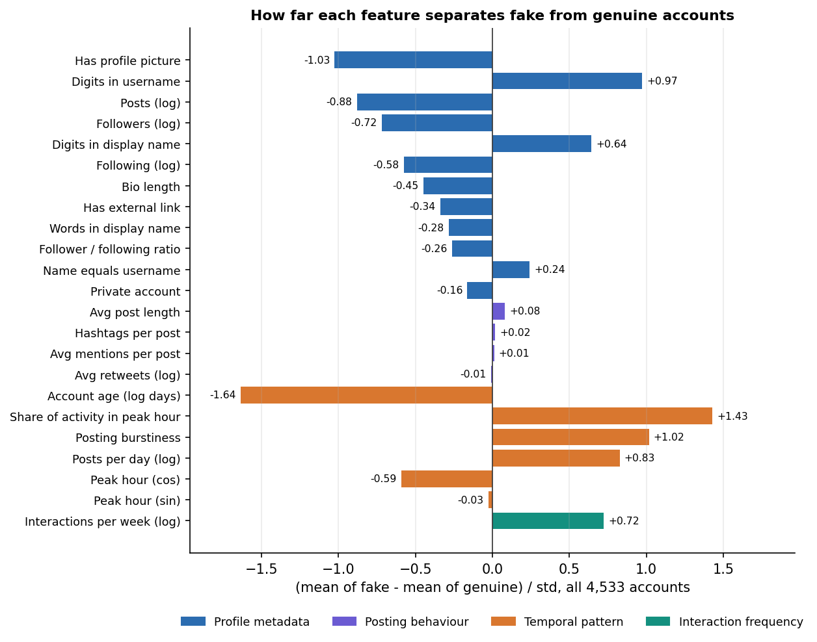
Figure 17: Standardised difference between fake and genuine accounts for each feature group.

6.4 Algorithm choice and justification

6.4.1 Why a graph neural network
A per-account classifier sees only the account's own columns. A bot that copies a genuine profile and posts at human-like rates gives such a classifier nothing to work with, yet its ties are unusual: it follows and is followed by other accounts of the same operation. A graph neural network lets each account's representation depend on its neighbours' features, so the evidence from a camouflaged account's neighbourhood reaches the account itself. The base paper uses the same idea for a different goal, classifying nodes of the Facebook graph by structural role with GraphSAGE [1], [10], and the project brief asks for the three standard architectures to be compared.

6.4.2 Why these three architectures
Table 24: The three message-passing layers compared
Model | How a node combines its neighbourhood | Why it is in the study
GCN [8] | Symmetrically normalised sum over neighbours and self; one weight matrix for both | The standard baseline for graph learning; smoothing is strong, so it tests whether plain smoothing helps
GAT [9] | Attention-weighted sum over neighbours; four heads in the first layer | Lets the model weigh suspicious neighbours more than ordinary ones
GraphSAGE [10] | Separate weights for the node itself and the mean of its neighbours | Keeps the account's own evidence apart from the neighbourhood; the base paper's backbone

6.4.3 Why a feature-only baseline
A graph model that beats nothing proves nothing. The baseline is a two-layer dense network with the same width, dropout, optimiser, loss, split, seeds and early stopping as the graph models, fed the same 23 features, with the graph removed. Its F1 of 0.827 is the number every graph model has to beat. The difference between a graph model and the baseline is the measured contribution of the ties.

6.4.4 Why class weights and a tuned threshold
Only 12.6% of accounts are fake, so plain cross-entropy would reward saying 'genuine' for everything (a classifier that does so scores 87.4% accuracy on the test split). The loss therefore weights the fake class by the square root of the class ratio, which is a milder correction than full inverse-frequency weighting and avoids flooding the queue with false alarms. The decision threshold is then chosen on the validation set from a grid of 33 values between 0.1 and 0.9 to maximise F1, instead of being fixed at 0.5. The headline metric is F1 with precision and recall alongside; accuracy is reported but not used to rank models.

6.4.5 Why Louvain over the embeddings
A botnet is a group of accounts that look alike to the model and are tied to each other. The second hidden layer of the served network gives each account a 64-dimensional embedding in which such accounts are close. Louvain [11] finds densely connected groups by maximising modularity, needs no preset number of clusters and runs in seconds on a few hundred nodes. Combining embedding similarity with real ties lets a group form either because its members behave alike or because they follow each other, and rejects accounts that only happen to share one of the two.

6.5 Mathematical formulation
Let the graph have n accounts, adjacency matrix A (symmetric, no self-loops), feature matrix X ∈ R^(n×23) after standardisation, and labels y_i ∈ {0, 1} (1 = fake). Every model has two hidden layers of width 64, an ELU activation and a linear head with two outputs. H⁽⁰⁾ = X, and for layer l = 1, 2:

6.5.1 Message-passing layers
GCN. With self-loops added, Ã = A + I and D̃ the diagonal degree matrix of Ã:
H⁽ˡ⁾ = ELU( D̃^(-1/2) Ã D̃^(-1/2) H⁽ˡ⁻¹⁾ W⁽ˡ⁾ + b⁽ˡ⁾ ) (4)
GraphSAGE (mean aggregator). With N(i) the neighbours of account i:
h_i⁽ˡ⁾ = ELU( W_self⁽ˡ⁾ h_i⁽ˡ⁻¹⁾ + b⁽ˡ⁾ + W_neigh⁽ˡ⁾ · mean_{j ∈ N(i)} h_j⁽ˡ⁻¹⁾ ) (5)
GAT. Attention coefficients are computed per head k over the neighbours of i and over i itself:
e_ij = LeakyReLU₀.₂( a_srcᵀ W h_j + a_dstᵀ W h_i ), α_ij = exp(e_ij) / Σ_{m ∈ N(i) ∪ {i}} exp(e_im), h_i' = ELU( ‖_k Σ_j α_ij^k W^k h_j ) (6)
The first layer uses four heads of 16 units whose outputs are concatenated into 64 units; the second layer uses one head of 64 units. The softmax over each node's incoming edges is implemented with scatter_reduce (maximum) and index_add_ (sum), which is why GAT results can move by about 0.01 F1 between runs: the summation order is not deterministic.
Baseline. The same two layers with the graph removed: H⁽ˡ⁾ = ELU( H⁽ˡ⁻¹⁾ W⁽ˡ⁾ + b⁽ˡ⁾ ).

6.5.2 Classifier and loss
The head maps the second embedding z_i = H⁽²⁾_i to two logits, and the fake-probability is the softmax of the second component:
p_i = softmax( W_o z_i + b_o )₁ (7)
Training minimises class-weighted cross-entropy over the training accounts T, with weight 1 on the genuine class and w₁ = √(n₀ / n₁) on the fake class, where n₀ and n₁ are the class counts in T:
L = − Σ_{i ∈ T} w_{y_i} · log p(y_i | i) / Σ_{i ∈ T} w_{y_i} (8)
(PyTorch normalises the weighted sum by the sum of the weights.) The network is regularised with dropout [23] 0.3 on the input, between layers and before the head, and L2 weight decay 5 × 10⁻⁴ in Adam [13].

6.5.3 Threshold and metrics
τ* = argmax_{τ ∈ {0.10, 0.125, …, 0.90}} F1( y_val , 1[p_val ≥ τ] ) (9)
An account is flagged when p_i ≥ τ*. With TP, FP, FN, TN counted on the test split:
Precision = TP / (TP + FP), Recall = TP / (TP + FN), F1 = 2 · Precision · Recall / (Precision + Recall) (10)

6.5.4 Clustering
Let S = {i : p_i ≥ 0.30} be the candidate accounts. Each candidate is linked to its K = 5 most similar candidates by cosine similarity of embeddings, with edge weight max(cos(z_i, z_j), 0), and every real tie between two candidates adds weight 1.0 to the pair. Louvain maximises the weighted modularity
Q = 1/(2m) · Σ_{ij} [ w_ij − k_i k_j / (2m) ] · δ(c_i, c_j) (11)
where w_ij is the edge weight, k_i the weighted degree, m the total weight and c_i the community of node i. Communities with fewer than 5 accounts are dropped. For each cluster of size s with E internal real ties:
density = E / ( s (s − 1) / 2 ) (12)
A cluster is labelled coordinated when its density is at least 5 % and diffuse otherwise. Recovery of an injected botnet is measured with recall = |botnet ∩ cluster| / |botnet| and precision = |botnet ∩ cluster| / |cluster| for the best-overlapping cluster; a botnet counts as recovered when both are at least 0.8.

6.5.5 Explanation of a score
For an account i, the app reports gradient × input attribution [25] of the fake-versus-genuine margin m_i = logit₁ − logit₀. Writing x for the standardised feature matrix:
contribution(i, f) = x_if · ∂m_i / ∂x_if, own total = Σ_f contribution(i, f), network = Σ_{j ≠ i} Σ_f x_jf · ∂m_i / ∂x_jf (13)
The seven largest own contributions are shown as bars, and the network term reports how much the other accounts' features push the margin through message passing. This is a first-order approximation of feature importance, not a proof of cause, and the app says so on the screen.

6.6 Model architecture and training configuration
Figure 18: Two-layer message-passing network with a classifier head, and the three layer types that fill the layer slots.
All four models are written in plain PyTorch [14] on sparse tensors; torch-geometric is not used, because its Windows wheels are a frequent build failure and the three layers are short enough to write directly. The models are small enough to train on a laptop CPU in seconds to a minute.
Table 25: Parameter counts and mean training time per model (3 seeds, CPU)
Model | Trainable parameters | Mean training time per run (s) | Uses graph
Feature-only baseline (MLP) | 5,826 | 3.0 | No
GCN | 5,826 | 10.4 | Yes
GAT | 6,082 | 40.6 | Yes
GraphSAGE | 11,394 | 11.7 | Yes

Table 26: Training configuration (identical for all models)
Setting | Value
Hidden width | 64
Layers | 2 message-passing (or dense) layers + linear head
Activation | ELU
Dropout | 0.3 (GAT attention dropout 0.2)
Optimiser | Adam, learning rate 0.01, weight decay 5 × 10⁻⁴
Loss | Cross-entropy, fake-class weight √(n_genuine / n_fake)
Epochs | up to 160, early stopping with patience 40 on validation F1 at threshold 0.5
Model selection | best-validation-F1 epoch restored
Seeds | 0, 1, 2 (mean and standard deviation reported)
Threshold | tuned on validation, grid 0.10 to 0.90 in steps of 0.025
Served model | best validation F1 among GCN, GAT, GraphSAGE (GraphSAGE: 0.959)

6.7 Botnet cluster detection
Figure 19: Steps of botnet cluster detection from model scores and embeddings.
Cluster detection runs on the served model's output. Candidates are accounts with p ≥ 0.30, a looser cut than the flagging threshold so that borderline members of a botnet can still be pulled in by their neighbours. Each cluster is described by its size, mean score, share flagged, internal ties and density, the busiest three-hour window and the share of members in it, the spread of creation dates (10th to 90th percentile of account age), and median posting rate, interactions, followers and follower ratio. These descriptions are what the moderator reads in the app before confirming or dismissing a whole cluster.
On the shipped model the procedure finds 9 groups: 8 of 8 injected botnets, each as a single community (mean recall 1.000, mean precision 0.988), plus one loose group of 160 accounts (lone spammers and look-alikes) whose members have almost no ties between them, which the app labels diffuse because its density is 0.0014. Results are discussed in Chapter 8.

6.8 Moderator feedback and retraining
A moderator confirms or dismisses a flagged account, or a whole cluster. Each decision is stored with the moderator, the note, the model's score at that moment and the list of affected accounts. A cluster decision applies to all of its members. When a moderator starts a retraining run, every logged decision becomes a training label (confirm → fake, dismiss → genuine); the latest decision on an account wins.
• Reviewed accounts that lie in the training or validation split join the training set (and leave the validation set); accounts in the test split are never relabelled, so before and after are measured on the same test accounts.
• The run trains all four models with one seed, rewrites the served scores and clusters, and stores the F1 of each model before and after in training_runs.
• The decisions it used are marked with the run number and can no longer be undone.
• Decisions that cannot be used (test-split accounts) are still kept in the log.

6.9 Application architecture
The application has three tiers. The ML package (ml/) is run from the command line and writes files: data/processed/graph.npz and accounts.csv, models/*.pt, scores.npz, clusters.json, meta.json, and experiments/*.json. The API (backend/app/) is a FastAPI application served by Uvicorn on port 8309. At start-up it creates the SQLite tables, seeds the two demo users and loads the graph, scores, embeddings and clusters into one in-memory Store. The web app (frontend/) is a React 18 single-page application built with Vite on port 5309 that proxies /api to the API.
Table 27: Backend modules
Module | Responsibility
main.py | Creates the app, lifespan hook (tables, demo users, store), CORS, registers five routers
settings.py | Reads .env.example then .env; ports, database URL, JWT secret and lifetime
db.py | SQLAlchemy 2 models User, Review, TrainingRun; SQLite with WAL journal and foreign keys on
auth.py | bcrypt password hashing, JWT creation and checking, current_user and require_moderator dependencies, demo users
services/store.py | In-memory view of artefacts: graph, scores, clusters, neighbour index, gradient × input explanation (cached)
routes/core.py | Health, login, current user, graph summary, overview
routes/accounts.py | Ranked account list with filters, account detail, neighbourhood graph
routes/clusters.py | Cluster list and cluster detail
routes/queue.py | Moderator queue, decisions, undo, decision log
routes/models.py | Model comparison, scalability, retraining job and its status

6.10 API design
All routes sit under /api and exchange JSON. Every route except GET /api/health and POST /api/auth/login needs an Authorization: Bearer <token> header. Routes that change data or start training additionally need the moderator role.
Table 28: API endpoints
Method | Path | Role | Purpose
GET | /api/health | public | Status, account and tie counts, served model, flagged count, botnet count, best and baseline F1
POST | /api/auth/login | public | Email and password in, token and user out
GET | /api/auth/me | any | The signed-in user
GET | /api/graph/summary | any | Node and tie counts (real and injected), class balance, split, feature summaries, degree histogram, dataset provenance
GET | /api/overview | any | KPIs, score histogram, model F1 list, top accounts, top clusters, recent decisions
GET | /api/accounts | any | Ranked accounts with search, status, cluster and flag filters, sorting and paging
GET | /api/accounts/{id} | any | Score, per-model scores, top contributing features, neighbourhood summary, profile, decision history
GET | /api/accounts/{id}/neighbourhood | any | Nodes and links of the account's neighbourhood for the graph view
GET | /api/clusters | any | Detected clusters with size, density, shared hour and status
GET | /api/clusters/{id} | any | Members, shared behaviour, reach, graph and headline of one cluster
GET | /api/queue | any | Pending or decided accounts and clusters, with summary counts
POST | /api/queue/decisions | moderator | Confirm or dismiss an account or cluster (201)
DELETE | /api/queue/decisions/{id} | moderator | Undo a decision not yet used in training
GET | /api/decisions | any | The decision log
GET | /api/models | any | Per-architecture metrics, ROC points, confusion matrices, cluster recovery, retraining runs
GET | /api/models/scalability | any | Training and inference time as the graph grows
POST | /api/models/retrain | moderator | Start a retraining run on the logged decisions (202)
GET | /api/models/retrain/status | any | State, progress and message of the running job

Request bodies are validated with Pydantic models: a decision must name a target_type (account or cluster), a target_id, a decision (confirm or dismiss) and a note of at most 500 characters; list endpoints bound page (at least 1) and page_size (at most 100). FastAPI also serves interactive documentation of every route at /docs.
Measured on 127.0.0.1 with a warm server, the read endpoints answered in a median of 3.0 to 16.0 ms (95th percentile at most 28.4 ms); sign-in took a median of 233 ms because bcrypt is deliberately slow, and the API needed 5.1 s from launch to its first healthy answer. These figures come from one shared laptop-class machine and are upper bounds (Chapter 7).

6.11 Security and error handling
• Authentication. Passwords are hashed with bcrypt (the password is cut at bcrypt's 72-byte limit before hashing). A successful login returns an HS256 JSON Web Token that carries the user id, the role and an expiry 12 hours ahead.
• Authorisation. current_user rejects a missing header, a malformed or expired token and a token for a user that no longer exists with 401 and a plain-language message. require_moderator returns 403 for analysts on decision, undo and retrain routes. The smoke test checks that an anonymous request gets 401 and that an analyst cannot record a decision.
• Wrong credentials. An unknown email or a wrong password gives the same 401 message, so the response does not reveal which accounts exist.
• Input validation. Unknown account ids give 404, non-numeric account ids give 422, unknown cluster ids give 404 with a hint that clusters change after retraining, paging bounds are enforced by the framework, and notes longer than 500 characters are refused.
• State conflicts. Undoing a decision already used in training gives 409; starting a second retraining run while one is running gives 409; retraining with no decisions gives 409 with an instruction.
• Retraining failures. The job runs in a background thread; an exception is stored on the training_runs row with status error and shown in the app, and the served model is left unchanged.
• Cross-origin requests. CORS allows only the web app's own origins (localhost and 127.0.0.1 on port 5309).
• Secrets. The JWT secret comes from .env; if it is missing or still the placeholder, a fixed development secret is used, which is acceptable for a local demo only. .env is excluded from version control and nothing is sent to any outside service.
These measures suit a local demonstration. They do not amount to a production security design: there are two seeded accounts with a shared demo password, no password reset, no multi-factor sign-in, no rate limiting, no token revocation and no audit trail beyond the decision log, and TLS is not configured (Chapter 10).

6.12 Installation and execution
BotGraph runs on one Windows computer with Python 3.11 or newer and Node.js (LTS). About 3 GB of disk space is needed, mostly for PyTorch, and an internet connection for the first setup.
1. Open the 8.ProjectCode folder and double-click run.bat. On the first run it calls setup.bat, which creates .venv, installs the Python packages from backend/requirements.txt and the web packages with npm install, and copies .env.example to .env.
2. run.bat starts the API (uvicorn backend.app.main:app on 127.0.0.1:8309) and the web app (npm run dev on 5309) in two minimised windows, waits up to about 90 seconds for /api/health to answer, and opens http://localhost:5309.
3. Sign in with moderator@botgraph.app (can decide and retrain) or analyst@botgraph.app (read-only); the password is Demo@1234 and the sign-in page fills it with one click.
4. Close the two windows to stop the application.
The trained models, scores and clusters are included, so nothing needs training before the first start. The pipeline can be re-run with python -m ml.data (rebuild the graph), python -m ml.train (train all models, a few minutes on CPU) and python -m ml.eval (scalability sweep), and python scripts/smoke_test.py runs the end-to-end test on a scratch database. Appendix B gives the full guide and troubleshooting.

CHAPTER 7: SYSTEM TESTING
This chapter describes how BotGraph was tested, what each kind of test covered, what passed and what was left untested. The testing is deliberately described at the size it really had: one automated end-to-end suite of 36 checks, a set of measured response times, a scalability sweep, and a manual walk-through of the web application. There is no unit-test suite in the repository, and the chapter says so rather than presenting the smoke test as more than it is.

7.1 Testing strategy
The product has three layers, tested where a failure would show: the model pipeline by the measured evaluation of Chapter 8, the API and its database by an end-to-end smoke test over HTTP, and the web application by scripted browser captures and a manual tour.
Table 29: Test levels used and what they cover
Level | Method | Where it lives | Status
Model evaluation | Held-out test split, three seeds, six metrics; ablation and threshold sweep | ml/train.py, ml/eval.py, scripts/run_extra_experiments.py | Done (Chapter 8)
Unit | No separate unit tests; units are exercised through the API by the smoke test | - | Not present
Integration | 36-check end-to-end run against a live API with a scratch database | scripts/smoke_test.py | 36/36 pass
Functional | Each feature F1-F7 checked through its API responses and, manually, its screen | smoke test; docs/03_HOW_TO_RUN.md tour | Done
Security | Anonymous, wrong-password and wrong-role requests | smoke test | Basic checks pass; see 7.6
Performance | Latency of ten GET endpoints; training and inference time up to 36 k accounts | measured 2026-10-26; experiments/scalability.json | Done, single machine
User interface | Responsive widths, dark mode, keyboard, reduced motion, console errors | scripts/ui_checks.py, scripts/capture_screens.py | Run when the UI was built; not re-run on 2026-10-26
Acceptance | Five-minute guided tour by a person | docs/03_HOW_TO_RUN.md, section 3a | Walk-through only; no formal user study

The smoke test never touches the shipped data. It copies the trained models and experiment files to a temporary directory, creates a scratch SQLite database, starts its own API on port 13091 through the environment variables DATABASE_URL, BOTGRAPH_MODELS_DIR and BOTGRAPH_EXPERIMENTS_DIR, and deletes everything afterwards. Retraining inside the test therefore rewrites only the copies.

7.2 Unit-level testing
There is no pytest or unit-test suite in the repository. Unit behaviour is checked only indirectly: a failure in the graph builder, the layers of ml/gnn.py, the clustering code or the store would surface as a wrong count, ordering or comparison in the smoke test, but would not be pinpointed to its function.
A proper unit suite would add tests for the sparse message-passing layers against a dense reference, for class_weights, best_threshold and metrics on hand-computed inputs, and for clustering.recovery. These are listed as future work in Chapter 10.

7.3 Integration testing: the smoke test
scripts/smoke_test.py runs 36 checks in one pass against a freshly started API: it signs in as both demo users, reads the graph, compares the models, scores accounts, opens clusters, records decisions as the moderator, retrains on those decisions and reads the results back. It stops at the first failed check. The run on 2026-10-26 passed all checks.
Table 30: The 36 smoke-test checks by feature
Feature | Checks | What is checked
Health and sign-in | 4 | graph size reported; anonymous and wrong-password requests rejected; both demo users sign in
F1 / F2 graph and features | 3 | node and edge counts add up; all features listed; labels imbalanced
F3 / F7 model comparison and scalability | 6 | each graph model beats the baseline; best model flagged; scalability covers a growing graph and training time grows with it
F4 account scoring | 6 | ranking, top contributing features, neighbourhood summary and graph, search, 404 for an unknown account
F5 botnet clusters | 3 | coordinated botnets found; injected botnets recovered; cluster detail has members and graph
F6 moderator queue | 6 | analyst refused; decisions counted, logged with their author and reflected in the status; cluster decision clears its members; undo
Retraining on decisions | 8 | analyst refused; run finishes and is recorded with labels used and F1 before and after; retrained model served; decisions marked used and not undoable; full graph still served

The retraining step is not a stub: the test starts a real run, polls it until it reports done, and checks the run record, the stored F1 for all four models, the served model and the used decisions; a final check confirms that the API still serves all 4,533 accounts after the swap.

7.4 Functional testing
Each of the seven features is reached through an API response that the smoke test inspects and through a screen that was captured with real data (Chapter 8). The table lists what was verified for each.
Table 31: Functional coverage of features F1-F7
Feature | Verified through the API | Verified on screen
F1 Graph builder | Counts and schema in /api/graph/summary | Graph & features
F2 Node features | 23 features listed with genuine and fake means | Graph & features
F3 Three architectures | Metrics for four models, best flagged, lift over baseline | Models & scale, Comparison tab
F4 Account scoring | Ranking, detail, per-model scores, reasons, neighbourhood, search, 404 | Accounts, Account detail
F5 Botnet clusters | Cluster list and detail with members and graph | Botnet clusters, Cluster detail
F6 Moderator queue | Roles, decisions, undo, log, retraining bookkeeping | Moderator queue, Decision log
F7 Evaluation | Metrics and scalability rows via /api/models and /api/models/scalability | Models & scale, Scalability tab

The moderator rules were tested as behaviour, not just as responses: a decision on a cluster applies to every member (the pending-account count falls by more than the three decisions recorded), the account status in the detail view changes to confirmed, the decision log names the moderator who made it, and an undo removes the decision. These are the rules that make the queue usable by more than one person.

7.5 Validation and edge cases
Table 32: Edge cases and how the system behaved
Case | Expected | Observed
Account id that does not exist (/api/accounts/99999999) | 404 with a plain message | 404 (smoke test)
Negative account id (/api/accounts/-1) | 404 | 404 (probe, 2026-10-26)
Cluster id that does not exist when deciding | 404 mentioning that clusters can change after retraining | 404 "No cluster BN-99999. It may have changed after the model was retrained." (probe)
Non-numeric account id in a decision | 422 | 422 "Account ids are numbers." (probe)
Decision value other than confirm or dismiss | 422 from schema validation | 422 "Input should be 'confirm' or 'dismiss'" (probe)
Page size 500 (maximum is 100) | 422 from query validation | 422 (probe)
Retraining with no decisions recorded | 409 with advice | 409 "There are no moderator decisions yet..." (probe)
Malformed bearer token | 401 | 401, but the message reads "Your session has expired" for any invalid token (probe)
Undo of a decision already used in a training run | 409 | 409 (smoke test and probe)
Undo of a decision before any training run | Decision removed | Removed (smoke test)
Analyst records a decision or starts retraining | 403 | 403 (smoke test and probe)
Request without a token | 401 | 401 (smoke test)
Test split during retraining | Never receives a moderator label | By code reading (fit_all skips split 2 in the feedback); of 129 labels in one run only 99 were used, the rest fell in the test split

The rows marked probe were run on 2026-10-26 by a throw-away script against a scratch copy of the application; they were not added to the smoke test, which is a gap. Two small defects came out of them: every invalid token is reported as an expired session, and the retraining step can change the served architecture (see 7.11).

7.6 Security testing
Security was tested at the level a demonstration application needs, and no further. The table separates what was checked from what was only reviewed.
Table 33: Security measures and their evidence
Measure | How it works | Evidence
Authentication | Email and password; passwords stored as bcrypt hashes, truncated to 72 bytes as bcrypt requires | Wrong password returns 401; demo users sign in (smoke test)
Session token | JWT signed with HS256, 12-hour expiry, carries user id and role; the user is re-read from the database on every request | Anonymous requests return 401 (smoke test); expiry not exercised
Role enforcement | require_moderator guards decisions, undo and retraining | Analyst receives 403 on a decision and on retraining (smoke test)
Cross-origin access | CORS allows only the web app's origins (localhost and 127.0.0.1 on port 5309) | By code reading (main.py); not tested from a foreign origin
Injection | SQLAlchemy parameterised queries; account search uses plain substring matching with regex=False | By code reading
Secrets | .env is git-ignored; the JWT secret comes from .env | See the weakness below

A weakness found while preparing this chapter. .env.example ships the placeholder generate-a-random-64-char-string as the JWT secret, and settings.py replaces any empty value or any value starting with generate-a-random by a fixed development secret written in the source. A copy of the project that is started without editing .env therefore signs its tokens with a secret that is public. This is acceptable for the local demonstration the project targets, and the README tells the reader to replace the placeholder for anything beyond a demo, but it would be a serious fault in a deployed service. There is also no rate limiting or lockout on the sign-in route (a request takes about 233 ms because of bcrypt, which slows guessing but does not prevent it), no password change or reset, no multi-factor sign-in and only two seeded accounts. No penetration test, dependency audit or fuzzing was carried out.

7.7 Performance testing

7.7.1 API response time
The ten read endpoints were each called 20 times against a warm server on 127.0.0.1, with a scratch database, after login. The API took 5.1 s to load the graph, scores and clusters and answer its first health request. The address 127.0.0.1 is used instead of localhost because, on the test machine, name resolution of localhost added about two seconds per call, which would have swamped the figures.
Table 34: API response times (20 requests per endpoint, milliseconds)
Endpoint | Median | 95th percentile
GET /api/health | 11.1 | 20.1
GET /api/overview | 12.6 | 26.9
GET /api/graph/summary | 8.3 | 22.8
GET /api/accounts (25 rows) | 8.9 | 23.1
GET /api/accounts/{id} | 10.6 | 27.5
GET /api/accounts/{id}/neighbourhood | 13.8 | 28.4
GET /api/clusters | 15.0 | 23.2
GET /api/queue | 6.7 | 22.4
GET /api/models | 16.0 | 24.3
GET /api/models/scalability | 3.0 | 27.7
POST /api/auth/login (5 requests, bcrypt) | 233 | -

Medians lie between 3 and 16 ms and no 95th percentile exceeds 29 ms, because the store loads the graph, scores and clusters once at start-up and each request slices arrays held in memory. Sign-in takes about 233 ms because of bcrypt. The measurements were taken while another program was using the processor, so they are upper bounds, and with 20 repetitions the 95th percentile is the second-largest value.
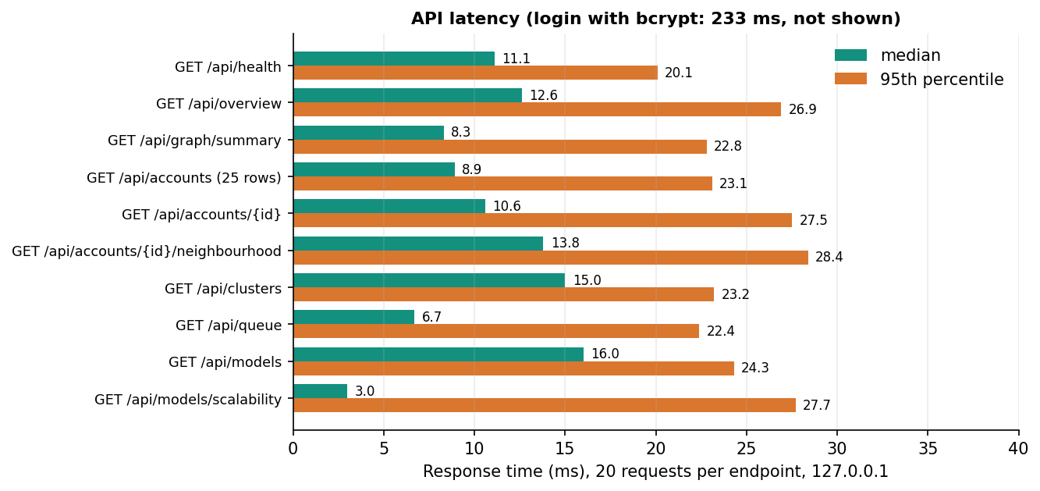
Figure 20: Median and 95th-percentile response time of ten API endpoints (20 requests each, 127.0.0.1).

7.7.2 Scalability of training and inference
The account graph was copied one, two, four and eight times as disjoint components, so that nodes and ties grow in step while the structure of each component stays the same. For each size, every model was trained for 10 epochs (the table gives seconds per epoch) and a forward pass over the whole graph was timed (the median of three).
Table 35: Training seconds per epoch / inference seconds, by graph size (CPU)
Accounts | Ties | Baseline MLP | GCN | GAT | GraphSAGE
4,533 | 94,456 | 0.073 / 0.011 | 0.142 / 0.036 | 0.255 / 0.051 | 0.060 / 0.027
9,066 | 188,912 | 0.022 / 0.002 | 0.152 / 0.065 | 0.597 / 0.129 | 0.115 / 0.054
18,132 | 377,824 | 0.041 / 0.003 | 0.307 / 0.143 | 1.103 / 0.259 | 0.203 / 0.099
36,264 | 755,648 | 0.085 / 0.008 | 0.577 / 0.235 | 2.022 / 0.584 | 0.392 / 0.186

From 4,533 to 36,264 accounts (8 times) and from 94,456 to 755,648 ties, a GraphSAGE epoch grew from 0.060 s to 0.392 s (6.5 times) and a forward pass from 0.027 s to 0.186 s; GAT grew from 0.255 s to 2.022 s per epoch. Growth is close to proportional to the number of ties, as expected from sparse message passing, and GAT is the most expensive because it computes attention on every tie. The first baseline timing is higher than its second (0.073 s against 0.022 s) because of start-up warm-up, so single entries should not be over-read.
These figures have three limits: the largest graph (36 thousand accounts) is far below platform scale, disjoint copies understate the cost of a real, well-mixed graph, and the whole graph is processed in one pass, so neighbourhood sampling would be needed at scale and was not implemented.

7.8 User interface checks
scripts/ui_checks.py drives the web application at 360, 768 and 1440 px in both themes and tests dark mode, keyboard focus, Escape on dialogs and reduced motion; scripts/capture_screens.py walks every screen and reports console errors. docs/FRONTEND_PLAN.md records both as passing when the interface was built; they were not re-run on 2026-10-26.

7.9 User acceptance
No formal acceptance test or user study was carried out. The nearest thing is the five-minute guided tour in docs/03_HOW_TO_RUN.md, which the project team used as an acceptance walk-through:
1. Graph & features - read the node and edge counts, which parts are real data, and the 23 features.
2. Models & scale - compare the three architectures against the no-graph baseline and open the Scalability tab.
3. Accounts - open the top-ranked account and read its probability, the traits behind it and its neighbourhood graph.
4. Botnet clusters - open a coordinated cluster and see that the injected botnets come back as single communities.
5. Moderator queue - dismiss one member, confirm another, see both in the decision log, and press Retrain with decisions.
Each step can be completed on the shipped data, which is what acceptance of the seven features means here. Whether a trust-and-safety moderator would find the explanations and the queue useful was not measured.

7.10 Environment note
On the measurement machine's system Python, import torch failed with WinError 1114 whenever fastapi or numpy had been imported first. Preloading torch avoids it; the 2026-10-26 runs did this through a throw-away sitecustomize.py outside the project, and the product code was not changed. The project's own .venv (made by setup.bat) does not show the problem but is not part of the delivered tree, so the system interpreter (PyTorch 2.14.1, CPU build) was used.

7.11 Limits of the testing done
• No unit tests and no coverage measurement; the smoke test is the only automated suite.
• Retraining side effects found, not fixed. In one run on correct decisions the served architecture changed from GraphSAGE to GAT, because the best architecture is chosen on the validation F1 of a single seed after the reviewed accounts have left the validation set; GraphSAGE had the higher test F1 (0.947 against 0.892) in that run. After such a switch /api/health reports the full-run F1 of the new architecture (0.900) rather than its retrained value. In another run two deliberately wrong moderator decisions lowered F1 for every model (Chapter 8). None of this is covered by the smoke test, which only checks that the run completes and is recorded.
• One run of the suite on one machine; no repeated runs to look for flaky checks. GAT results can drift by about 0.01 between runs because its edge softmax sums in a non-deterministic order, so the check that GAT beats the baseline has a margin (0.900 against 0.827) but no guarantee.
• No load or concurrency test: latency was measured with a single client; the behaviour with many moderators deciding at once, and SQLite's locking under that load, was not tested.
• No adversarial testing: nothing tests whether an attacker who knows the model can shape a bot's profile and ties to evade it; the camouflage built into the data is a first, mild stand-in.
• No test on data the model has not seen the kind of: all evaluation is on one synthetic-plus-real benchmark with one split; there is no second dataset and no cross-validation.
• Security only at the demonstration level (7.6).
• Interface checks not repeated after the last change, and no assistive-technology test beyond keyboard focus.
• Timings come from a shared i5-12500 without a GPU; they show the shape of the cost, not production numbers.

CHAPTER 8: RESULTS AND OUTPUT SCREENS
This chapter reports what BotGraph achieved: the comparison of the models, what the result depends on, the botnet clusters, scalability, a comparison with the base paper, every output screen, sample API responses, the effect of moderator decisions on retraining, where the system succeeds and fails, and the objectives measured against the outcomes. Where a number looks better than it should, the chapter says what it rests on.

8.1 Experimental set-up
Every number in this chapter comes from files written by the project's own scripts: experiments/metrics.json (the three-seed comparison, written by ml/train.py), experiments/scalability.json and experiments/eval/metrics.json (ml/eval.py), experiments/extra/metrics.json (scripts/run_extra_experiments.py: threshold sweep, error analysis, feature-group ablation) and, for the API samples and retraining runs, responses captured from a scratch copy of the application on 2026-10-26. No result was typed in by hand. The measurements were made on one machine: 12th Gen Intel Core i5-12500 (6 cores, 12 threads), 16 GB RAM, Windows 11 Pro, CPU only, Python 3.11.9 and PyTorch 2.14.1 (CPU build). The machine was shared with other programs, so timings are indicative; accuracy figures do not depend on load.
Table 36: Data used in the evaluation
Item | Content | Status
Topology | 3,963 accounts and 88,156 ties from ten SNAP Facebook ego networks | Real public data
Profile attributes | 696 labelled Instagram rows, resampled and jittered onto every account | Real rows, resampled
Posting behaviour | 50,000 labelled Twitter rows; retweets, mentions, post length, hashtags | Real rows; the label carries almost no signal
Injected botnets | 8 botnets of sizes 62, 50, 52, 60, 48, 56, 58, 34 (420 accounts) and 150 lone spammers; 6,300 injected ties | Synthetic, seeded (seed 7)
Timing and interaction features, handles | Posting rate, burstiness, peak hour, interactions per week, names | Synthetic, seeded
Camouflage | 198 bots given a genuine-looking profile; 231 genuine accounts given a fake-looking one | Synthetic, by design
Final graph | 4,533 accounts, 94,456 ties, 570 fake (12.6%) | Stratified split 60/20/20: 2,719 / 906 / 908

The test split holds 908 accounts, 114 of them fake. Because only 12.6 % of accounts are fake, a classifier that answers genuine for everybody would score 87.4 % accuracy, so the headline measure in this chapter is F1 (with precision and recall), not accuracy. All four models use the same 23 features, the same split and the same training budget (two layers, 64 hidden units, dropout 0.3, Adam with learning rate 0.01, up to 160 epochs with early stopping on validation F1, class-weighted loss); the decision threshold is tuned on the validation set. Each model was trained with seeds 0, 1 and 2 and the tables give the mean and the standard deviation over the three seeds. Three seeds is a small sample, so deviations are indicative only.

8.2 Model performance
The first table below compares the four models on the held-out test split. GraphSAGE has the best value on every column: F1 0.939 ± 0.006, precision 0.975, recall 0.906 and ROC-AUC 0.990. It was also chosen as the served model by the project's own rule, the best mean validation F1 among the three graph models (0.959, against 0.955 for GAT and 0.891 for GCN).
Table 37: Test-split results, mean ± standard deviation over three seeds (908 accounts, 114 fake)
Model | Accuracy | Precision | Recall | F1 | ROC-AUC | PR-AUC | Train s
Feature-only baseline (MLP) | 0.959 ± 0.003 | 0.868 | 0.789 | 0.827 ± 0.010 | 0.967 | 0.907 | 3.0
GCN | 0.964 ± 0.002 | 0.958 | 0.743 | 0.837 ± 0.009 | 0.988 | 0.939 | 10.4
GAT | 0.977 ± 0.004 | 0.963 | 0.845 | 0.900 ± 0.018 | 0.978 | 0.946 | 40.6
GraphSAGE (served) | 0.985 ± 0.001 | 0.975 | 0.906 | 0.939 ± 0.006 | 0.990 | 0.974 | 11.7

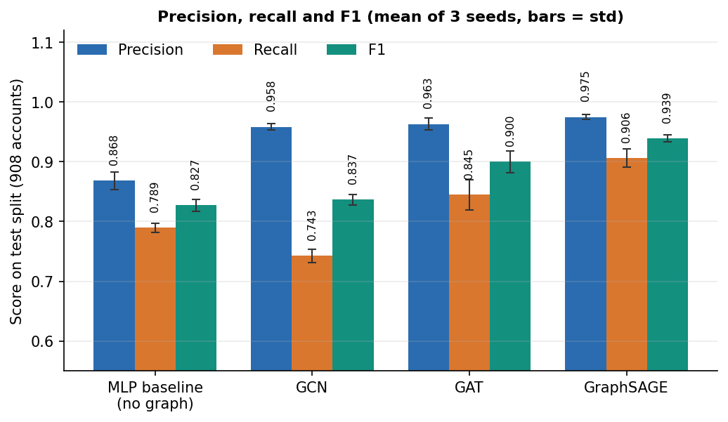
Figure 21: Precision, recall and F1 of the four models on the test split (mean over three seeds).
The graph helps, but by very different amounts. Over the feature-only baseline (F1 0.827), GCN gains 1.0 point, GAT 7.3 points and GraphSAGE 11.2 points. GCN's small gain is a trade: its precision rises to 0.958 but its recall (0.743) is lower than the baseline's (0.789), so it finds fewer fake accounts than a model that ignores the graph. A plausible reason, which these experiments do not prove, is that GCN's symmetric normalisation averages an account with its neighbours, so a fake account with a few genuine neighbours is pulled towards them, whereas GraphSAGE keeps the account's own features in a separate weight from the neighbourhood mean. GAT is in between and is the least stable: its F1 over the three seeds is 0.901, 0.877 and 0.922.
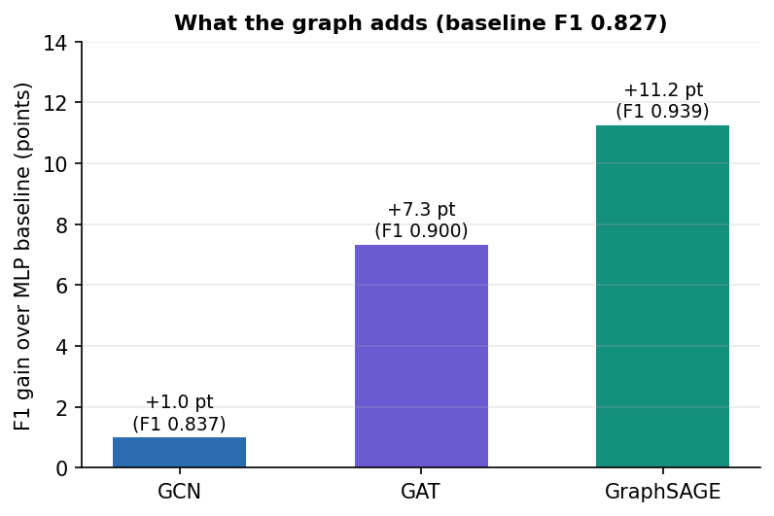
Figure 22: F1 gained over the feature-only baseline by each graph architecture, in F1 points.

8.2.1 Seed variation
Table 38: F1 by training seed (with the validation-tuned threshold)
Model | Seed 0 | Seed 1 | Seed 2
Feature-only baseline (MLP) | 0.833 (thr 0.500) | 0.835 (thr 0.500) | 0.813 (thr 0.500)
GCN | 0.847 (thr 0.675) | 0.837 (thr 0.625) | 0.826 (thr 0.750)
GAT | 0.901 (thr 0.475) | 0.877 (thr 0.500) | 0.922 (thr 0.425)
GraphSAGE | 0.946 (thr 0.500) | 0.941 (thr 0.500) | 0.931 (thr 0.525)

GraphSAGE's three values lie within 0.015 of each other and every one is above every value of GAT, GCN and the baseline, so its ranking does not depend on the seed. GAT's spread is large enough that its best seed (0.922) nearly reaches GraphSAGE's worst (0.931). GAT's edge softmax sums in a non-deterministic order, so re-running it can move its F1 by about 0.01.
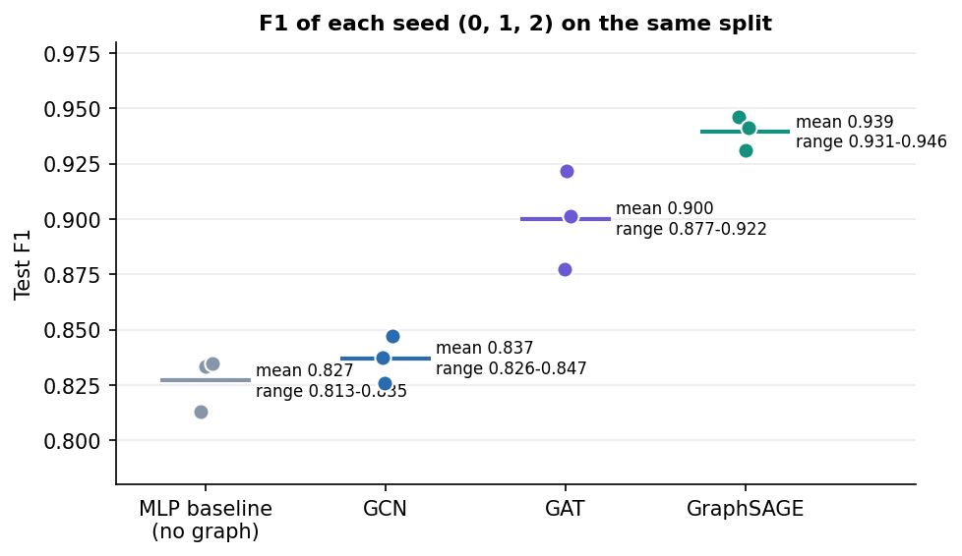
Figure 23: F1 of every model for each of the three training seeds.

8.2.2 Confusion matrices and ROC curves
The stored confusion matrices belong to the first seed. GraphSAGE misses 9 of the 114 fake accounts and wrongly flags 3 of 794 genuine accounts; the baseline misses 24 and wrongly flags 12.
Table 39: Confusion counts on the 908-account test split (seed 0)
Model | TP | FN | FP | TN | Threshold
Feature-only baseline (MLP) | 90 | 24 | 12 | 782 | 0.500
GCN | 86 | 28 | 3 | 791 | 0.675
GAT | 96 | 18 | 3 | 791 | 0.475
GraphSAGE | 105 | 9 | 3 | 791 | 0.500

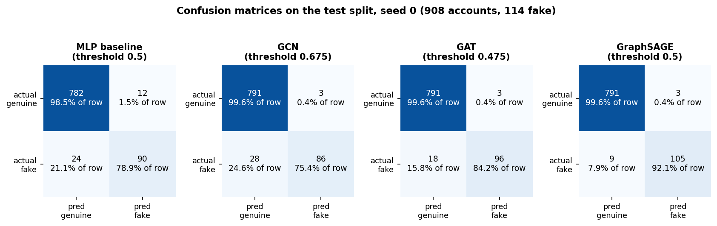
Figure 24: Confusion matrices of the four models on the test split (seed 0).
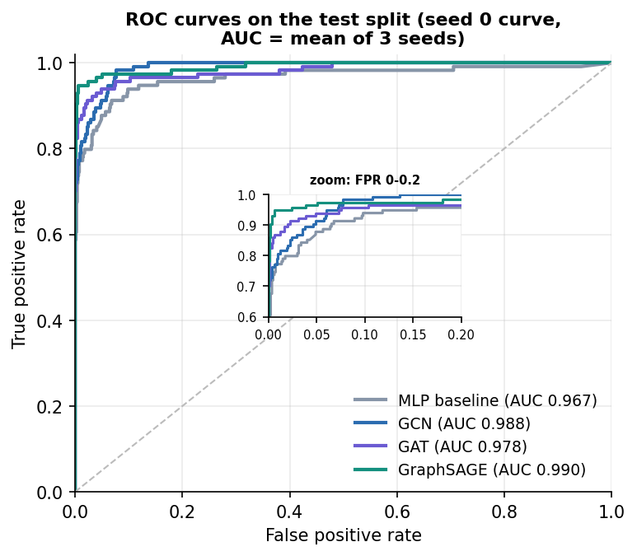
Figure 25: ROC curves of the four models on the test split (seed 0).

8.3 Threshold analysis
An account is flagged when its fake-probability reaches the threshold. The served model uses 0.5, which the validation set chose. To see how much the result depends on that choice, the stored GraphSAGE scores (seed 0) were swept over thresholds on the test split.
Table 40: Served GraphSAGE at different thresholds (test split, seed 0)
Threshold | Precision | Recall | F1 | False positives | False negatives
0.20 | 0.838 | 0.956 | 0.893 | 21 | 5
0.30 | 0.908 | 0.947 | 0.927 | 11 | 6
0.40 | 0.956 | 0.947 | 0.952 | 5 | 6
0.50 | 0.972 | 0.921 | 0.946 | 3 | 9
0.60 | 0.981 | 0.904 | 0.941 | 2 | 11
0.70 | 0.980 | 0.877 | 0.926 | 2 | 14
0.80 | 0.990 | 0.851 | 0.915 | 1 | 17
0.90 | 0.989 | 0.798 | 0.883 | 1 | 23

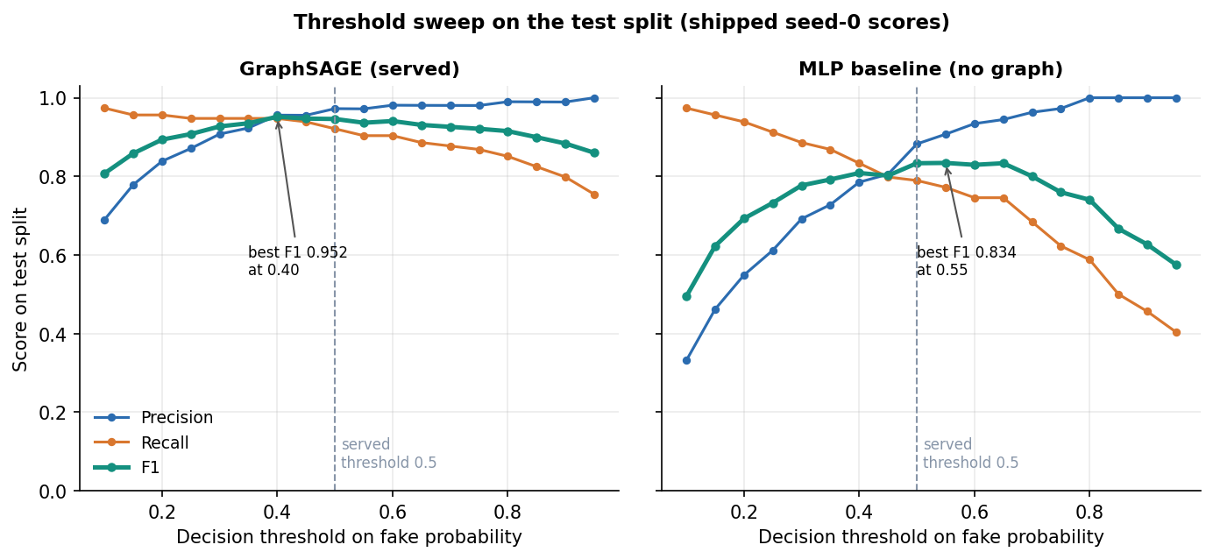
Figure 26: Precision, recall and F1 of the served GraphSAGE model against the decision threshold (test split, seed 0).
F1 stays between 0.927 and 0.952 for every threshold from 0.30 to 0.60, so the result does not hinge on the tuned threshold. Raising the threshold buys precision at the cost of recall: at 0.90 only one genuine account is flagged but 23 of the 114 fake accounts are missed. Lowering it does the opposite: at 0.20, 21 genuine accounts are flagged and 5 fake accounts are missed. The peak of the sweep (F1 0.952 at 0.40) is measured on the test split itself, so it is shown for analysis only; the served threshold was fixed on validation data. The baseline's best F1 over the same sweep is 0.834 (threshold 0.55); to reach a recall above 0.9 it has to accept a precision below 0.62, whereas GraphSAGE keeps a precision of 0.87 at a recall of 0.947. For a moderation team this is the useful reading: the graph model lets a team choose how many false alarms to accept without losing much recall.

8.4 Which features matter: an ablation
To find out where the performance comes from, the baseline and GraphSAGE were retrained with groups of features removed, three seeds each, in memory and without touching the shipped models. The row all 23 features (baseline 0.822, GraphSAGE 0.942) differs slightly from the main table (0.827 and 0.939) because it is a separate run with its own seeds' random draws.
Table 41: Test F1 with feature groups removed (mean ± standard deviation over three seeds)
Variant | Features | Baseline MLP | GraphSAGE | GraphSAGE precision / recall
all 23 features | 23 | 0.822 ± 0.009 | 0.942 ± 0.001 | 0.966 / 0.918
without profile metadata | 11 | 0.803 ± 0.013 | 0.887 ± 0.004 | 0.969 / 0.819
without posting behaviour | 19 | 0.822 ± 0.016 | 0.946 ± 0.005 | 0.973 / 0.921
without temporal pattern | 17 | 0.515 ± 0.003 | 0.840 ± 0.003 | 0.898 / 0.789
without interaction frequency | 22 | 0.825 ± 0.010 | 0.919 ± 0.022 | 0.975 / 0.871
profile metadata only | 12 | 0.512 ± 0.011 | 0.831 ± 0.012 | 0.878 / 0.789
behaviour only (posting, temporal, interaction) | 11 | 0.803 ± 0.013 | 0.887 ± 0.004 | 0.969 / 0.819
degree only (structure, no attributes) | 1 | 0.338 ± 0.003 | 0.965 ± 0.003 | 0.962 / 0.968

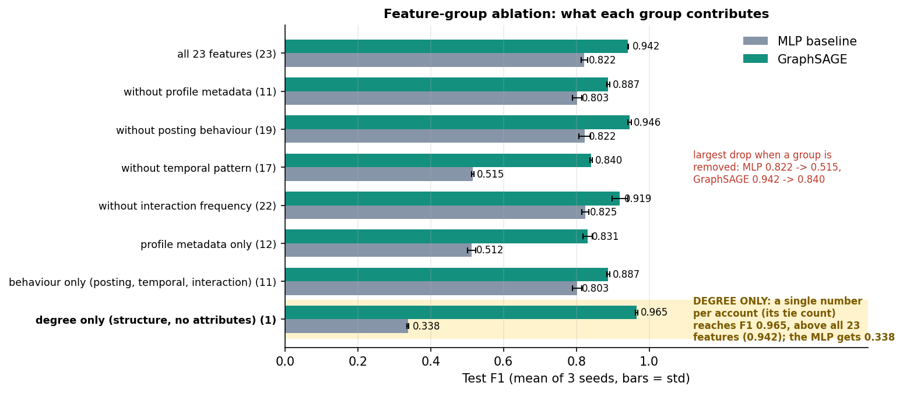
Figure 27: Test F1 of the baseline and GraphSAGE when feature groups are removed (three seeds).
1. The temporal group matters most. Removing the temporal features (account age, posts per day, burstiness, peak-hour share and its sine and cosine) drops the baseline from 0.822 to 0.515 and GraphSAGE from 0.942 to 0.840. These features are synthetic: botnet members share a creation window and a peak hour by construction, so this is the place where the benchmark is most generous.
2. Posting behaviour adds nothing. GraphSAGE scores 0.946 without it, which fits the finding that the Twitter bot label carries almost no signal.
3. The neighbourhood supplies what the profile lacks. On the 12 profile features alone the baseline reaches only 0.512 while GraphSAGE reaches 0.831.
4. One structural feature is enough here. GraphSAGE given nothing but the logarithm of each account's number of ties scores F1 0.965 (precision 0.962, recall 0.968), above the model with all 23 features (0.942). The no-graph model on the same single feature scores 0.338: an account's own degree is not enough, but its neighbours' degrees separate the classes.
The last finding changes how the headline result must be read. In this benchmark the injected botnets and lone spammers have a distinctive local degree pattern (dense ties inside a botnet, two to ten ties to real accounts), so message passing over degrees alone nearly solves the task. The benchmark therefore rewards structure more than a real platform would, and the graph lift of 11.2 F1 points is real for this data but partly produced by how the botnets were injected. The F1 of 0.939 must not be read as accuracy on a real platform. Showing this was the purpose of the ablation: a result that looks excellent should be asked what it depends on.

8.5 Botnet cluster detection
The embeddings of every account scored at 0.30 or more were linked to their five most similar neighbours and to their real ties, and Louvain community detection was run on that graph. Groups under five accounts were dropped. Nine groups remained: eight coordinated clusters and one loose group of 160 accounts. A botnet counts as recovered when one cluster contains at least 80 % of its accounts and at least 80 % of that cluster's accounts belong to it.
Table 42: Recovery of the eight injected botnets
Botnet | Accounts | Matched cluster | Recall | Precision | Recovered
Botnet 1 | 62 | cluster 2 | 1.000 | 1.000 | yes
Botnet 2 | 50 | cluster 6 | 1.000 | 1.000 | yes
Botnet 3 | 52 | cluster 5 | 1.000 | 1.000 | yes
Botnet 4 | 60 | cluster 1 | 1.000 | 0.923 | yes
Botnet 5 | 48 | cluster 7 | 1.000 | 1.000 | yes
Botnet 6 | 56 | cluster 4 | 1.000 | 1.000 | yes
Botnet 7 | 58 | cluster 3 | 1.000 | 0.983 | yes
Botnet 8 | 34 | cluster 8 | 1.000 | 1.000 | yes

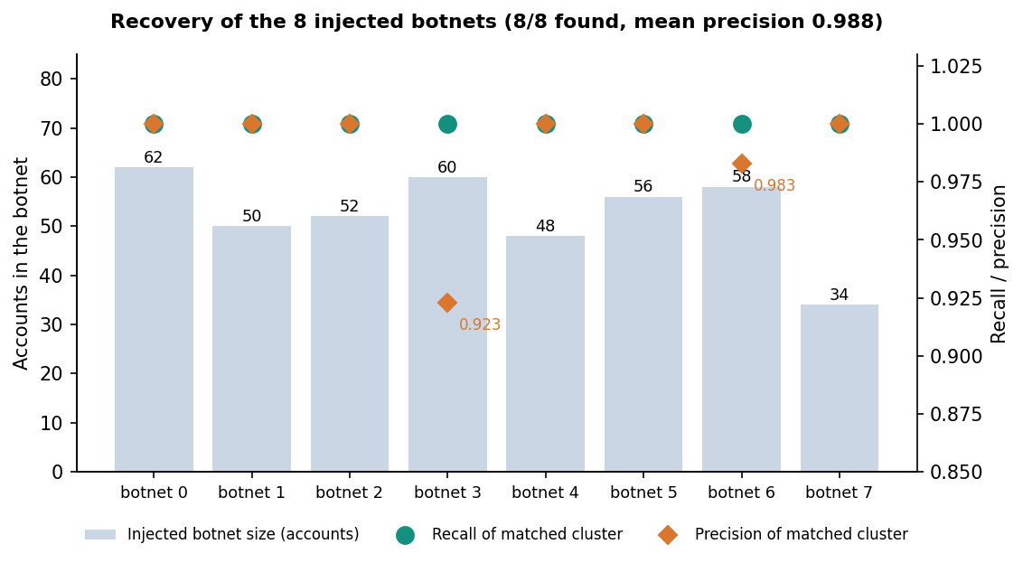
Figure 28: Recall and precision of the cluster that best matches each injected botnet.
All eight botnets are recovered as single communities: the mean recall is 1.000 and the mean precision 0.988; the lowest precision is 0.923 (botnet 4, whose cluster also contains five accounts that are not part of it). The fake purity of all clustered accounts is 0.913, which is lower than the botnet precision because the loose group of 160 accounts holds lone spammers together with look-alike genuine accounts: it has a tie density of 0.14 % and only 18 internal ties, and the application labels it loose group instead of coordinated because its density is below 5 %. That label is what separates a coordinated network from independent accounts that merely look alike.
This is a known-answer test. The botnets were injected with a tie probability of 0.28 between members, a shared creation window and a shared posting hour, so they are easy to find by construction. The result shows that the method recovers this kind of coordination; it says nothing about the recall of real botnets that hide their ties.
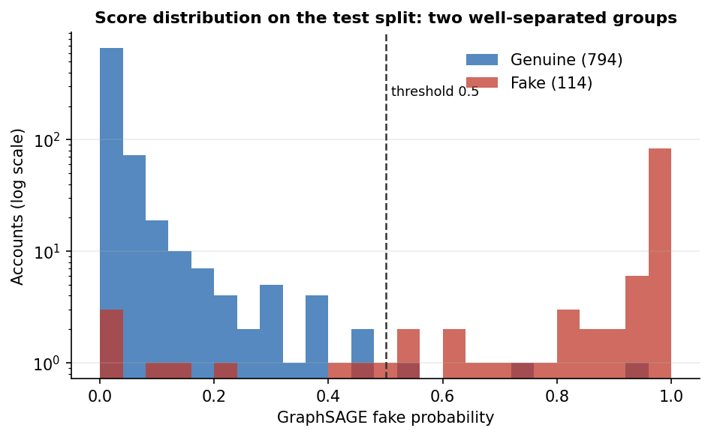
Figure 29: Distribution of GraphSAGE fake-probabilities for genuine and fake accounts.

8.6 Scalability and response time
The sweep of Section 7.7 grows the graph from 4,533 accounts and 94,456 ties to 36,264 accounts and 755,648 ties. A GraphSAGE epoch takes 0.060 s on the smallest graph and 0.392 s on the largest, GCN 0.142 s and 0.577 s, GAT 0.255 s and 2.022 s; one forward pass over the whole graph takes 0.186 s for GraphSAGE and 0.584 s for GAT at the largest size. Cost grows roughly in proportion to the number of ties, and GAT is the most expensive. GraphSAGE is both the most accurate and, among the graph models, the cheapest, so on this benchmark there is no accuracy-for-speed trade-off to make.
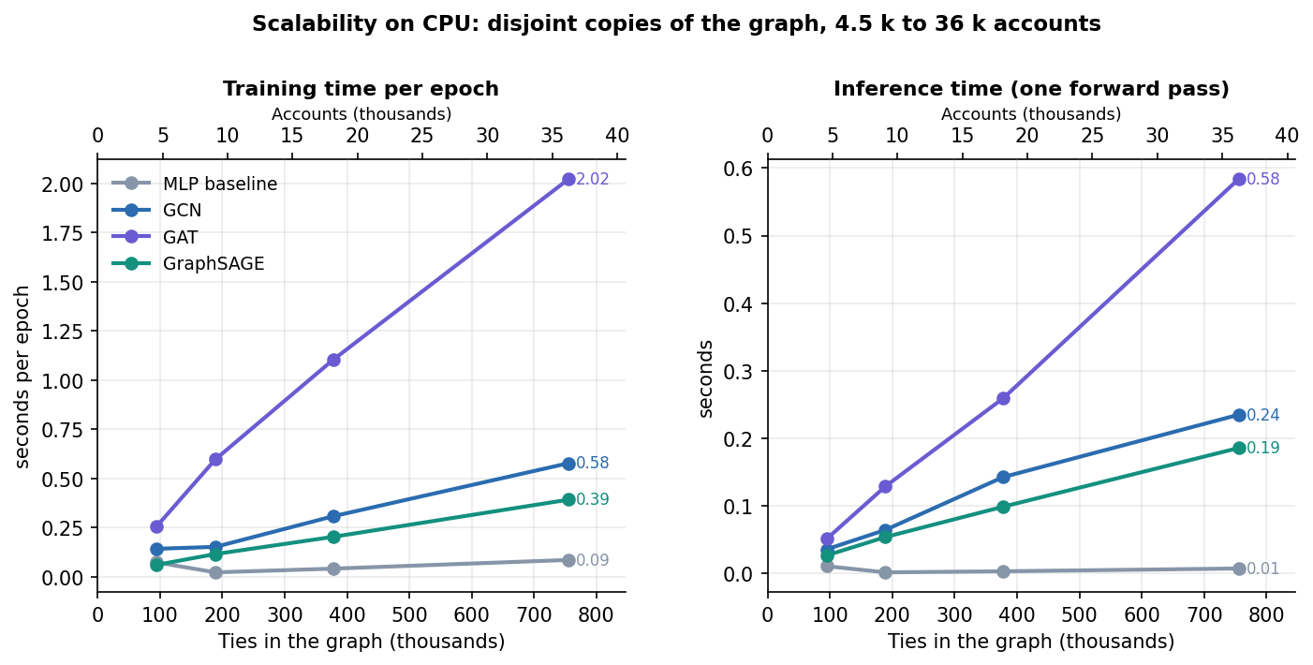
Figure 30: Training time per epoch and inference time against graph size, CPU, for the four models.
The API answers read requests in 3 to 16 ms (median; 95th percentile at most 29 ms), sign-in takes about 233 ms because of bcrypt and start-up takes 5.1 s; the limits of these figures are in Section 7.7.

8.7 Comparison with the base paper
The base paper [1] proposes PruferNET: Prufer-sequence features from a minimum spanning tree, added to classical centralities and fed to a GraphSAGE model that classifies each node by its depth in the tree. Its task is to find influential nodes, not fake ones, and its data carry no fake-account labels. The two works share a family of data (SNAP Facebook networks), a model family (GraphSAGE) and the idea that structure adds information a per-node model lacks, but they do not measure the same thing. Their numbers cannot be compared like for like, and no ranking is claimed.
Table 43: What each work reports
Aspect | PruferNET (base paper) | BotGraph (this project)
Task | 3-class node classification by depth in a minimum spanning tree (Very Shallow / Shallow / Deep) | Binary fake-account detection plus botnet cluster detection
Labels | Depth classes computed from the graph itself | Dataset labels: genuine / fake (12.6 % fake); partly synthetic
Data | SNAP Facebook, 4,039 nodes and 88,234 edges; Email-Eu-core, 986 nodes and 16,064 edges | 4,533 nodes, 94,456 ties: SNAP Facebook topology (3,963 nodes) plus injected accounts, real profile rows, synthetic timing features
Model | GraphSAGE, 64 hidden units, dropout 0.5, AdamW lr 0.003, 300 epochs | GCN, GAT and GraphSAGE, 2 layers, 64 hidden units, dropout 0.3, Adam 0.01, up to 160 epochs, plus an MLP baseline
Features | Prufer-sequence statistics, degree, closeness, PageRank, trust score | 23 attributes: profile, posting, temporal, interaction; no Prufer or centrality features
Split | 60/20/20 | Stratified 60/20/20 (2,719 / 906 / 908)
Headline result | Test accuracy 99.63% with Prufer features, 96.54% without | GraphSAGE F1 0.939 ± 0.006 (accuracy 98.5%); baseline F1 0.827
Hardware | T4 GPU, 16 GB RAM | CPU only (i5-12500, 16 GB)
Clusters, scalability, review loop | None reported | Louvain botnet clusters (8 of 8 recovered), scalability to 36 k accounts, moderator queue with retraining

Three points of reading follow. First, accuracy is not the right yardstick for BotGraph, because 87.4 % of accounts are genuine; the accuracy of 98.5 % corresponds to an F1 of 0.939. Second, PruferNET's classes are defined by the same graph from which its features are computed, which makes high scores likely, and its own caveat that the paper is not about a new network architecture applies equally here: BotGraph's contribution is the application, not a new layer. Third, the Prufer features were not used in BotGraph and testing whether they help bot detection is listed as future work. The companion works in the batch survey (RABot and HW-GNN) address imbalance, noisy ties and homophily in bot detection; they were used to frame the problem and were not reproduced, so no number from them is quoted.

8.8 Summary of the numbers
Table 44: Headline numbers
Measure | Value
Served model | GraphSAGE
Test F1 (mean ± std, 3 seeds) | 0.939 ± 0.006
Test precision / recall | 0.975 / 0.906
Test ROC-AUC / PR-AUC | 0.990 / 0.974
Lift over the no-graph baseline | +11.2 F1 points (baseline 0.827)
Confusion (seed 0, 908 accounts) | TP 105, FN 9, FP 3, TN 791
Botnets recovered | 8 of 8 (mean recall 1.000, precision 0.988)
Accounts flagged at 0.5 | 548 of 4,533
GraphSAGE epoch at 36,264 accounts | 0.392 s
API median response | 3-16 ms (p95 up to 28 ms)
Smoke test | 36 of 36 checks pass

8.9 Learning from moderator decisions
Two retraining runs were made on a scratch copy of the application. Each trains all four models with one seed on the original labels plus the labels from the decisions, and F1 is measured before and after on the same 908 test accounts (decisions on test accounts are ignored; the before value is the first seed of the main run).
Table 45: F1 on the test split before and after retraining on moderator decisions (one seed)
Scenario | Model | F1 before | F1 after | Change (points)
A. Correct decisions | Feature-only baseline (MLP) | 0.833 | 0.836 | +0.2
 | GCN | 0.847 | 0.826 | -2.1
 | GAT | 0.901 | 0.892 | -0.9
 | GraphSAGE | 0.946 | 0.947 | +0.1
B. Includes two deliberate errors | Feature-only baseline (MLP) | 0.833 | 0.830 | -0.3
 | GCN | 0.847 | 0.765 | -8.2
 | GAT | 0.901 | 0.887 | -1.5
 | GraphSAGE | 0.946 | 0.905 | -4.1

Scenario A. Confirmation of the three largest coordinated clusters (BN-00112, BN-03963, BN-03936) and dismissal of three flagged accounts whose dataset label is genuine; every decision agrees with the dataset labels. 187 accounts received a label; 144 of them were outside the test split and were used. The run took 60 s. Afterwards the application flagged 521 accounts (548 before) and showed 8 botnets (8 before).
Scenario B. One confirmation of a flagged account and of cluster BN-00112 (65 accounts), both correct, and two deliberate errors: a dismissal of a fake account (@juniper2) and a dismissal of the whole cluster BN-03963 (62 accounts, a true botnet). 129 accounts received a label; 99 of them were outside the test split and were used. The run took 93 s. Afterwards the application flagged 534 accounts (548 before) and showed 7 botnets (8 before).
In scenario A every decision agrees with the dataset labels. Confirming botnets the model already scores near 100 % adds little, so F1 barely moves for the baseline (+0.2) and GraphSAGE (+0.1) and falls for GCN (-2.1) and GAT (-0.9), changes of the size of the seed-to-seed variation; the run shows that the loop works, not that it improves the model. It also exposed a defect: the application then served GAT instead of GraphSAGE, because the best architecture is picked on the validation F1 of one seed after the reviewed accounts have left the validation set, although GraphSAGE has the higher test F1 after the run (0.947 against 0.892). In scenario B the two errors cost F1 for every model (GCN -8.2 points, GraphSAGE -4.1, GAT -1.5, baseline -0.3), the botnets shown fell from 8 to 7 because the 62 accounts of the wrongly dismissed botnet were relabelled genuine, and 534 accounts remained flagged instead of 548. The loop learns whatever it is told, so moderator errors are costly; two runs with one seed each support no statistical statement.

8.10 Output screens
The 18 screenshots in docs/screenshots/ are real captures of the running application (1440 x 900) with the shipped GraphSAGE model and the committed graph, taken with scripts/capture_screens.py on 2026-10-24; the decisions visible in the queue screens were made during that session, and accounts shown as injected are the seeded synthetic accounts of Section 8.1. The remaining ten screens are in Appendix C.

8.10.1 Landing page (light theme)
The landing page: headline, two buttons and a schematic drawing (labelled as such, not real data) with two live counters from the API, 8 botnets found and 4,533 accounts in the graph.
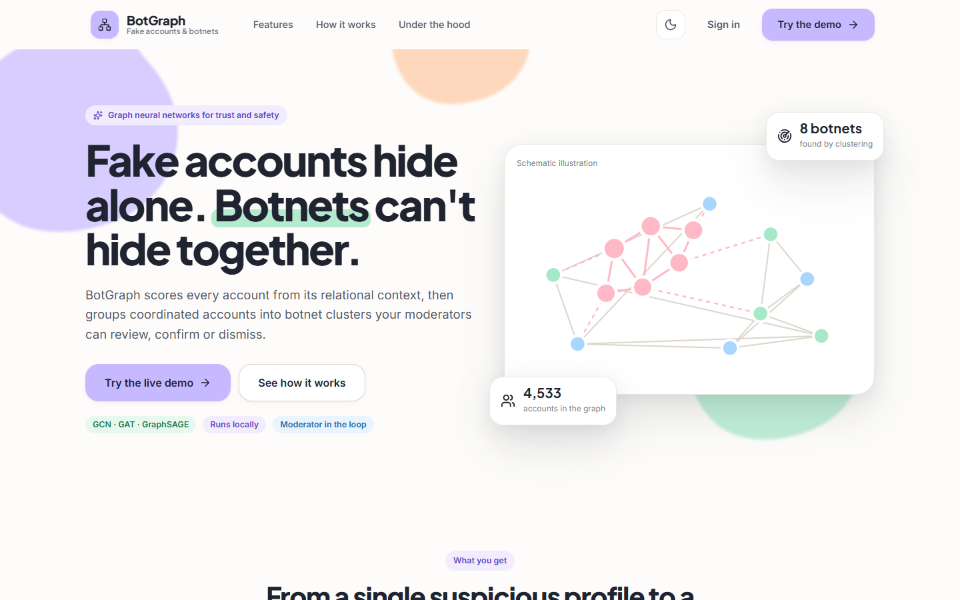
Figure 31: Landing page (light theme).

8.10.2 Overview screen, light theme
Five counters read from the API: 4,533 accounts, 548 flagged (12.1 %), 8 botnet clusters plus one loose group, 510 items waiting for review and GraphSAGE's F1 of 93.9 %, 11.2 points above the no-graph model. A histogram shows nearly all accounts below 10 % and a small group at 90-100 %; a bar chart compares the F1 of the four models.
Figure 32: Overview screen, light theme.

8.10.3 Ranked accounts screen
Every account with its fake-probability, filterable by name, status and botnet and sortable by five keys. The top rows are all members of BN-04235 at 100 %; their badges show decisions recorded before the capture, including a dismissal of an account whose dataset label is fake.
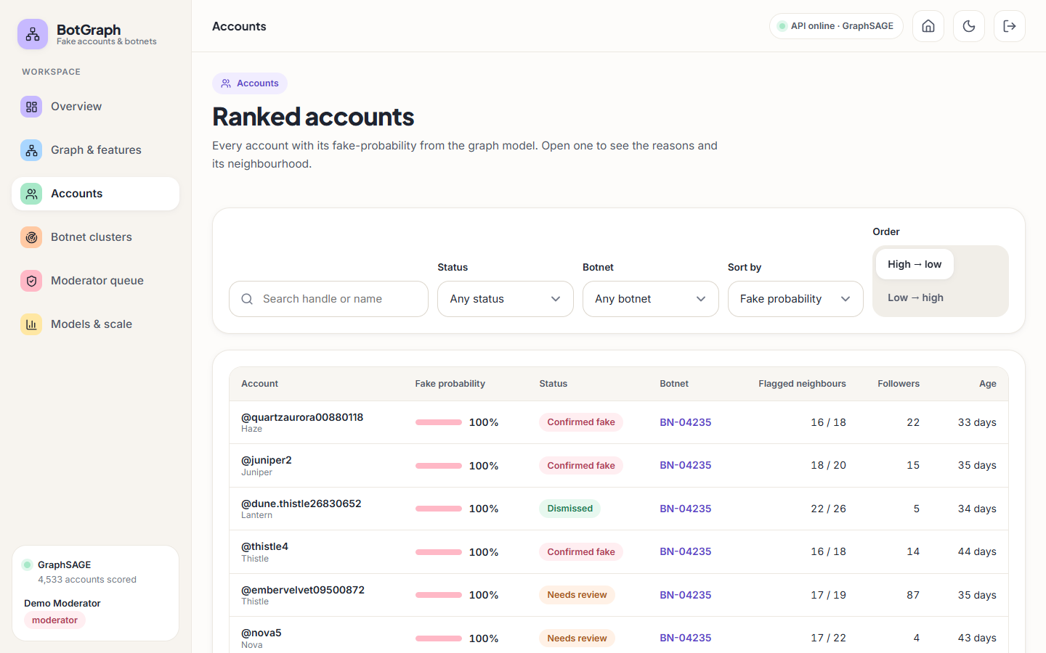
Figure 33: Ranked accounts screen.

8.10.4 Account detail screen, upper half
The page for @quartzaurora00880118, an injected account: a 100 % gauge, membership of BN-04235 (56 accounts) and the probability from every model. All four models, including the baseline, score it near 100 %, so the graph adds nothing for this easy case. The panel on the right offers Confirm fake and Dismiss.
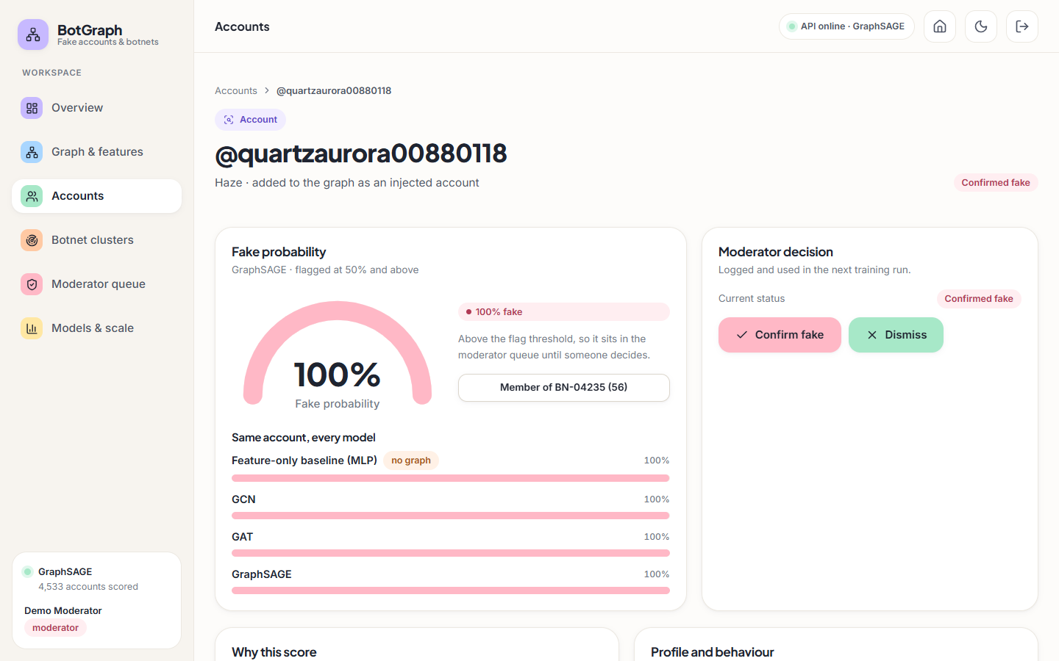
Figure 34: Account detail screen, upper half.

8.10.5 Botnet clusters screen
Louvain communities over the embeddings. The loose group BN-00055 (160 accounts, tie density 0 %) comes first, followed by coordinated clusters from BN-00112 (65 accounts, 26 % density, 94 % active around 22:00) down to BN-04187 (48 accounts, 33 %); all are marked Needs review.
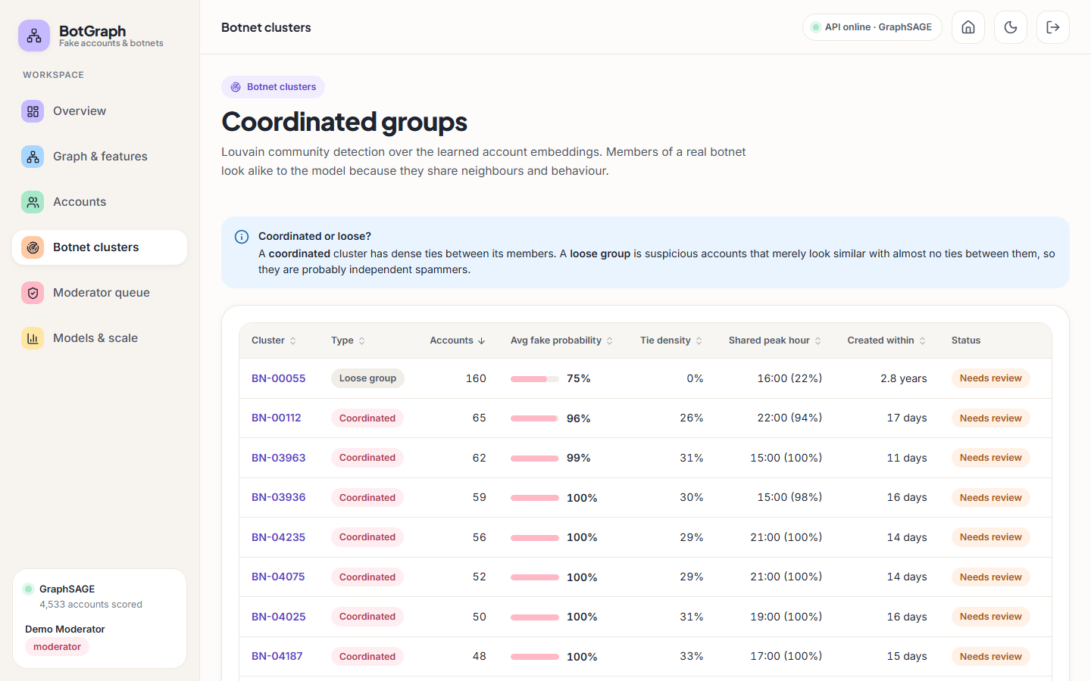
Figure 35: Botnet clusters screen.

8.10.6 Cluster detail screen for BN-00112
BN-00112 in detail: 65 accounts with 544 ties among them, a shared peak hour of 22:00 and 289 outside accounts tied to them. A decision here applies to all 65 members. The cluster graph is drawn small because the force layout had not yet spread out.
Figure 36: Cluster detail screen for BN-00112.

8.10.7 Moderator queue, accounts tab
The moderator's working screen: 510 accounts and 8 clusters to review, 4 confirmed and 1 dismissed. The right-hand panel reports 38 labelled accounts ready for the next training run and carries the Retrain with decisions button.
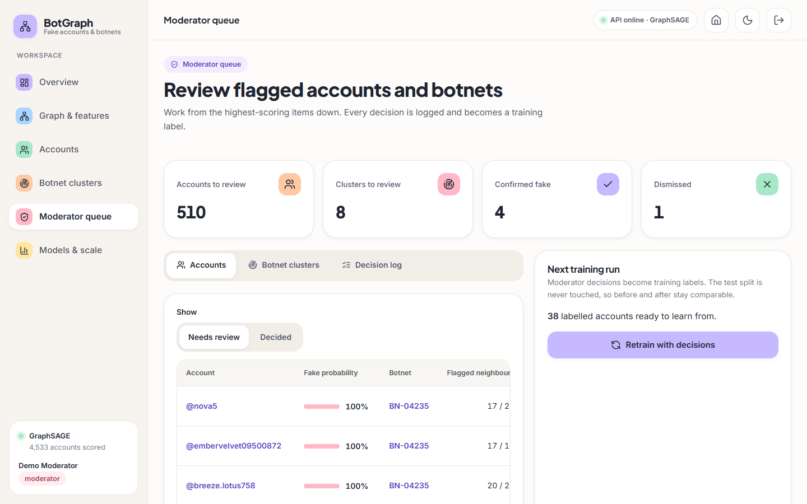
Figure 37: Moderator queue, accounts tab.

8.10.8 Models and scale screen, comparison tab
The comparison tab: GraphSAGE is best (F1 93.9 %, +11.2 points over no graph), 8 of 8 botnets are recovered, and a table gives accuracy, precision, recall, F1, ROC-AUC, PR-AUC and training time for the four models on the same 908-account test split.
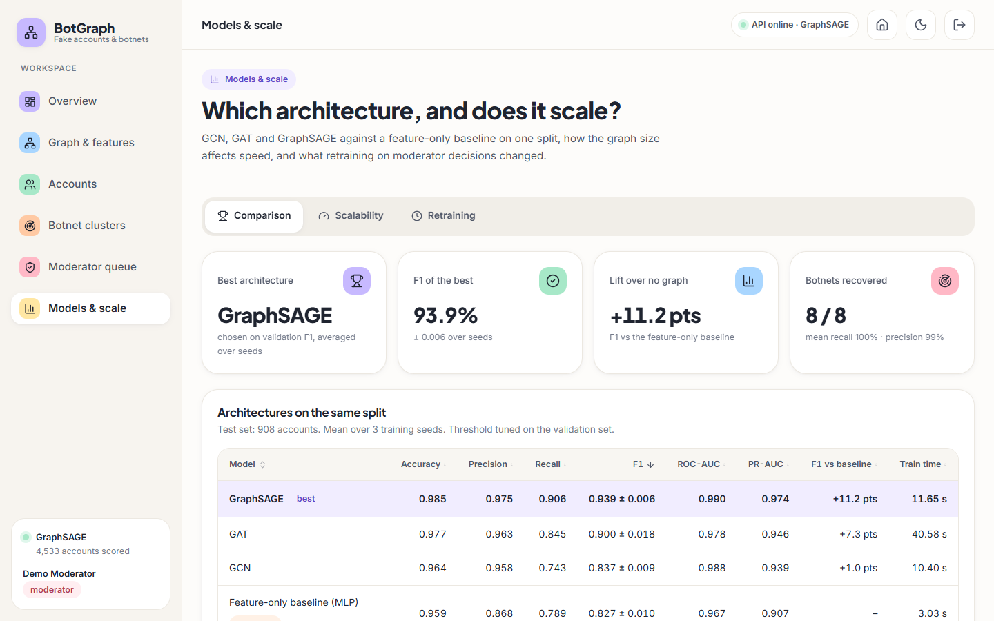
Figure 38: Models and scale screen, comparison tab.

8.11 Sample inputs and outputs
The excerpts below are real responses of the API, captured on 2026-10-26 from a scratch copy of the application (long lists shortened with ...). They show the shape of the data behind the screens.

8.11.1 Sign-in and access control
POST /api/auth/login {"email": "moderator@botgraph.app", "password": "x"}
-> 401 {"detail": "That email and password do not match. Use one of the demo logins shown on the sign-in page."}

GET /api/overview (no token)
-> 401 {"detail": "Please sign in to continue."}

POST /api/queue/decisions (analyst token)
-> 403 {"detail": "Only moderators can record decisions or retrain the model."}

8.11.2 One ranked account and its explanation
GET /api/accounts?page_size=3 -> first item
{"id": 4286, "handle": "quartzaurora00880118", "display_name": "Haze", "score": 1.0, "flagged": true, "status": "pending", "cluster_id": "BN-04235", "followers": 22, "following": 22, "account_age_days": 33, "degree": 18, "flagged_neighbours": 16}

GET /api/accounts/4286 (trimmed)
{
"id": 4286,
"handle": "quartzaurora00880118",
"score": 1.0,
"flagged": true,
"status": "pending",
"model": "GraphSAGE",
"model_scores": {
"baseline": 0.9987,
"gcn": 0.9997,
"gat": 1.0,
"sage": 1.0
},
"cluster_id": "BN-04235",
"cluster_size": 56,
"explanation": {
"margin": 16.99,
"own_total": 5.38,
"network": 9.73,
"top": [
{
"feature": "log_account_age_days",
"value": 3.499,
"contribution": 1.93
},
{
"feature": "peak_hour_share",
"value": 0.364,
"contribution": 1.05
},
{
"feature": "posting_burstiness",
"value": 0.655,
"contribution": 0.89
}
]
},
"neighbourhood": {
"degree": 18,
"flagged": 16,
"mean_score": 0.89,
"injected_ties": 18
}
}

Every model, including the one that ignores the graph, scores this account near 1. The explanation attributes +5.38 of the margin of 16.99 to the account's own traits and +9.73 to its neighbours through message passing.

8.11.3 A decision and an error
POST /api/queue/decisions {"target_type": "account", "target_id": "4286", "decision": "confirm", "note": "sample"}
-> 201 {"id": 1, "target_type": "account", "target_id": "4286", "decision": "confirm", "affected_accounts": 1, "at": "2026-10-26T05:38:44.856480+00:00"}

GET /api/accounts/99999999
-> 404 {"detail": "No account with id 99999999."}

8.12 Success and failure analysis

8.12.1 Where the system succeeds
• Coordinated accounts. All 82 botnet members in the test split are caught by GraphSAGE; the feature-only baseline catches 64. The graph rescues 18 fake accounts the baseline misses (a net gain of 18 botnet members), typically accounts with a camouflaged profile whose neighbours are not camouflaged.
• Few false alarms. At the served threshold 3 of 794 genuine accounts are flagged (0.4 %); all three are accounts of the real topology, with 4, 10 and 41 ties.
• Cluster recovery. Eight of eight injected botnets come back as single communities, and the density rule separates them from the loose group.

8.12.2 Where it fails
• Lone spammers. Of 32 lone spammers in the test split GraphSAGE catches 23, and the baseline 26: for accounts with no coordinated neighbourhood the graph does not help, and it loses 3 accounts the baseline caught. All 9 missed fake accounts are lone spammers with only 4 to 8 ties (median 7, against 20 for caught fake accounts); their scores range from 0.02 to 0.50. 6 fake accounts are missed by both models.
• GCN loses recall below the no-graph baseline (0.743 against 0.789), so a graph model is not automatically a better detector.
• Moderator mistakes spread. In the retraining experiment (Section 8.9), a wrong dismissal of a cluster relabelled every member as genuine and lowered the F1 of three of four models. The queue offers no second opinion or confidence check on a decision.
• The loose group needs a person. The 160-account group has no internal structure; it is flagged because its members individually look suspicious, and the system cannot say whether they are related.
• Easy cases look the same as hard cases on screen. The account shown on the account detail screen is scored 100 % by every model, including the baseline; the interface does not tell the moderator whether the graph contributed anything to a given score.
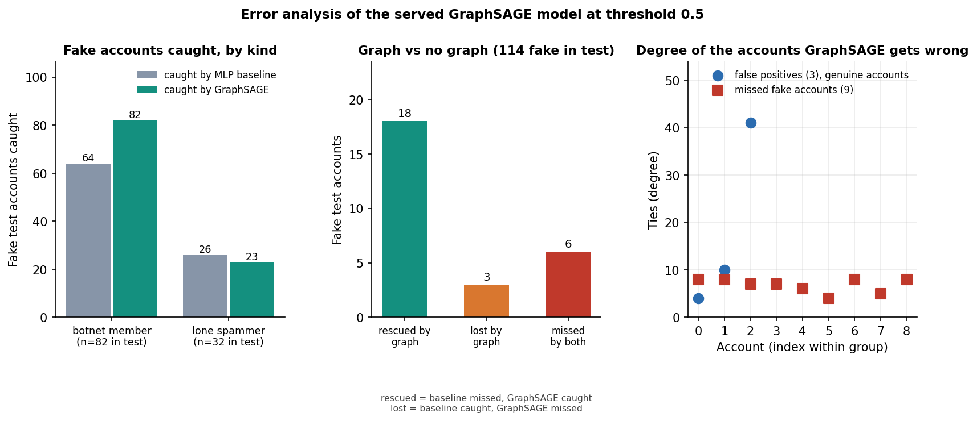
Figure 39: Test fake accounts caught and missed by GraphSAGE and by the baseline, by kind (botnet member, lone spammer).
Figure 40: Mean value of each feature for genuine and fake accounts (standardised).
Figure 41: Number of ties per account for genuine and fake accounts.

8.13 Limitations of the results
• The data are partly synthetic. The eight botnets, the 150 lone spammers, the timing and interaction features and the handles are generated, and the profile and posting rows come from different people. The results describe this benchmark, not Indian platforms such as ShareChat or Moj.
• Structure alone nearly solves the benchmark (Section 8.4): GraphSAGE on log degree alone scores F1 0.965. The graph lift is partly an effect of how the botnets were injected.
• One split and three seeds. There is no cross-validation, no second dataset and no significance test; the deviations are over three seeds only. The confusion matrices and the threshold sweep use the first seed.
• No real botnets and no adversary. Recovery is measured against seeded botnets that do not try to hide their ties, and no attack on the model was tried.
• No text features. The abstract mentions linguistic cues; the 23 features contain none.
• The explanation is approximate. Reasons are gradient times input of one forward pass, which is a first-order approximation, as the screen itself says.
• Scale was measured on disjoint copies of a 4.5 thousand-account graph, up to 36 thousand accounts, on one CPU.
• The retraining experiment has two runs, one seed each, so its before-and-after differences are not statistically supported.

8.14 Objectives against outcomes
Table 46: The six objectives of the project and what was measured
# | Objective | Outcome | Evidence
1 | Construct a graph of accounts (nodes) and interactions (edges) | Met. 4,533 nodes, 94,456 undirected ties, documented schema; 88,156 real and 6,300 injected ties | Graph & features screen; Section 8.1
2 | Engineer node features: profile, posting behaviour, interaction frequency | Met. 23 features in four groups; no text features | Graph & features screen; ablation, Section 8.4
3 | Implement and compare GCN, GAT and GraphSAGE | Met. Same split, features and budget, three seeds, plus a no-graph baseline; GraphSAGE best (F1 0.939), GCN +1.0, GAT +7.3, GraphSAGE +11.2 points | Sections 8.2-8.4
4 | Detect coordinated botnet clusters from learned embeddings | Met on injected botnets. 8 of 8 recovered, mean recall 1.000, precision 0.988; real-world botnets not tested | Section 8.5
5 | Evaluate accuracy, precision and recall against labelled data | Met. Six metrics, ROC, confusion matrices, threshold sweep; labels are partly synthetic | Sections 8.2-8.3
6 | Assess scalability as nodes and edges grow | Met to 36 k accounts / 756 k ties on CPU, roughly linear in ties; platform scale untested | Section 8.6; Chapter 7.7

Beyond the six objectives the project added a moderator queue with a retraining loop, explanations for every score and an API with role-based access. Where an objective is marked as met, the margin of the claim is given in the evidence column and in Section 8.13.

CHAPTER 9: CONCLUSION

9.1 Summary of the work
This project built BotGraph, a system that finds fake accounts and coordinated botnets from the shape of a social graph. It assembles a graph of 4,533 accounts and 94,456 ties from real Facebook ego-network topology, real labelled profile and posting rows and seeded injected botnets; describes each account with 23 features; trains a feature-only baseline and GCN, GAT and GraphSAGE models on one split; clusters suspicious accounts with Louvain over the learned embeddings; and serves scores, explanations, clusters and a moderator queue through a FastAPI backend and a React interface. The work was measured on a held-out test split, in a threshold sweep, an error analysis, a feature-group ablation and a scalability sweep, and verified with a smoke test of 36 checks.

9.2 Objectives achieved
Table 47: The six objectives of the batch against the outcome
# | Objective | Outcome
1 | Graph of accounts (nodes) and interactions (edges) | Met: 4,533 nodes, 94,456 undirected ties (88,156 real, 6,300 injected), documented schema
2 | Node features: profile, posting behaviour, interaction frequency | Met: 23 features in four groups; no text features
3 | Implement and compare GCN, GAT, GraphSAGE | Met: same split, features and budget, 3 seeds, plus a no-graph baseline; GraphSAGE best (F1 0.939)
4 | Detect botnet clusters from embeddings | Met on injected botnets: 8 of 8 recovered; real botnets not tested
5 | Evaluate accuracy, precision, recall | Met: six metrics, ROC and PR curves, confusion matrices, threshold sweep; labels are partly synthetic
6 | Assess scalability | Met up to 36,264 accounts and 755,648 ties on CPU, roughly linear; platform scale not tested

9.3 Key findings
1. The graph helps, but not every architecture equally. On the 908-account test split GraphSAGE reaches F1 0.939 ± 0.006 (precision 0.975, recall 0.906, ROC-AUC 0.990) against 0.827 ± 0.010 for the no-graph baseline, a gain of 11.2 points. GAT gains 7.3 points and GCN only 1.0, with a recall (0.743) below the baseline's (0.789). In the seed-0 confusion matrix GraphSAGE makes 3 false positives and 9 false negatives among 908 accounts.
2. The result does not hinge on the threshold. F1 stays between 0.927 and 0.952 for every threshold from 0.30 to 0.60; the tuned threshold of 0.5 gave precision 0.972 and recall 0.921 at seed 0.
3. Botnets are found, lone spammers less so. All 82 botnet members in the test split were caught (the baseline 64), but only 23 of 32 lone spammers (the baseline 26); the graph rescued 18 fake accounts the baseline missed, lost 3 and left 6 missed by both. Louvain over the embeddings recovered 8 of 8 injected botnets as single communities (mean recall 1.000, mean precision 0.988).
4. The benchmark is structurally easy, and this limits what the headline number means. GraphSAGE on node degree alone scores F1 0.965, above the model with all features (0.942); the synthetic temporal group is the most valuable attribute group (removing it lowers GraphSAGE to 0.840 and the baseline to 0.515), and posting behaviour adds nothing. The high scores describe this benchmark with injected botnets, not a real platform.
5. Cost grows roughly in proportion to the number of ties. From 4,533 to 36,264 accounts a GraphSAGE epoch took 0.060 s and then 0.392 s; GAT took 0.255 s and then 2.022 s. GraphSAGE is both the most accurate and the cheapest graph model here.
6. The application behaves as specified. The smoke test passes 36 of 36 checks, API reads take a median of 3 to 16 ms, and the moderator loop records decisions, retrains and logs F1 before and after without touching the test split.
7. Against the base paper. PruferNET [1] classifies nodes by spanning-tree depth and reports 99.63% accuracy; BotGraph detects fake accounts on a partly synthetic imbalanced graph. The tasks, labels and data differ, so the numbers are not compared; the shared finding is that structural information improves a GraphSAGE node classifier.

9.4 Practical applications
• Trust-and-safety triage. A ranked queue of flagged accounts with reasons and neighbourhood, in place of a flat list of reports.
• Coordinated-behaviour review. A moderator can act on a whole botnet in one decision after inspecting its shared peak hour, creation spread and tie density.

9.5 Known limitations
The injected botnets are densely tied and share timing, so cluster recovery and the graph's lift are measured on an easy case (degree alone gives F1 0.965); half of the attribute signal is synthetic; text features, temporal graphs and real labelled botnets are absent; evaluation uses one split and three seeds; scalability was tested to 36 k accounts with copies of the graph; and security is for a demonstration. Chapter 10 turns each into future work.

CHAPTER 10: FUTURE SCOPE

10.1 Improvements to the models and the evidence
1. Harder, less structurally distinctive botnets. The degree-only result (0.965) shows that the injected botnets are easy. A next benchmark should vary botnet density, mix bots into the real community structure, use bots with ordinary degree and add bots that imitate real neighbourhoods.
2. Real labelled botnets. Evaluate on public bot-detection benchmarks with real accounts and labels (for example TwiBot-20 and TwiBot-22 [19], [21]) to replace the known-answer test with real-world evidence.
3. Structural features from the base paper. Add Prüfer-sequence, closeness, PageRank and trust features [1] to the node features and measure their value with the ablation already built, now that node degree is known to carry so much.
4. Text and behavioural NLP. Add features from post text and language-model embeddings, as the batch abstract proposed and as LGB [4] does for sparsely connected accounts, which would address the lone spammers that the graph does not catch.
5. Imbalance and noise handling. Compare the class-weighted loss with graph augmentation and edge filtering in the style of RABot [2] and with homophily-aware filtering as in HW-GNN [3].
6. Temporal graphs. Replace the one-snapshot graph with a sequence of snapshots or a dynamic graph model [5], [6] so that bots can be found by how their ties and activity change.
7. Rigorous evaluation. Repeated stratified cross-validation, confidence intervals, significance tests between architectures, and a held-out set of accounts that were never in the graph (inductive evaluation).

10.2 Additional features
• Pairwise and group evidence in the queue: why two accounts are in one cluster, with the shared traits highlighted.
• Export of confirmed accounts and clusters, and a feed of new flags.

10.3 Scalability and deployment
• Neighbour sampling and mini-batch training (as in GraphSAGE's original design [10]), and a GPU path, so that graphs of millions of accounts fit in memory; measure on a real, well-mixed graph rather than copies.
• A pytest suite for the ML and API layers, a load test with many concurrent users, and a continuous-integration run of the smoke test.
• A production database (PostgreSQL), containerised deployment, TLS, single sign-on with multi-factor authentication, rate limiting, token revocation and an audit log.

10.4 Further research
• Robustness to adaptive bots that add ties to genuine accounts or copy profiles, and defences such as edge filtering.
• Explanations that are faithful rather than first-order: integrated gradients or subgraph explainers, compared with the gradient × input bars used here.

REFERENCES
[1] A. Saha, N. K. Sarkar and S. Pratihar, "PruferNET: An augmented graph neural network for influential node detection in social networks," IEEE Access, vol. 14, pp. 79940-79959, 2026, doi: 10.1109/ACCESS.2026.3695637.
[2] L. Zhang, X. Wang, H. Du, Y. Xu, Z. Liu and Y. Liu, "RABot: Reinforcement-guided graph augmentation for imbalanced and noisy social bot detection," arXiv:2602.21749, Feb. 2026.
[3] Z. Liu, J. Gao, Z. Ji and L. Zhao, "HW-GNN: Homophily-aware Gaussian-window constrained graph spectral network for social network bot detection," arXiv:2511.22493, Nov. 2025.
[4] M. Zhou, D. Zhang, Y. Wang, Y. Geng, Y. Dong and J. Tang, "LGB: Language model and graph neural network-driven social bot detection," arXiv:2406.08762, Jun. 2024.
[5] B. He, Y. Yang, Q. Wu, H. Liu, R. Yang, H. Peng, X. Wang, Y. Liao and P. Zhou, "BotDGT: Dynamicity-aware social bot detection with dynamic graph transformers," arXiv:2404.15070, Apr. 2024 (IJCAI 2024 per the arXiv record).
[6] W. Wang, T. Zang and X. Zhang, "Temporal-aware social bot detection with graph contrastive learning," in Computational Science - ICCS 2025, Springer, 2025.
[7] S. Shi, K. Qiao, Z. Wang, J. Yang, B. Song, J. Chen and B. Yan, "Multi-scale graph neural network with signed-attention for social bot detection: A frequency perspective," arXiv:2307.01968, Jul. 2023.
[8] T. N. Kipf and M. Welling, "Semi-supervised classification with graph convolutional networks," in Proc. Int. Conf. Learn. Represent. (ICLR), 2017, arXiv:1609.02907.
[9] P. Velickovic, G. Cucurull, A. Casanova, A. Romero, P. Lio and Y. Bengio, "Graph attention networks," in Proc. Int. Conf. Learn. Represent. (ICLR), 2018, arXiv:1710.10903.
[10] W. L. Hamilton, R. Ying and J. Leskovec, "Inductive representation learning on large graphs," in Advances in Neural Information Processing Systems (NeurIPS), vol. 30, 2017, pp. 1024-1034.
[11] V. D. Blondel, J.-L. Guillaume, R. Lambiotte and E. Lefebvre, "Fast unfolding of communities in large networks," J. Stat. Mech.: Theory Exp., no. 10, p. P10008, 2008.
[12] J. McAuley and J. Leskovec, "Learning to discover social circles in ego networks," in Advances in Neural Information Processing Systems (NeurIPS), vol. 25, 2012, pp. 539-547.
[13] D. P. Kingma and J. Ba, "Adam: A method for stochastic optimization," in Proc. Int. Conf. Learn. Represent. (ICLR), 2015, arXiv:1412.6980.
[14] A. Paszke et al., "PyTorch: An imperative style, high-performance deep learning library," in Advances in Neural Information Processing Systems (NeurIPS), vol. 32, 2019, arXiv:1912.01703.
[15] F. Pedregosa et al., "Scikit-learn: Machine learning in Python," J. Mach. Learn. Res., vol. 12, pp. 2825-2830, 2011.
[16] A. A. Hagberg, D. A. Schult and P. J. Swart, "Exploring network structure, dynamics, and function using NetworkX," in Proc. 7th Python in Science Conf. (SciPy), 2008, pp. 11-15.
[17] S. Cresci, "A decade of social bot detection," Commun. ACM, vol. 63, no. 10, pp. 72-83, Oct. 2020.
[18] E. Ferrara, O. Varol, C. Davis, F. Menczer and A. Flammini, "The rise of social bots," Commun. ACM, vol. 59, no. 7, pp. 96-104, Jul. 2016.
[19] S. Feng, H. Wan, N. Wang, J. Li and M. Luo, "TwiBot-20: A comprehensive Twitter bot detection benchmark," in Proc. 30th ACM Int. Conf. Inf. Knowl. Manag. (CIKM), 2021, pp. 4485-4494.
[20] S. Feng, H. Wan, N. Wang and M. Luo, "BotRGCN: Twitter bot detection with relational graph convolutional networks," in Proc. IEEE/ACM Int. Conf. Adv. Soc. Netw. Anal. Min. (ASONAM), 2021, pp. 236-239.
[21] S. Feng et al., "TwiBot-22: Towards graph-based Twitter bot detection," in Advances in Neural Information Processing Systems (NeurIPS), Datasets and Benchmarks Track, vol. 35, 2022.
[22] H. Prüfer, "Neuer Beweis eines Satzes über Permutationen," Arch. Math. Phys., vol. 27, pp. 142-144, 1918.
[23] N. Srivastava, G. Hinton, A. Krizhevsky, I. Sutskever and R. Salakhutdinov, "Dropout: A simple way to prevent neural networks from overfitting," J. Mach. Learn. Res., vol. 15, pp. 1929-1958, 2014.
[24] D.-A. Clevert, T. Unterthiner and S. Hochreiter, "Fast and accurate deep network learning by exponential linear units (ELUs)," in Proc. Int. Conf. Learn. Represent. (ICLR), 2016, arXiv:1511.07289.
[25] A. Shrikumar, P. Greenside, A. Shcherbina and A. Kundaje, "Not just a black box: Learning important features through propagating activation differences," arXiv:1605.01713, 2016.
[26] N. V. Chawla, K. W. Bowyer, L. O. Hall and W. P. Kegelmeyer, "SMOTE: Synthetic minority over-sampling technique," J. Artif. Intell. Res., vol. 16, pp. 321-357, 2002.
[27] S. Ramírez, "FastAPI," software framework, https://fastapi.tiangolo.com (accessed Oct. 2026).
[28] M. Bayer, "SQLAlchemy," in The Architecture of Open Source Applications, Volume II, A. Brown and G. Wilson, Eds. 2012.
[29] M. Jones, J. Bradley and N. Sakimura, "JSON Web Token (JWT)," IETF RFC 7519, May 2015.
[30] N. Provos and D. Mazières, "A future-adaptable password scheme," in Proc. USENIX Annu. Tech. Conf., FREENIX Track, 1999, pp. 81-91.
[31] free4ever1, "Instagram fake spammer genuine accounts," Kaggle dataset, licence CC BY 3.0, https://www.kaggle.com/datasets/free4ever1/instagram-fake-spammer-genuine-accounts (accessed Oct. 2026).
[32] goyaladi, "Twitter bot detection dataset," Kaggle dataset, licence CC0, https://www.kaggle.com/datasets/goyaladi/twitter-bot-detection-dataset (accessed Oct. 2026).
[33] J. Sharma and S. Borah, "Stacking of machine learning classifiers for bot detection using account level data," Int. J. Informatics Commun. Technol. (IJ-ICT), vol. 15, no. 2, pp. 477-487, Jun. 2026, doi: 10.11591/ijict.v15i2.pp477-487 (nearest match to batch survey item 4; the batch title could not be found).
[34] "AdapTGN: An adaptive temporal-relational graph neural network for social media bot detection," 2026 (listed in the batch survey; not independently verified).
[35] "A novel graph neural network approach for social network fake news identification in Arabic," in Proc. 18th Int. Conf. Agents Artif. Intell., 2026 (listed in the batch survey; not independently verified).
[36] "Social media bot detection using account metadata, advanced feature selection, and stacking," Int. J. Sci. Res. (IJSR), 2026 (listed in the batch survey; not independently verified; see [33] for the nearest match found).

APPENDIX A: IMPORTANT CODE
The key functions are copied from 8.ProjectCode in the state in which the results were measured (whole statements; the full files are in the repository).

A.1 The GCN and GraphSAGE layers (`ml/gnn.py`)
class GCNLayer(nn.Module):
def __init__(self, i, o):
super().__init__()
self.lin = nn.Linear(i, o)

def forward(self, x, g: Graph):
return torch.sparse.mm(g.a_hat, self.lin(x))

class SAGELayer(nn.Module):
def __init__(self, i, o):
super().__init__()
self.self_lin = nn.Linear(i, o)
self.neigh_lin = nn.Linear(i, o, bias=False)

def forward(self, x, g: Graph):
return self.self_lin(x) + self.neigh_lin(torch.sparse.mm(g.a_mean, x))

A.2 The training loop
def train_model(arch: str, x: torch.Tensor, g: Graph, y: np.ndarray, train_idx: np.ndarray, val_idx: np.ndarray,
seed: int = 0, epochs: int = C.EPOCHS, patience: int = C.PATIENCE, y_train: np.ndarray | None = None):
"""Train with a class-weighted loss, keep the epoch with the best validation F1.

y_train lets the caller override the labels the loss sees on train_idx (moderator feedback).
"""
from sklearn.metrics import f1_score

torch.manual_seed(seed)
np.random.seed(seed)
model = Net(arch, x.shape[1])
opt = torch.optim.Adam(model.parameters(), lr=C.LR, weight_decay=C.WEIGHT_DECAY)
yt = torch.as_tensor(y if y_train is None else y_train, dtype=torch.long)
tr = torch.as_tensor(train_idx)
w = class_weights(yt[tr].numpy())
best, best_state, bad = -1.0, None, 0
t0 = time.perf_counter()
for ep in range(epochs):
model.train()
opt.zero_grad()
logits, _ = model(x, g)
loss = F.cross_entropy(logits[tr], yt[tr], weight=w)
loss.backward()
opt.step()
p, _ = prob_fake(model, x, g)
f1 = f1_score(y[val_idx], p[val_idx] >= 0.5, zero_division=0)
if f1 > best:
best, bad = f1, 0
best_state = {k: v.clone() for k, v in model.state_dict().items()}
else:
bad += 1
if bad >= patience:
break
model.load_state_dict(best_state)
return model, {"train_seconds": time.perf_counter() - t0, "epochs_run": ep + 1, "best_val_f1_at_0.5": best}

A.3 Botnet clusters (`ml/clustering.py`)
def detect(emb: np.ndarray, prob: np.ndarray, edge_index: np.ndarray, seed: int = 0) -> list[np.ndarray]:
cand = np.where(prob >= C.CANDIDATE_PROB)[0]
if len(cand) < C.MIN_CLUSTER:
return []
e = emb[cand]
e = e / np.maximum(np.linalg.norm(e, axis=1, keepdims=True), 1e-9)
sim = e @ e.T
np.fill_diagonal(sim, -1)
k = min(C.KNN, len(cand) - 1)
nn_idx = np.argpartition(-sim, k - 1, axis=1)[:, :k]
G = nx.Graph()
G.add_nodes_from(cand.tolist())
for a in range(len(cand)):
for b in nn_idx[a]:
w = max(float(sim[a, b]), 0.0)
if w > 0:
G.add_edge(int(cand[a]), int(cand[b]), weight=w)
cand_set = set(cand.tolist())
for u, v in edge_index:
if int(u) in cand_set and int(v) in cand_set:
G.add_edge(int(u), int(v), weight=G.get_edge_data(int(u), int(v), {"weight": 0.0})["weight"] + 1.0)
comms = nx.community.louvain_communities(G, weight="weight", resolution=1.0, seed=seed)
out = [np.array(sorted(c)) for c in comms if len(c) >= C.MIN_CLUSTER]
out.sort(key=lambda c: -len(c))
return out

A.4 Moderator feedback and retraining
y_train = y.copy()
n_fb = 0
if feedback:
fb_ids = np.array([i for i in feedback if split[i] != 2], dtype=np.int64) # never touch the test split
if len(fb_ids):
for i in fb_ids:
y_train[i] = feedback[int(i)]
tr = np.union1d(tr, fb_ids)
va = np.setdiff1d(va, fb_ids)
n_fb = len(fb_ids)

def _feedback(db: Session) -> tuple[dict[int, int], list[int]]:
reviews = list(db.scalars(select(Review).order_by(Review.created_at)))
fb: dict[int, int] = {}
for r in reviews:
for m in r.members or []:
fb[int(m)] = 1 if r.decision == "confirm" else 0
return fb, [r.id for r in reviews]

@router.post("/queue/decisions", status_code=201)
def decide(body: DecisionIn, user: User = Depends(require_moderator), db: Session = Depends(get_db)):
s = get_store()
if body.target_type == "account":
try:
i = int(body.target_id)
except ValueError:
raise HTTPException(422, "Account ids are numbers.")
if not 0 <= i < s.n:
raise HTTPException(404, f"No account with id {i}.")
members, score, tid = [i], float(s.score[i]), str(i)
else:
c = s.cluster_by_id.get(body.target_id)
if not c:
raise HTTPException(404, f"No cluster {body.target_id}. It may have changed after the model was retrained.")
members, score, tid = list(c["members"]), float(c["mean_score"]), c["id"]
rv = Review(target_type=body.target_type, target_id=tid, decision=body.decision, note=body.note.strip(),
score=score, members=members, user_id=user.id)
db.add(rv)
db.commit()
return {"id": rv.id, "target_type": rv.target_type, "target_id": rv.target_id, "decision": rv.decision,
"affected_accounts": len(members), "at": rv.created_at.isoformat()}

APPENDIX B: INSTALLATION AND USER GUIDE

B.1 Requirements and start
• Windows 10 or 11, Python 3.11 or newer (tick Add python.exe to PATH), Node.js LTS, about 3 GB of free disk space (PyTorch is the large part) and an internet connection for the first set-up only.
• Double-click run.bat in 8.ProjectCode. The first run calls setup.bat, which creates .venv, installs the Python and web packages and takes several minutes. Afterwards it starts the API on http://127.0.0.1:8309 and the web app on http://localhost:5309 and opens the browser. Two minimised windows named BotGraph API and BotGraph web app keep it running; close them to stop.
Table 48: Demo sign-ins (password Demo@1234)
Role | Email | Can do
Moderator | moderator@botgraph.app | Everything, including confirm / dismiss and retraining
Analyst | analyst@botgraph.app | Explore accounts, botnets and model results (read-only)

ml.data rebuild the graph from the committed datasets
ml.train train all models -> models/, experiments/metrics.json (a few minutes on CPU)
ml.eval scalability sweep -> experiments/scalability.json, experiments/eval/metrics.json
scripts/smoke_test.py 36 end-to-end checks on a scratch copy
scripts/run_extra_experiments.py threshold sweep, error analysis, feature-group ablation
scripts/capture_screens.py re-capture the screenshots (app must be running)

• Python was not found: install Python 3.11+ with Add to PATH, open a new terminal and run setup.bat again. API offline: close both windows and run run.bat again. Port in use: change BACKEND_PORT / FRONTEND_PORT in .env. Wrong password: use Demo@1234, or delete data/app.db and restart to re-create the demo users.

APPENDIX C: ADDITIONAL SCREENS
These screens complete the set of real captures of the running application (1440 x 900, shipped GraphSAGE model and committed data). The screens used in Chapter 8 are not repeated here.
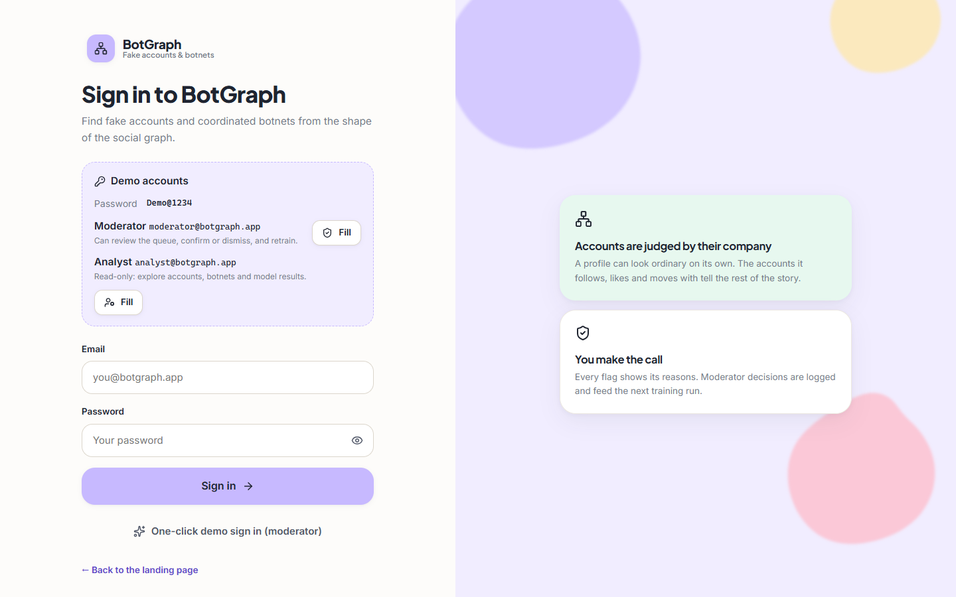  Figure 42: Sign-in page with the one-click demo accounts. | 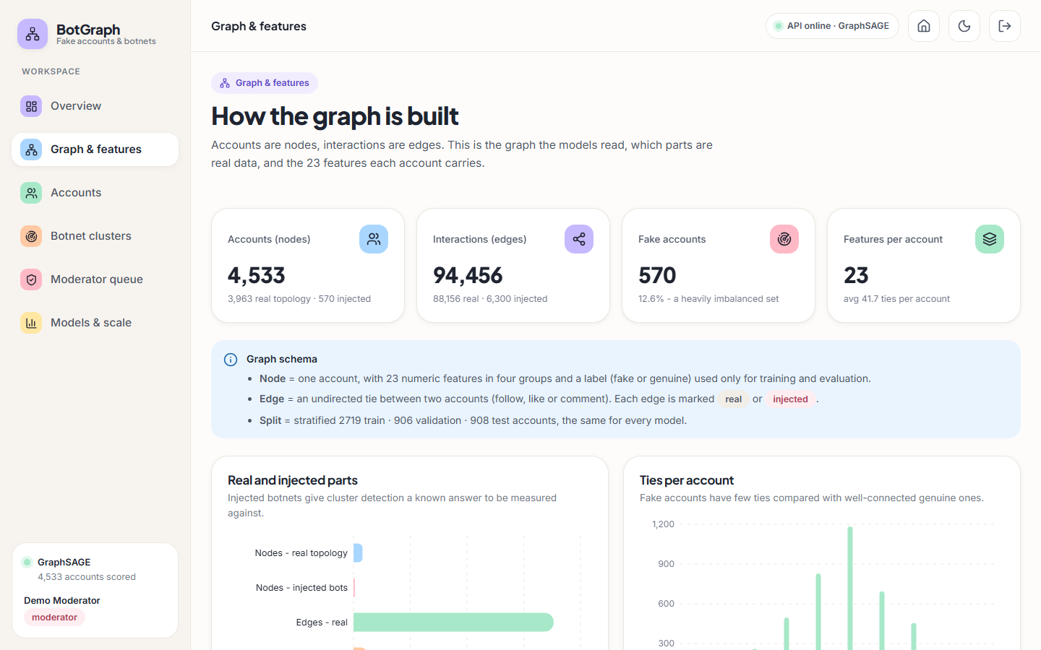  Figure 43: Graph and features screen: counts, data provenance and the 23 features.

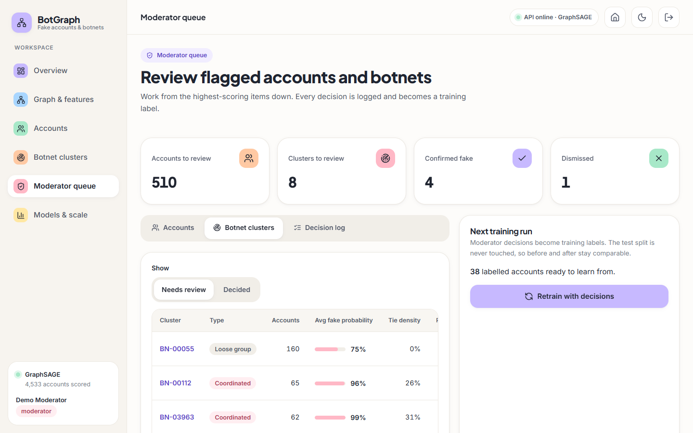  Figure 44: Moderator queue, botnet clusters tab. | 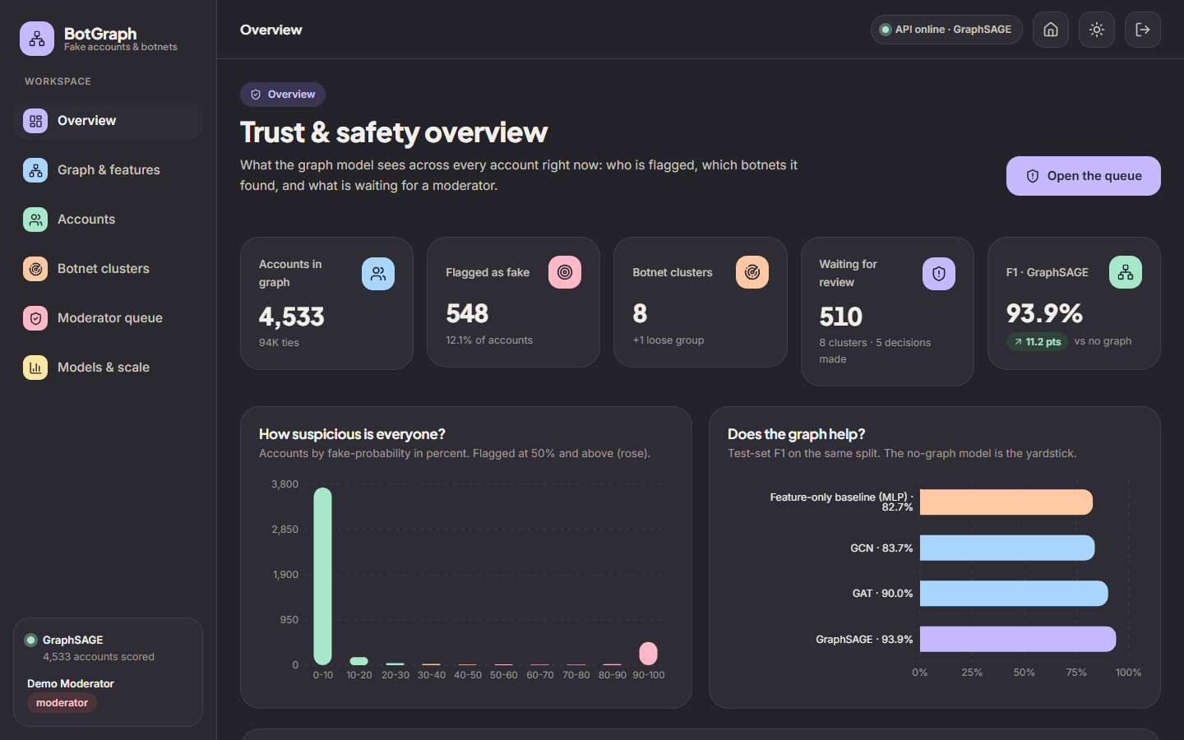  Figure 45: Overview screen in the dark theme.

  Figure 46: Landing page, dark theme. | 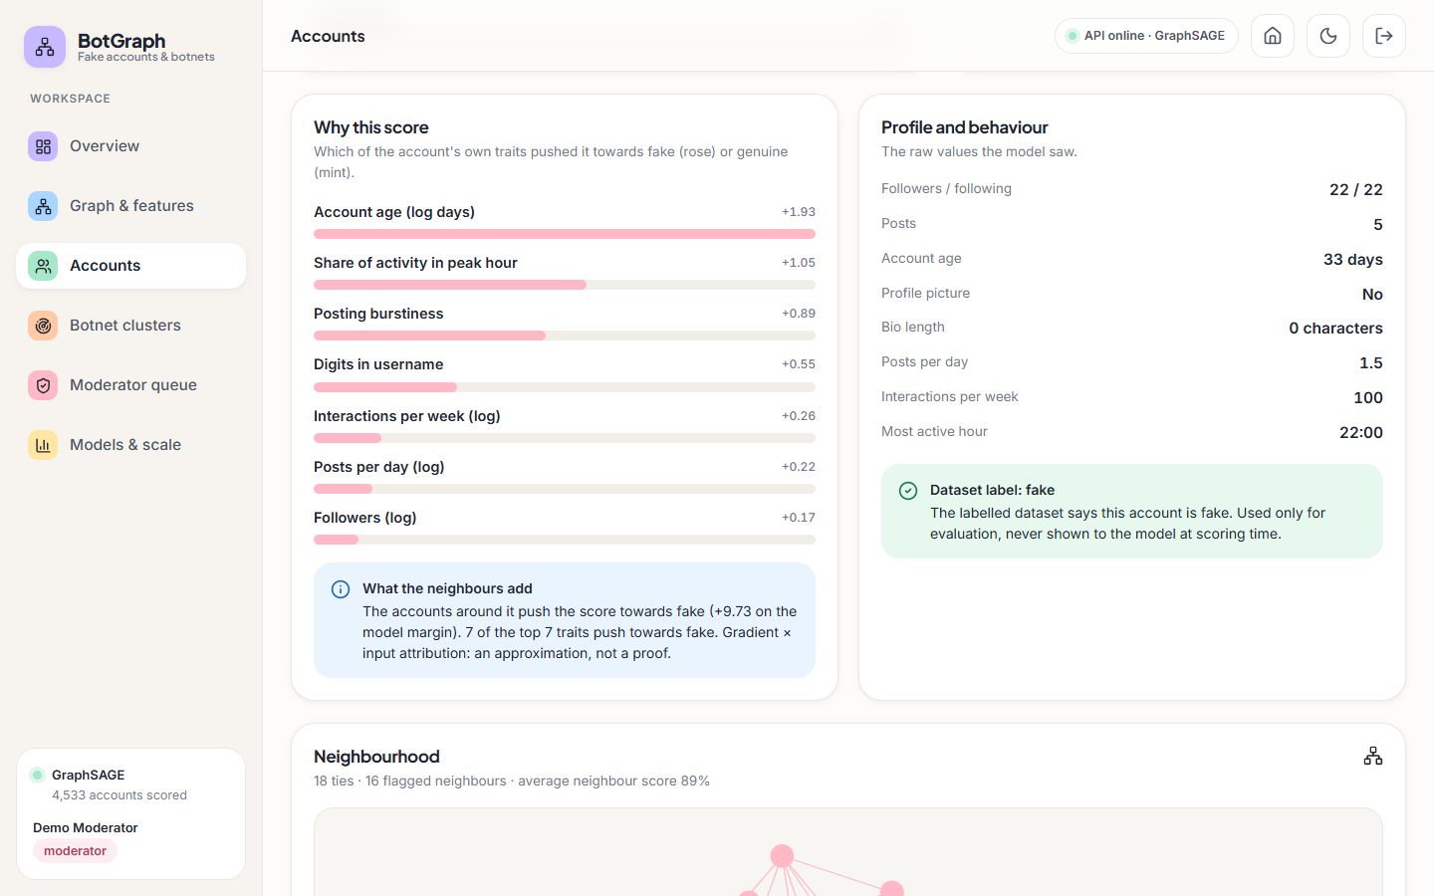  Figure 47: Account detail, lower half: reasons and neighbourhood.

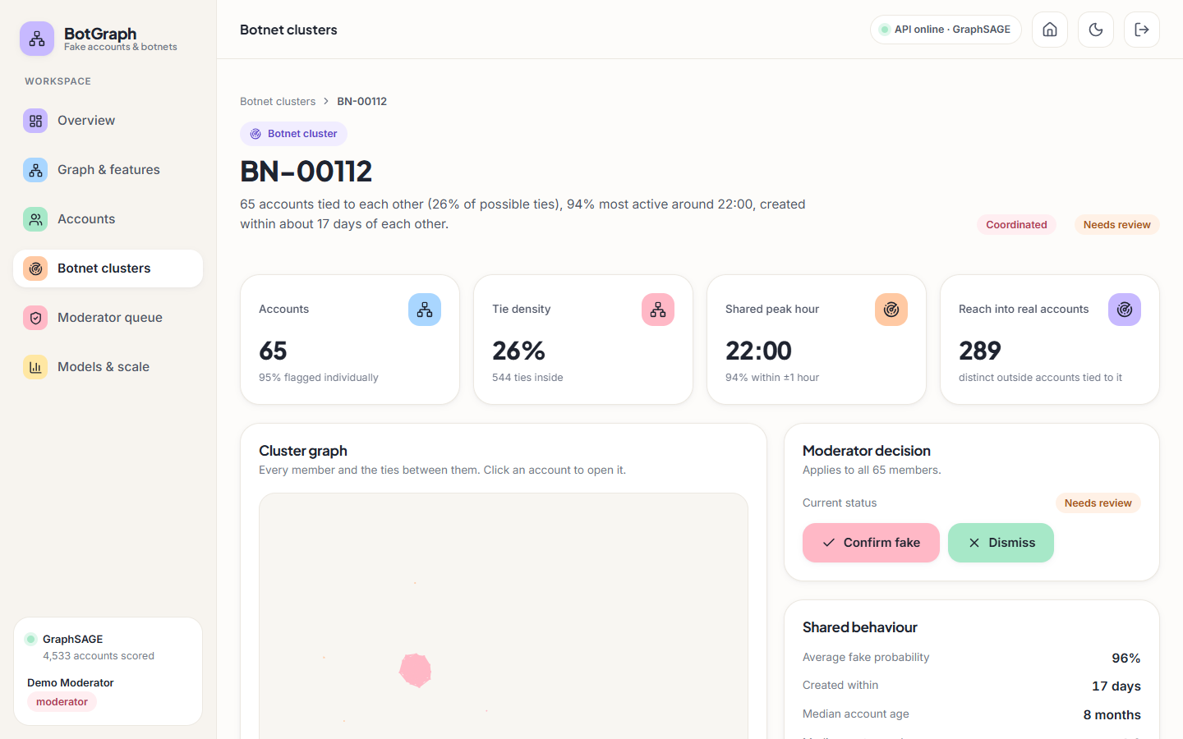  Figure 48: Cluster detail with the cluster graph in a second layout state. | 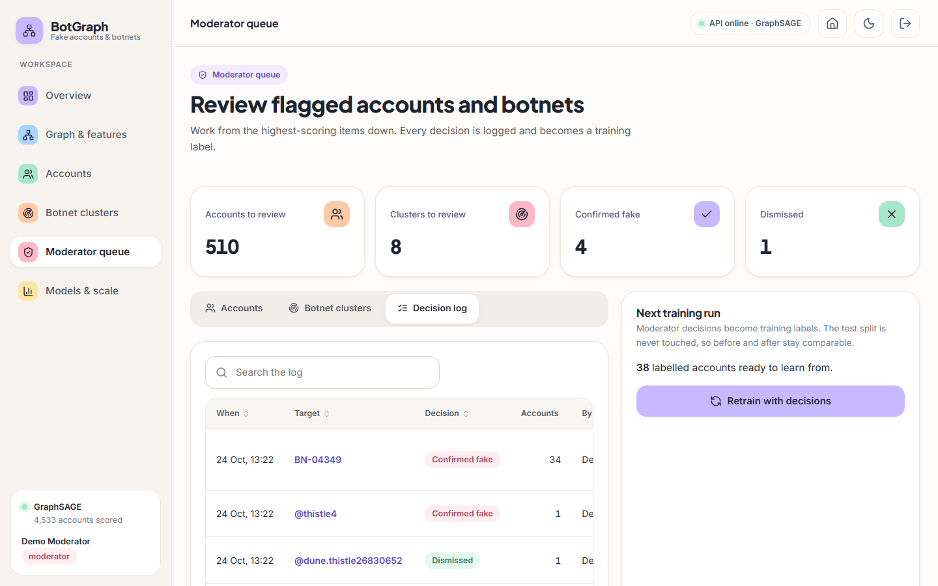  Figure 49: Moderator queue, Decision log tab.

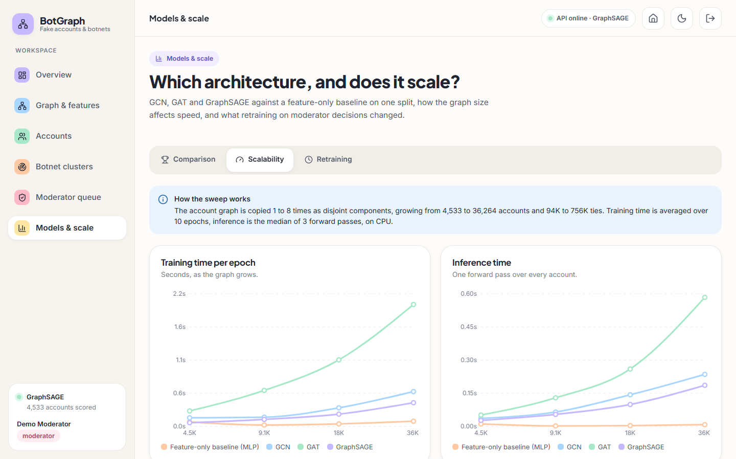  Figure 50: Models & scale, Scalability tab. | 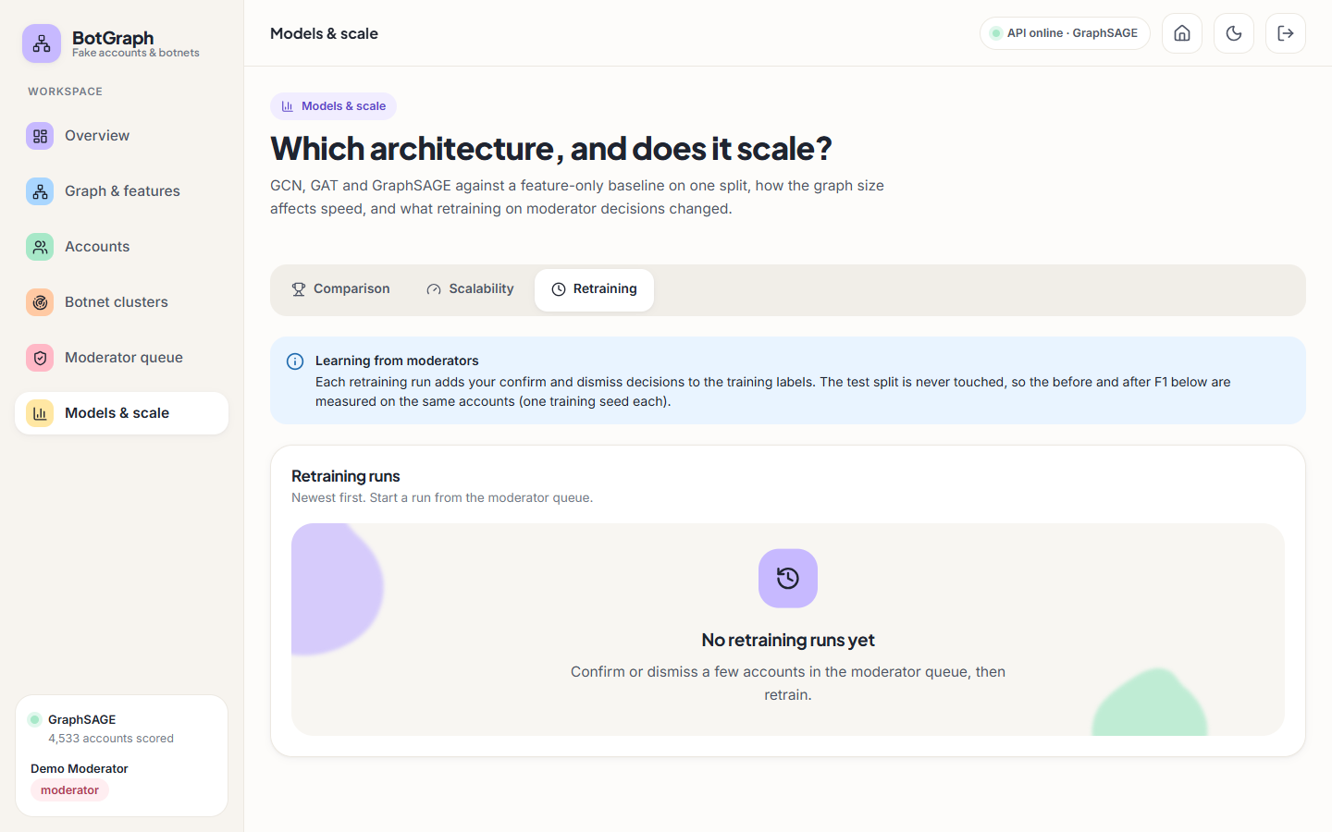  Figure 51: Models & scale, Retraining tab before any run.

Left to right, top to bottom: the sign-in page; the graph and features screen; the clusters tab of the moderator queue; the Overview screen in the dark theme; the landing page in the dark theme; the reasons and neighbourhood of one account; the cluster graph of BN-00112 in a second layout state; the decision log with a 34-account cluster decision; the scalability curves; and the Retraining tab before any run. Each is described in its caption.

